RECOMMENDATION ITU-R BO.1213-1
Reference receiving earth station antenna pattern
for the broadcasting-satellite service
in the 11.7-12.75 GHz band
(Question ITU-R 73/6)

(1995-2005)

Scope
This Recommendation intends to establish reference earth station co-polar and cross-polar antenna patterns for the broadcasting-satellite service (BSS) in the 11.7-12.75 GHz band.
The ITU Radiocommunication Assembly,
considering
a) that a common reference antenna pattern was used at WRC-97 and WRC-2000 for revising the Regions 1 and 3 broadcasting-satellite service (BSS) Plan;
b) that this same reference antenna pattern was used at WRC-03 for revising the inter and intraregional/inter- and intraservice sharing criteria contained in Appendix 30 of the Radio Regulations (RR);
c) that data from measurements of BSS receiving antennas support this same reference antenna pattern1;
d) that this same reference antenna pattern may be useful for interservice sharing between the BSS and other services and for other coordination purposes,
recommends
1 that the co-polar and cross-polar antenna patterns given by formulae provided in Annex 1 should be recognized as reference earth station antenna patterns for the BSS in the 11.7-12.75 GHz band.

Annex 1

Antenna pattern formulae:
These formulae are valid for D/λ ≥ 11:
Co-polar pattern:
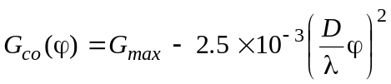 for 0 ≤ ϕ < ϕ_{m}
where:
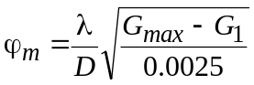
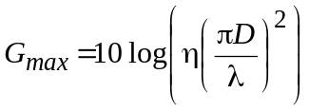
G₁ = 29 – 25 log ϕr, and 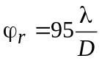
Gco (ϕ) = G1 for ϕm ≤ ϕ < ϕ_{r}
Gco (ϕ) = 29 – 25 log ϕ for ϕr ≤ ϕ < ϕ_{b} where ϕ_{b} = 10^{(34/25)}
Gco (ϕ) = –5 dBi for ϕb ≤ ϕ < 70°
Gco (ϕ) = 0 dBi for 70° ≤ ϕ < 180°
Cross-polar pattern:
Gcross (ϕ) = Gmax – 25 for 0 ≤ ϕ < 0.25 ϕ0
where ϕ0 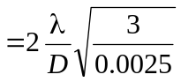
= 3 dB beamwidth
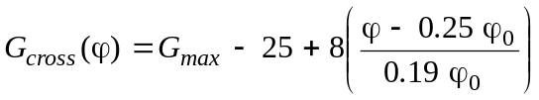 for 0.25 ϕ0 ≤ ϕ < 0.44 ϕ0
Gcross (ϕ) = Gmax – 17 for 0.44 ϕ0 ≤ ϕ < ϕ0
G_{cross} (ϕ) = G_{max} – 17 + C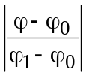 for ϕ₀ ≤ ϕ < ϕ₁ where 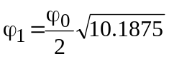
and C = 21 – 25 log(ϕ₁) – (G_{max} – 17)*
Gcross (ϕ) = 21 – 25 log ϕ for ϕ1 ≤ ϕ < ϕ₂ where ϕ₂ = 10^{(26/25)}
Gcross (ϕ) = –5 dBi for ϕ2 ≤ ϕ < 70°
Gcross (ϕ) = 0 dBi for 70º ≤ ϕ < 180º
where:
D: equivalent antenna diameter
λ: wavelength expressed in the same unit as the diameter
ϕ: off-axis angle of the antenna relative to boresight (degrees)
η: antenna efficiency.
Examples:
For the 60 cm reference antenna pattern used at WRC-03 for revising the interregional/interservice sharing criteria contained in RR Appendix 30, the following parameters apply:
Co-polar:
Gmax = 35.5 dBi
η = 0.65
D/λ = 23.4 (assumed frequency is 11.7 GHz)
ϕm = 3.98°
ϕr = 4.06°
G1 = 13.78 dB
ϕb = 10 (34/25)
Cross-polar:
ϕ0 = 2.96º
ϕ1 = 4.73º
ϕ2 = 10.96º
C = –14.36 dB
The corresponding reference antenna pattern is given in Fig. 1.
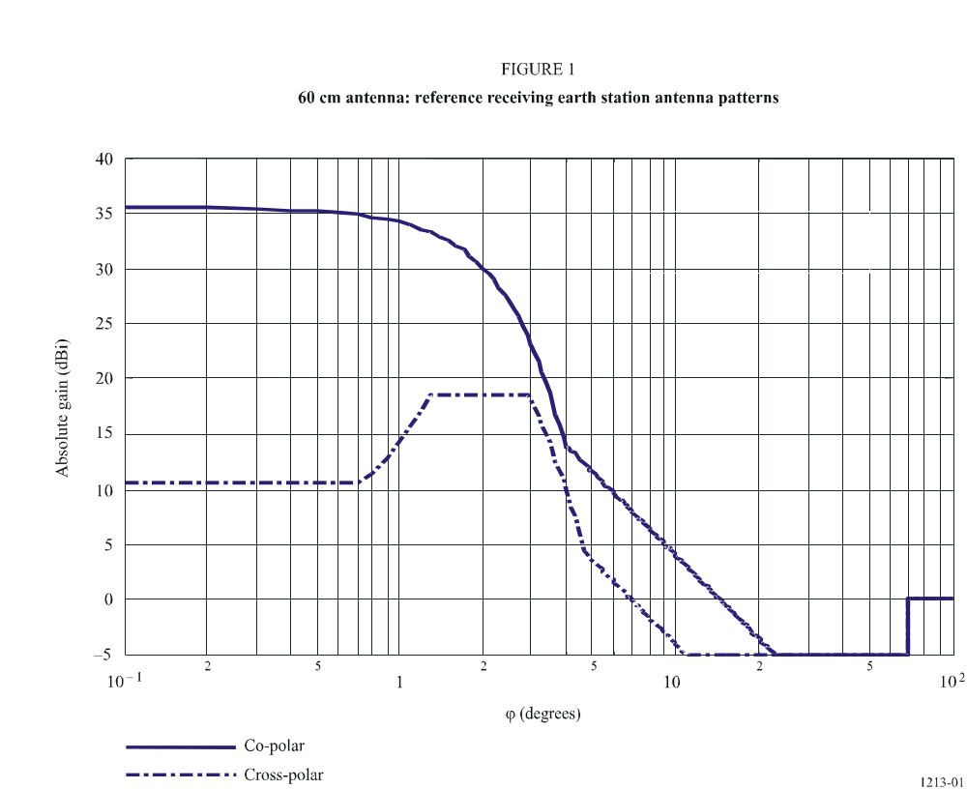
For the 45 cm reference antenna pattern used at WRC-03 for revising the interregional/interservice sharing criteria contained in RR Appendix 30, the following parameters apply:

Co-polar:
G_{max} = 33.3 dBi
η = 0.65
D/λ = 18.3 (assumed frequency is 12.2 GHz)
ϕ_{m} = 5.15°
ϕ_{r} = 5.19°
G₁ = 11.12 dB
ϕ_{b} = 10^{(34/25)}
Cross-polar:
ϕ₀ = 3.79°
ϕ₁ = 6.04°
ϕ₂ = 10.96°
C = –14.83 dB
The corresponding reference antenna pattern is given in Fig. 2.
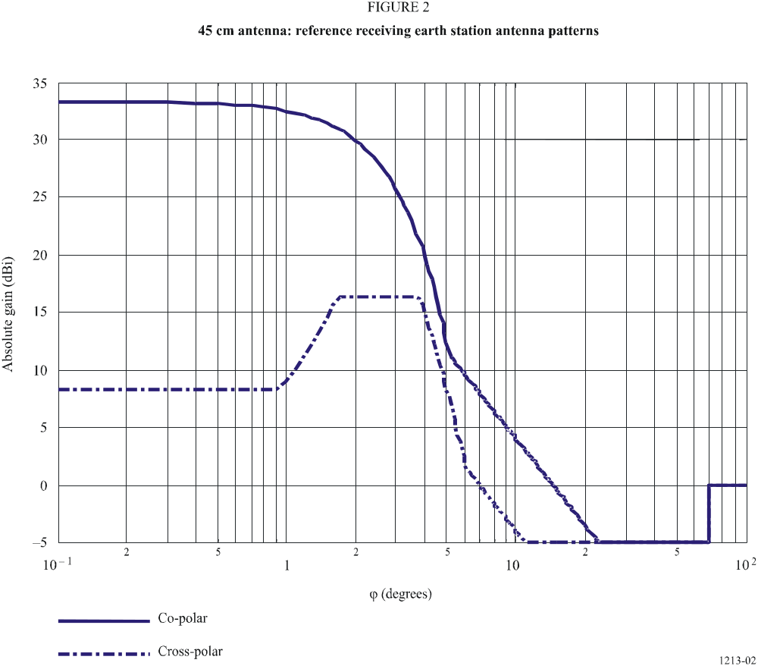

1 It should be noted that the antenna measurements were performed on single-feed antennas.
* The value of C must be less than 0 for any combination of antenna efficiency (η) and D/λ.

