|  |
| --- |
| **Recommendation ITU-R P.837-7**  **(06/2017)** |
| **Characteristics of precipitation for propagation modelling** |
| **P Series**  **Radiowave propagation** |

Foreword

The role of the Radiocommunication Sector is to ensure the rational, equitable, efficient and economical use of the radio-frequency spectrum by all radiocommunication services, including satellite services, and carry out studies without limit of frequency range on the basis of which Recommendations are adopted.

The regulatory and policy functions of the Radiocommunication Sector are performed by World and Regional Radiocommunication Conferences and Radiocommunication Assemblies supported by Study Groups.

# Policy on Intellectual Property Right (IPR)

ITU-R policy on IPR is described in the Common Patent Policy for ITU-T/ITU-R/ISO/IEC referenced in Annex 1 of Resolution ITU-R 1. Forms to be used for the submission of patent statements and licensing declarations by patent holders are available from <http://www.itu.int/ITU-R/go/patents/en> where the Guidelines for Implementation of the Common Patent Policy for ITU‑T/ITU‑R/ISO/IEC and the ITU-R patent information database can also be found.

|  |  |
| --- | --- |
| Series of ITU-R Recommendations  (Also available online at <http://www.itu.int/publ/R-REC/en>) | |
| **Series** | Title |
| **BO** | Satellite delivery |
| **BR** | Recording for production, archival and play-out; film for television |
| **BS** | Broadcasting service (sound) |
| **BT** | Broadcasting service (television) |
| **F** | Fixed service |
| **M** | Mobile, radiodetermination, amateur and related satellite services |
| P | Radiowave propagation |
| **RA** | Radio astronomy |
| **RS** | Remote sensing systems |
| **S** | Fixed-satellite service |
| **SA** | Space applications and meteorology |
| **SF** | Frequency sharing and coordination between fixed-satellite and fixed service systems |
| **SM** | Spectrum management |
| **SNG** | Satellite news gathering |
| **TF** | Time signals and frequency standards emissions |
| **V** | Vocabulary and related subjects |

|  |
| --- |
|  |

|  |
| --- |
| ***Note***: *This ITU-R Recommendation was approved in English under the procedure detailed in Resolution ITU-R 1.* |

*Electronic Publication*

Geneva, 2017

© ITU 2017

All rights reserved. No part of this publication may be reproduced, by any means whatsoever, without written permission of ITU.

RECOMMENDATION ITU-R P.837-7[1]*

Characteristics of precipitation for propagation modelling

(Question ITU-R 201/3)

(1992-1994-1999-2001-2003-2007-2012-2017)

Scope

Rainfall rate statistics with a 1-min integration time are required for the prediction of rain attenuation in terrestrial links (e.g. Recommendation ITU-R P.530) and Earth-space links (e.g. Recommendation ITU-R P.618).

When reliable long-term local rainfall rate data is not available, Annex 1 of this Recommendation provides a rainfall rate prediction method for the prediction of rainfall rate statistics with a 1‑min integration time. This prediction method is based on: a) total monthly rainfall data generated from the GPCC Climatology (V 2015) database over land and from the European Centre for Medium-Range Weather Forecast (ECMWF) ERA Interim re‑analysis database over water, and b) monthly mean surface temperature data in Recommendation ITU-R P.1510.

When reliable long-term local rainfall rate data is available with integration times greater than 1-min, Annex 2 of this Recommendation provides a method for converting rainfall rate statistics with integration times that exceed 1-min to rainfall rate statistics with a 1-min integration time.

Keywords

Rainfall rate, annual statistics, conversion method, GPCC, ERA Interim

The ITU Radiocommunication Assembly,

considering

*a)* that information on the yearly statistics of precipitation parameters are needed for the prediction of attenuation and scattering caused by precipitation;

*b)* that the information is needed for all locations on the surface of the Earth and a wide range of probabilities;

*c)* that rainfall rate statistics with a 1-min integration time are required for the prediction of rain attenuation and scattering in terrestrial and satellite links;

*d)* that long-term measurements of rainfall rate may be available from local sources with a 1‑min integration time and, also, with integration times that exceed 1-minute;

*e)* that using a model to convert local rainfall rate measurements with integration times up to 1 hour into an integration time of 1-minute may provide higher accuracy than Annex 1 of this Recommendation,

recommends

**1** that local long-term measurements of annual rainfall rate with a 1-minute integration time should be used if available;

**2** that local measurements, if used, are collected over a sufficiently long period of time (typically longer than 10 years), to ensure statistical stability;

**3** that long-term measurements of annual rainfall rate with integration times that exceed 1 minute should be used if available, and the conversion method in Annex 2 should be used to convert these measurements to annual rainfall rate with a 1-minute integration time;

**4** that, in the absence of reliable local rainfall rate data, the step-by-step prediction method in Annex 1 should be used to obtain the rainfall rate, *Rp*, exceeded for the desired annual probability of exceedance, *p*, for any location on the surface of the Earth, and for an integration time of 1 minute.

Annex 1  
  
Prediction method to derive the rainfall rate exceeded for a given  
average annual probability of exceedance and given location

This prediction method calculates the rainfall rate exceeded for a desired average annual probability of exceedance and a given location on the surface of the Earth using digital maps of monthly total rainfall and monthly mean surface temperature. The monthly mean total rainfall maps were derived from 50 years (1951-2000) of data from the GPCC Climatology (V 2015) database over land and from 36 years (1979-2014) of the European Centre of Medium-range Weather Forecast (ECMWF) ERA Interim data over water.

The monthly mean total rainfall data, *MTii* (mm), where *ii* = {01, 02, 03, 04, 05, 06, 07, 08, 09, 10, 11 and 12}, are an integral part of this Recommendation and are available as digital maps. The latitude grid is from −90.125° N to +90.125° N in 0.25° steps, and the longitude grid is from −180.125° E to +180.125° E in 0.25° steps.

The annual rainfall rate data exceeded for 0.01% of an average year, *R*0.01 (mm/hr), is also an integral part of this Recommendation and are available as digital maps. The latitude grid is from −90° N to +90° N in 0.125° steps, and the longitude grid is from −180° E to +180° E in 0.125° steps.

These digital maps are available in the Supplement file R-REC-P.837-7-Maps.zip.

Input parameters:

*p*: Desired annual probability of exceedance (%)

*Lat*: Latitude of the desired location (degrees, N)

*Lon*: Longitude of the desired location (degrees, E)

Output parameter:

*Rp*: Rainfall rate exceeded for the desired probability of exceedance (mm/h).

***Step 1***: For each month of the year, define the month number, *ii*, and the number of days in each month, , as follows:

|  |  |  |  |  |  |  |  |  |  |  |  |  |
| --- | --- | --- | --- | --- | --- | --- | --- | --- | --- | --- | --- | --- |
| Month | Jan | Feb | Mar | Apr | May | Jun | Jul | Aug | Sep | Oct | Nov | Dec |
| *ii* | 01 | 02 | 03 | 04 | 05 | 06 | 07 | 08 | 09 | 10 | 11 | 12 |
| *Nii* | 31 | 28.25 | 31 | 30 | 31 | 30 | 31 | 31 | 30 | 31 | 30 | 31 |

***Step 2***: For each month number, *ii,* where *ii* = {01, 02, 03, 04, 05, 06, 07, 08, 09, 10, 11 and 12}, determine the monthly mean surface temperatures, *Tii* (K), at the desired location (*Lat*, *Lon*) from reliable long-term local data.

If reliable long-term local data is not available, the monthly mean surface temperatures, *Tii* (K), at the desired location (*Lat*, *Lon*) can be obtained from the digital maps of monthly mean surface temperature in Recommendation ITU-R P.1510.

***Step 3***: For each month number *ii,* where *ii* = {01, 02, 03, 04, 05, 06, 07, 08, 09, 10, 11 and 12}, determine the monthly mean total rainfall, *MTii* (mm), at the desired location (*Lat, Lon*) from reliable long-term local data.

If reliable long-term local data is not available, the monthly mean total rainfall at the desired location (*Lat, Lon*) can be determined from the digital maps of monthly mean total rainfall, *MTii* (mm), provided as an integral part of this Recommendation as follows:

a) determine the four grid points (*Lat*1, *Lon*1), (*Lat*2, *Lon*2), (*Lat*3, *Lon*3) and (*Lat*4, *Lon*4) surrounding the desired location (*Lat, Lon*);

b) determine the monthly mean total rainfall, , , , and  at the four surrounding grid points of the maps provided with this Recommendation;

c) determine  at the desired location (*Lat*, *Lon*) by performing a bi-linear interpolation using the four surrounding grid points as described in Annex 1 Paragraph 1b of Recommendation ITU-R P.1144.

***Step 4***:For each month number, *ii*, convert *Tii* (K) to *tii* (**°**C).

***Step 5***: For each month number, *ii*, calculate *rii* as follows:

  (1)

***Step 6a***: For each month number, *ii*, calculate the monthly probability of rain as follows:

$P_{0_{ii}}=100\frac{MT_{ii}}{24{ ×N}_{ii}×r_{ii}}$ (%) (2)

***Step 6b***: For each month number, *ii*, if , set  and 

***Step 7***:Calculate the annual probability of rain,  as follows:

 (%) (3)

***Step 8***:If the desired rainfall rate probability of exceedance, *p*, is greater than , the rainfall rate at the desired rainfall rate probability of exceedance, $R_{p}$, is 0 mm/hr.

If the desired rainfall rate probability of exceedance, *p*, is less than or equal to , adjust the rainfall rate, *Rref*, until the absolute value of the relative error between the annual rainfall rate probability of exceedance, , and the desired rainfall rate probability of exceedance, *p*, is less than 0.001% (i.e. until $100\left|\frac{P(R>R_{ref})}{p}-1\right|<0.001$), where:

 (%) (4)

 (%) (5)

and

 (6)

At the end of the adjustment process, set *Rp* = *Rref*.

NOTE 1 – When the 0.01% average annual probability of exceedance is required, and where memory and computational complexity are considerations, the pre-computed map of $R_{0.01}$ can be used with insignificant loss in accuracy. If this map is used, the rainfall rate at the 0.01% average annual probability of exceedance at any desired location on the surface of the Earth can be calculated by performing a bi-linear interpolation using the method described in Annex 1 Paragraph 1b of Recommendation ITU-R P.1144. The absolute value of the difference between the full rainfall rate prediction method and the pre-computed $R_{0.01}$ map is less than 0.3 mm/hr for greater than 99.9% of the surface of the Earth, and the absolute value of the difference between the full rainfall rate prediction method and the $R_{0.01}$ map is less than 1 mm/hr for greater than 99.99% of the surface of the Earth.

NOTE 2 – When the 0.01% average annual probability of exceedance is required using the full rainfall rate prediction method, the pre-computed map of $R_{0.01}$, the rainfall rate at the 0.01% exceedance probability could be used as the initial starting point *Rref* for the iterative procedure in Step 8.

For reference, a map of *R*0.01, the annual rainfall rate exceeded for 0.01% of an average year, is shown in Fig. 1.

FIGURE 1

Rainfall rate exceeded for 0.01% of an average year

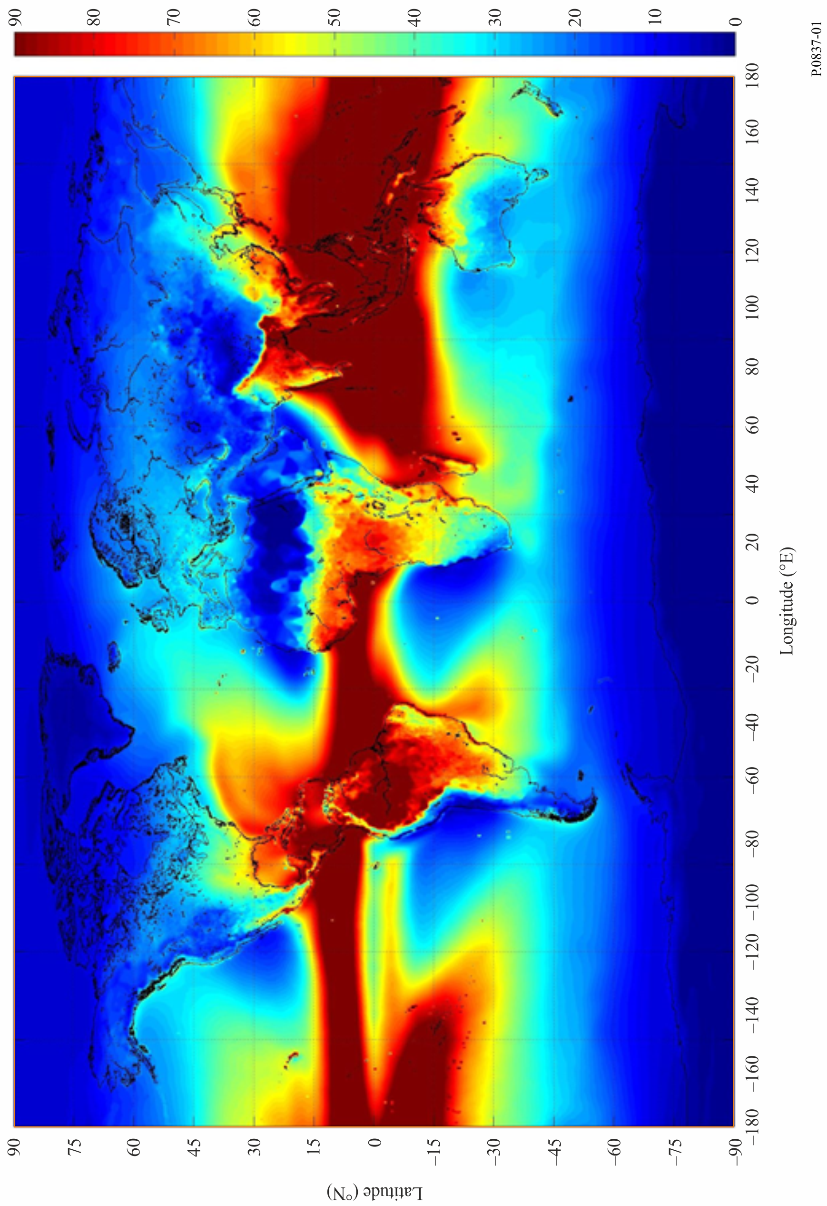

Annex 2

**1** The cumulative distribution of rainfall rate at 1-min integration time can be obtained by converting local cumulative distributions measured at integration times of between 5 and 60 minutes.

**2** The recommended method requires as input both the cumulative distribution as well as the integration time of the source rainfall statistics and the geographical coordinates of the site of interest.

**3** The method is based on the simulated movement of synthetic rain cells, whose parameters derive from the local input data and ECMWF products.

**4** The recommended method is incorporated in a computer program available at the Supplement. The name of the software package implementing this part of the Recommendation is R‑REC-P.837-7-Convrrstat.zip.

1. * Radiocommunication Study Group 3 made editorial amendments to this Recommendation in the year 2019 in accordance with Resolution ITU-R 1.