REPORT ITU-R BO.2029
Broadcasting-satellite service earth station antenna pattern
measurements and related analyses
(Question ITU-R 93/11)
(2002)

1 Introduction
Recommendation ITU-R BO.1443 – Reference BSS earth station antenna patterns for use in interference assessment involving non-GSO satellites in frequency bands covered by RR Appendix S30, describes broadcasting-satellite service (BSS) reference antenna patterns to be used in non-geostationary-satellite service (non-GSO) interference analyses. Of particular interest are small, offset-fed BSS earth station antennas which have non-axially symmetric patterns. Millions of these antennas have been deployed worldwide. To support the development of these antenna reference patterns several Sector Members performed detailed measurements, analyses and modelling of three-dimensional antenna patterns. A Special Rapporteur Group was formed to collect and organize the extensive data sets and analyses performed during the development of the Recommendation described above. It was felt that information of this nature would be valuable in future BSS studies.
The three tasks assigned to the Special Rapporteur were:
– Collect antenna measurement data and analyses performed by administrations during development of the Recommendation cited above.
– Prepare a summarizing report describing the antenna measurements analyses and catalogue the relevant data on one or more CD-ROMs.
– Compare the submitted measured data with the three-dimensional reference antenna patterns contained in Recommendation ITU-R BO.1443.
To accomplish these tasks, data from administrations was solicited via e-mail. Data was received from the United Kingdom, Canada and Telenor, and is summarized in the following sections.
This Report is organized as follows. Section 2 describes the basic geometry and coordinate system for the antenna measurements. A brief summary of the measurements is also provided. Sections 3, 4 and 5 describe the antenna measurements and analyses performed by the United Kingdom, Telenor, and Canada, respectively. A subset of the data is plotted in gain vs. azimuth angle format; in several cases, polar plots are also provided. Plots comparing the measured data with the reference antenna patterns in Recommendation ITU-R BO.1443 are provided for some of the data sets. Section 6 describes the text and data file layout on the CD-ROM.
Data was submitted as either Microsoft Excel spreadsheets or as ASCII files. This Report, the data sets provided, the spreadsheets containing the graphical analysis performed by the Special Rapporteur Group, and the spreadsheets used to plot the reference antenna patterns from Recommendation ITU-R BO.1443 are included on the CD-ROM.

2 Summary of BSS earth station antenna measurements and analyses provided by Sector Members
More than 30 small earth station antennas were measured by the United Kingdom, Telenor, and Canada. Their results are summarized in Sections 3, 4 and 5.

2.1 Antenna data summary
The antenna measurements demonstrate that spillover sidelobes are a common feature of small, offset-fed earth station dish antennas used for BSS systems. This issue, and its relevance to non-GSO fixed-satellite service (FSS) and GSO BSS sharing studies, was first reported. The plots provided which are only a small subset of the data provided to the Special Rapporteur Group, show how the sidelobes change with location around the dish and with operating frequency. For example, as shown in Fig. 73, the angular position and the relative gain of the spillover sidelobe changes from about –39 dB at ϕ = 150° in the 0° plane to about –34 dB at ϕ = 90° in the 90° plane.

2.2 Antenna measurement coordinate system
The antenna data in this Report were generally recorded using the conventions shown in Fig. 1. Eight measurement planes were used for the three-dimensional earth station antenna pattern measurements. The planes are equally spaced by 22.5°. Note that the boresight of the antenna gain pattern is included in each of the eight planes.

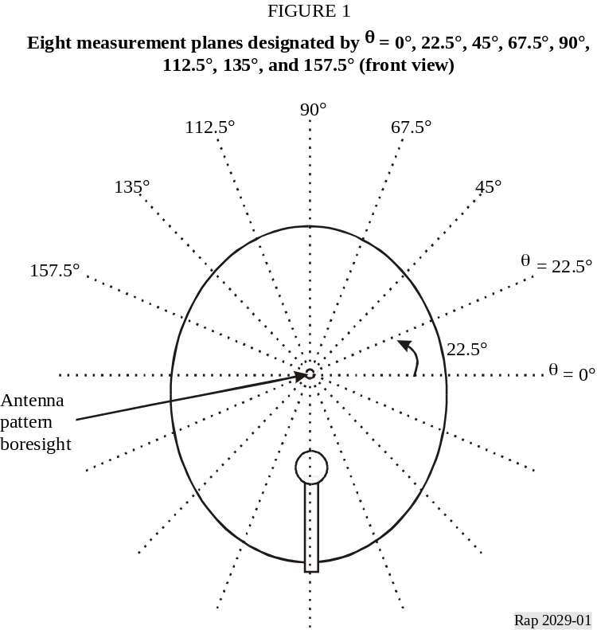
Figure 2 a view from above that show hows ϕ, the azimuth angle in the plane of the measurement, is defined. Some data sets include the full ϕ = –180° to +180°, while others cover about –120° to +120°.

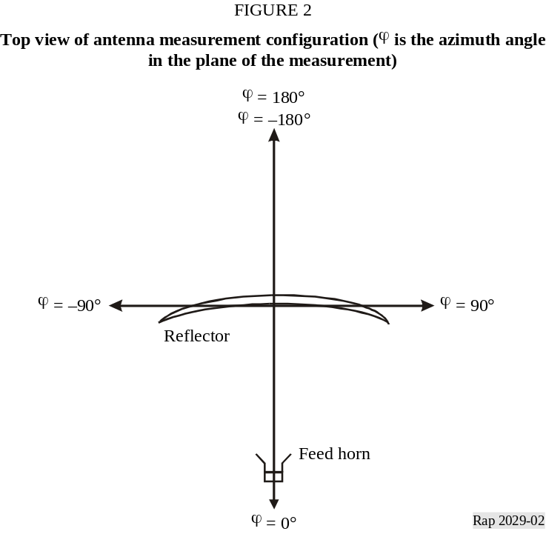
Note that not all of the data sets used the conventions outlined above. Telenor, for example, used conventions that were very similar, but not exactly, as those described above.

3 BSS earth station antenna measurements and analyses provided by the United Kingdom

3.1 Antenna measurements summary
Co-polar radiation pattern measurements were obtained for widely available commercial offset-fed reflector (43 cm, 45 cm and 59 cm) GSO earth station dishes in 8 measurement planes (0°, 22.5°, 45°, 67.5°, 90°, 112.5°, 135°, and 157.5°). Measurements were obtained for each individual plane at frequencies of 11 GHz, 11.7 GHz and 12.5 GHz. A 65 m outdoor test range was used for these measurements. The antennas were circularly polarized, and linear polarization was transmitted for these measurements.

3.2 Antenna measurement data
Co-polarization patterns reported for the 43, 45 and 59 cm antennas in the 0°, 45°, and 90° planes are shown in Figs. 3 to 32. Data is available for the other planes, but is not shown in these Figures. Selected patterns are also plotted in a polar format; this provides another way to observe the symmetry or asymmetry that may be present in the patterns. The polar plots are prepared so that the counter-clockwise angular displacement from antenna boresight is the negative ϕ angles shown in the x-y plots. Also provided are plots comparing the measured data with the masks in Recommendation ITU-R BO.1443.
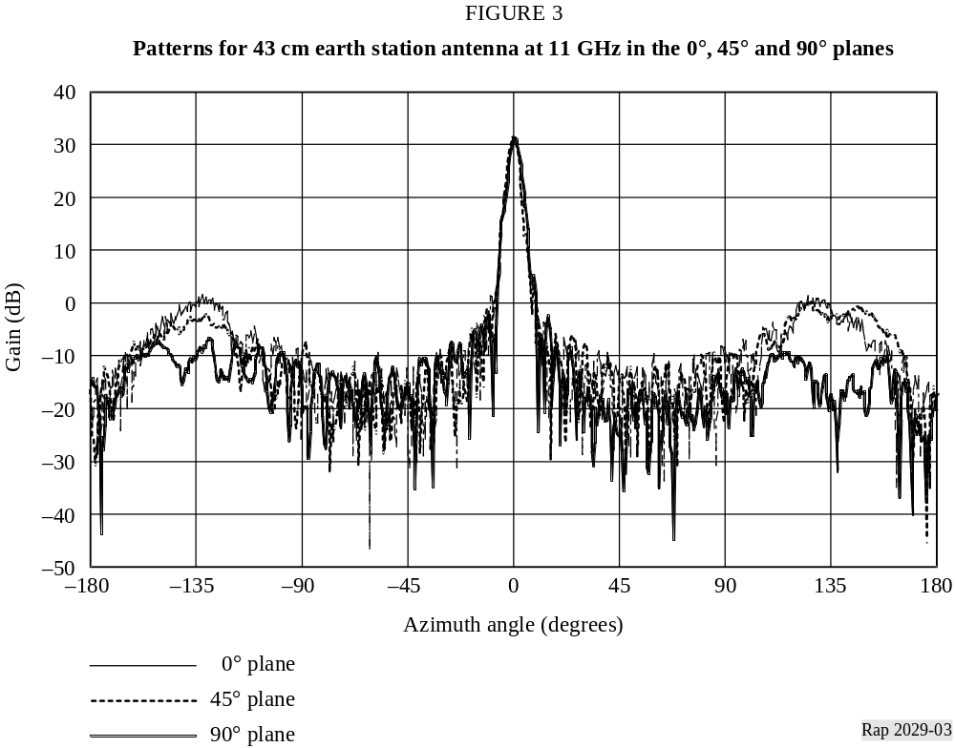

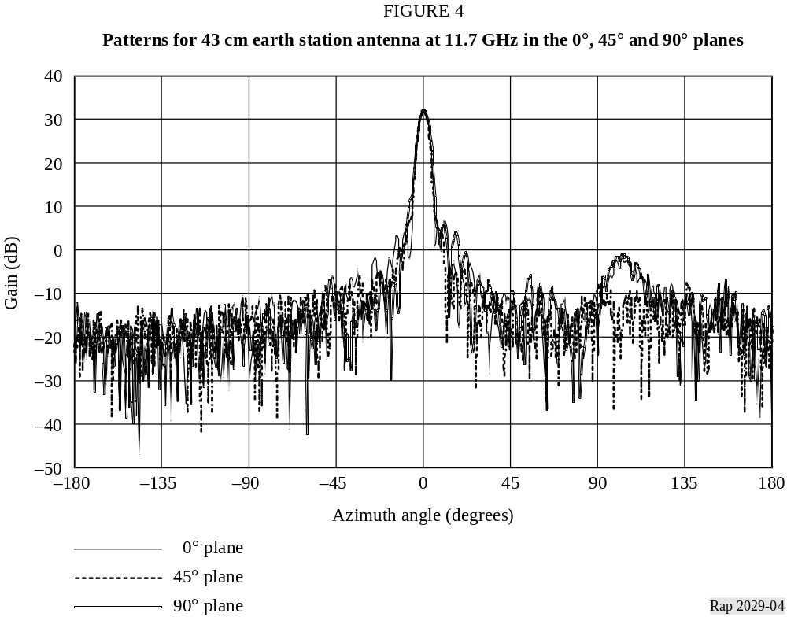
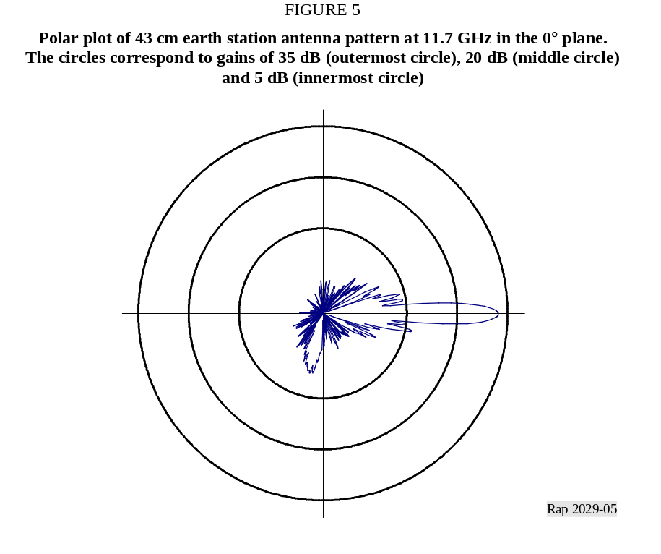

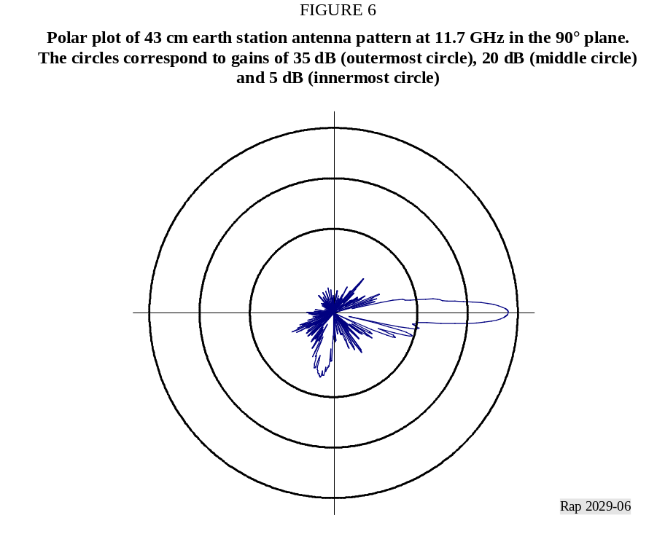
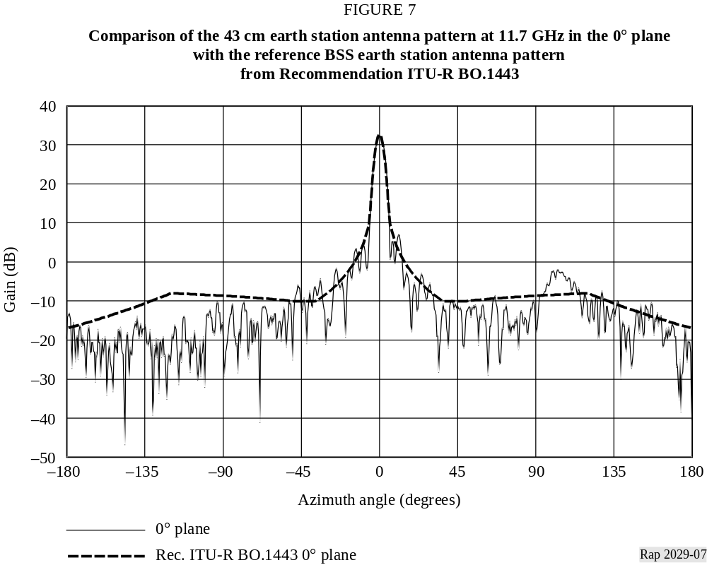

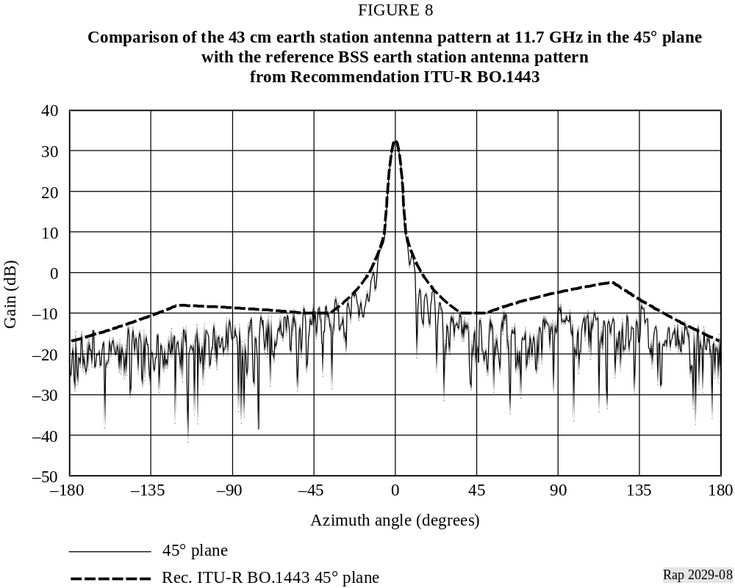
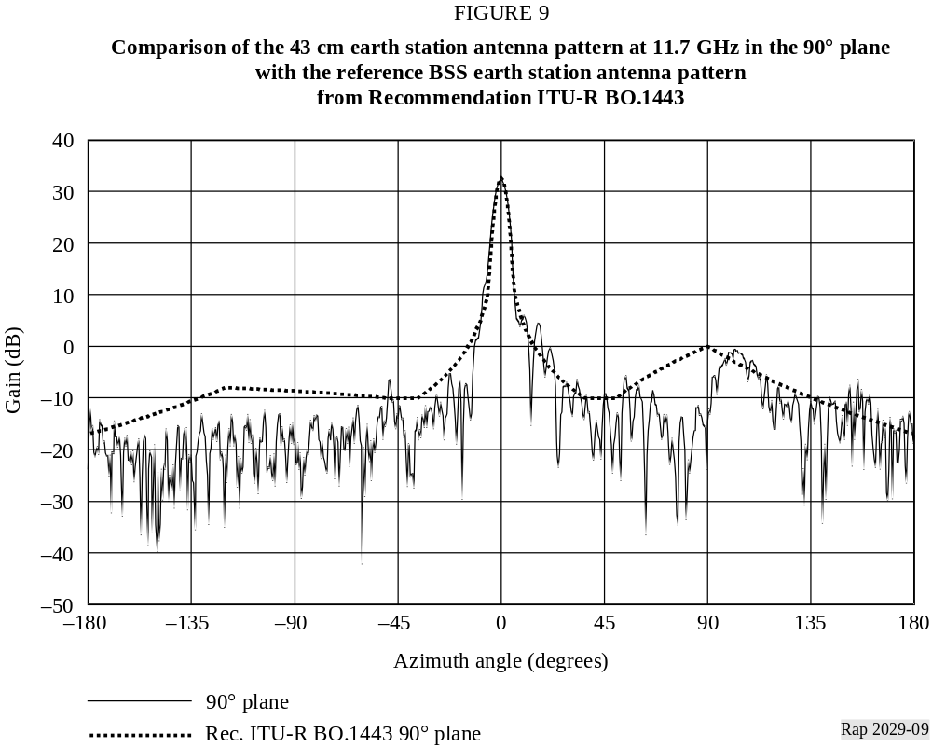

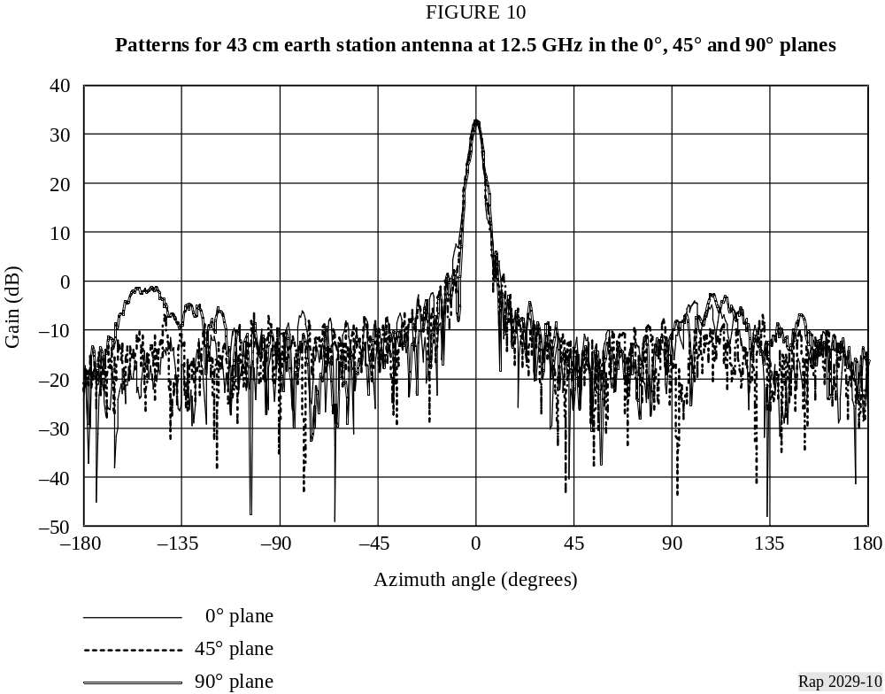
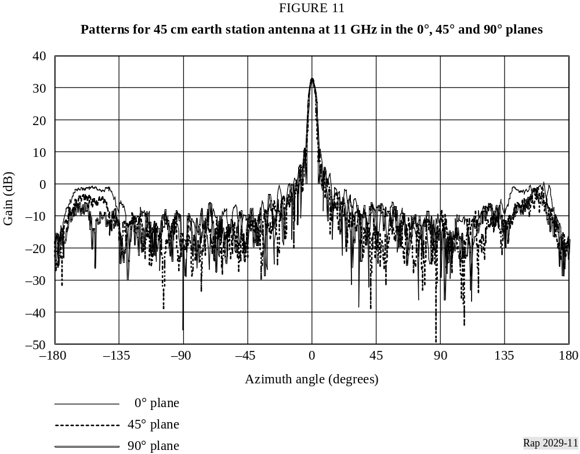

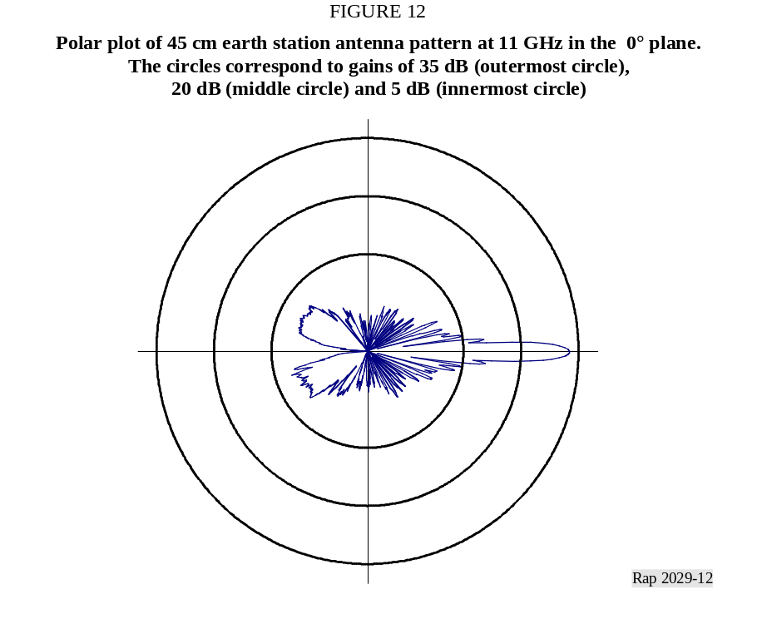
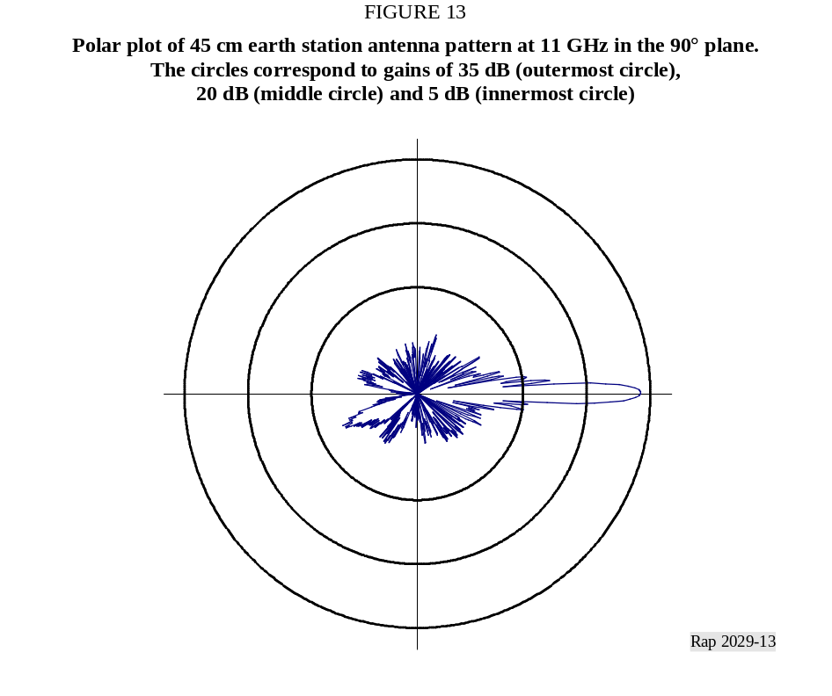

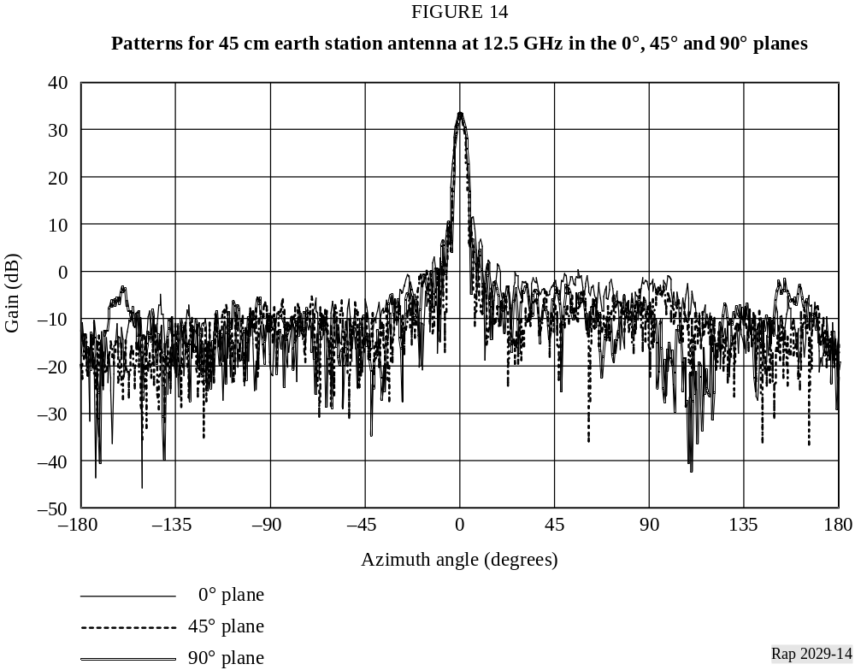
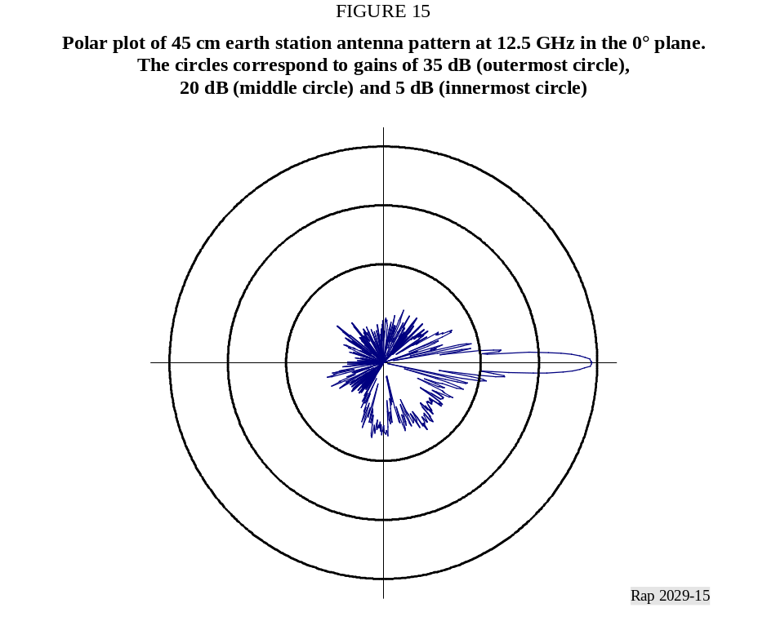

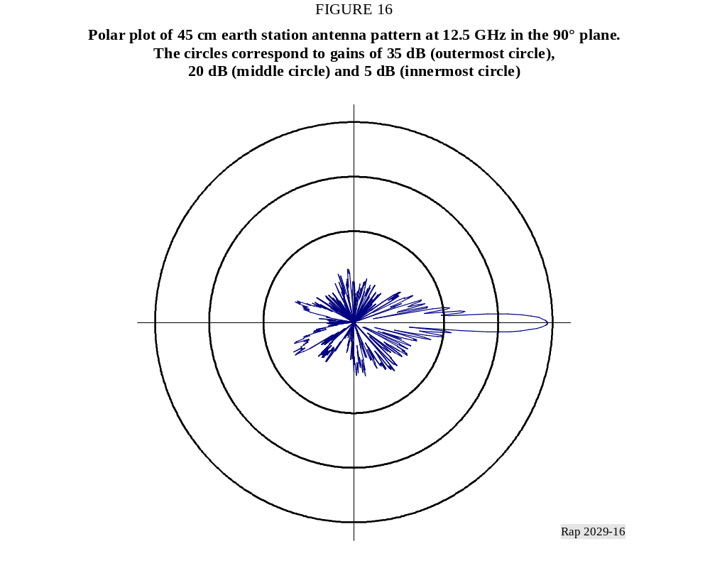
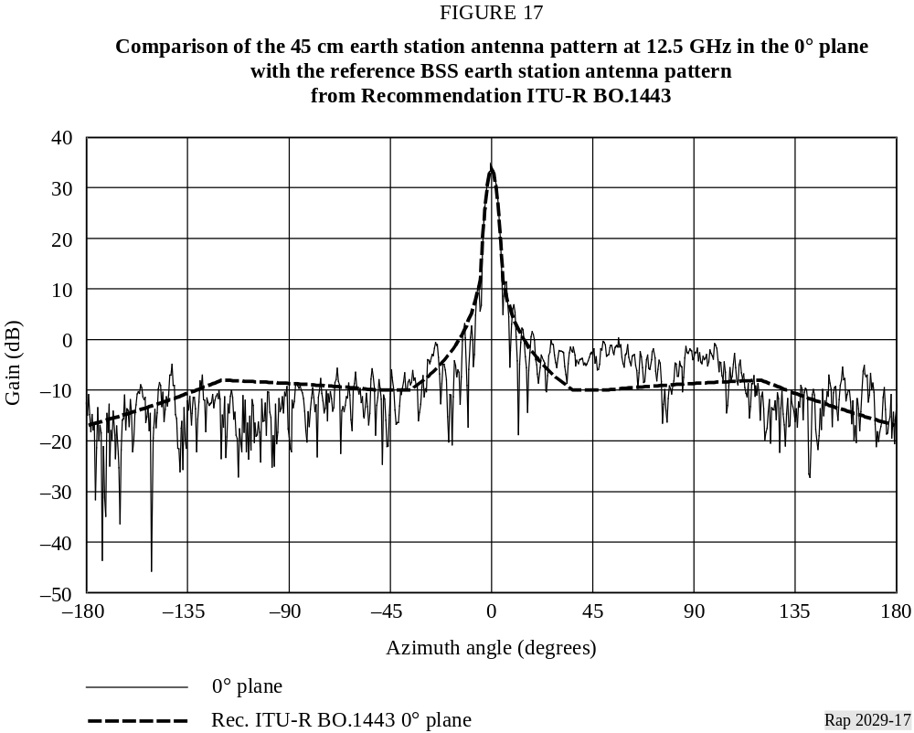

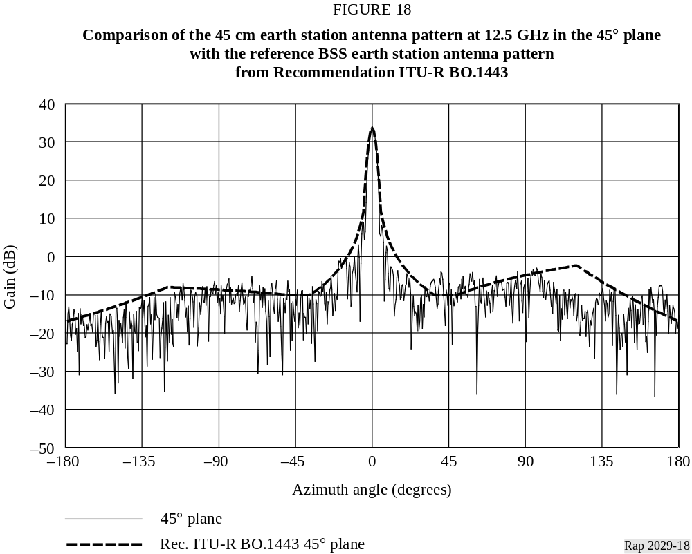
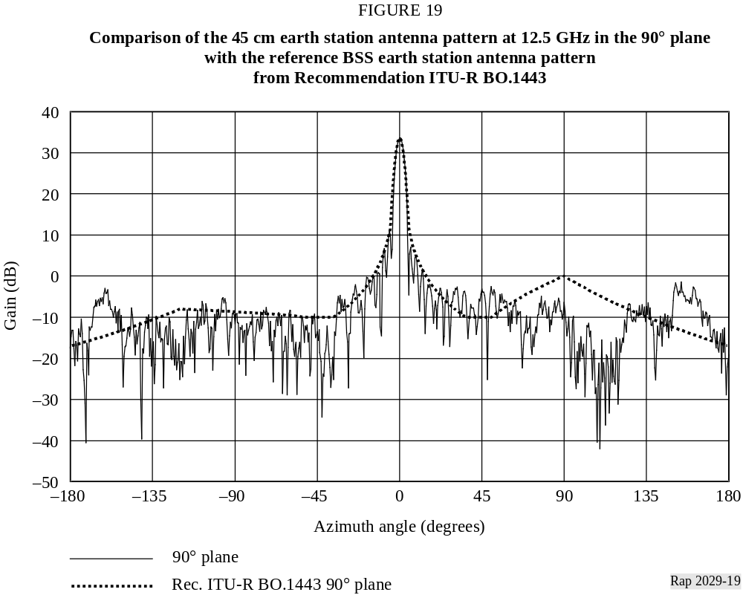

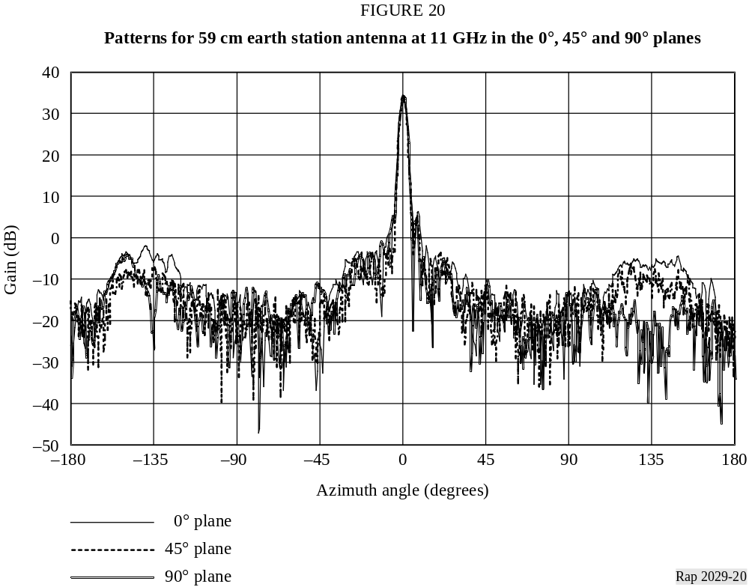
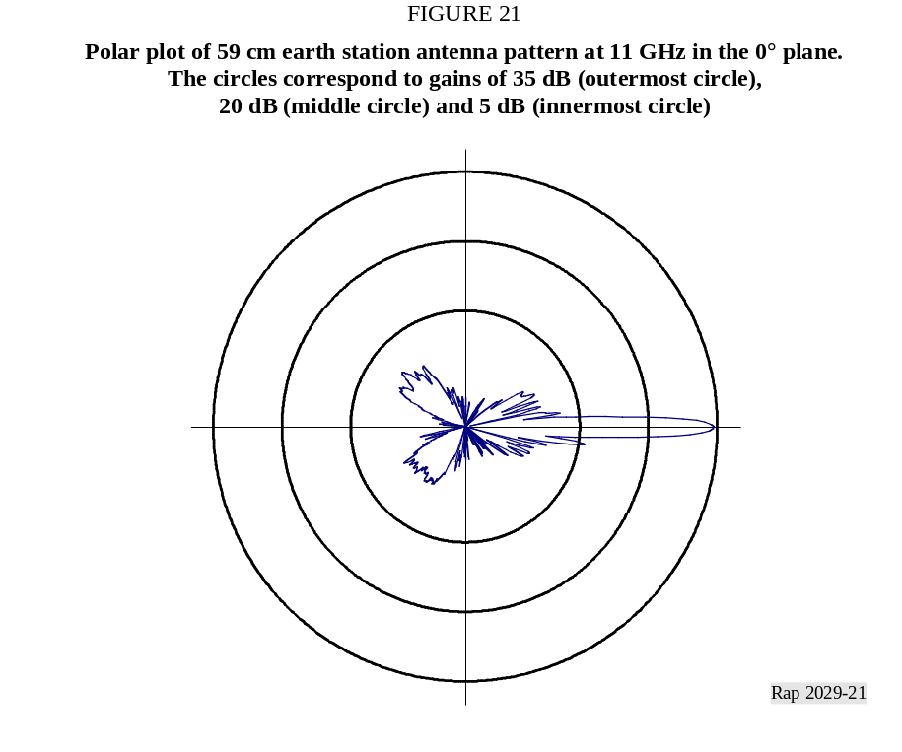

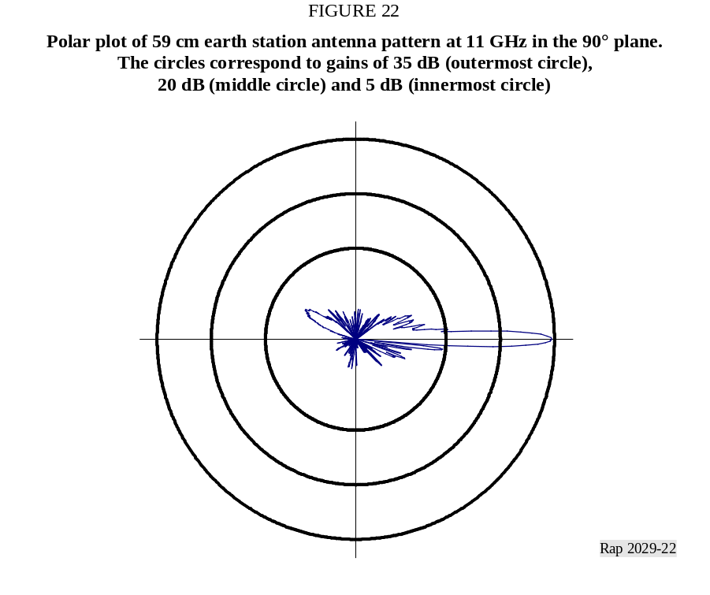
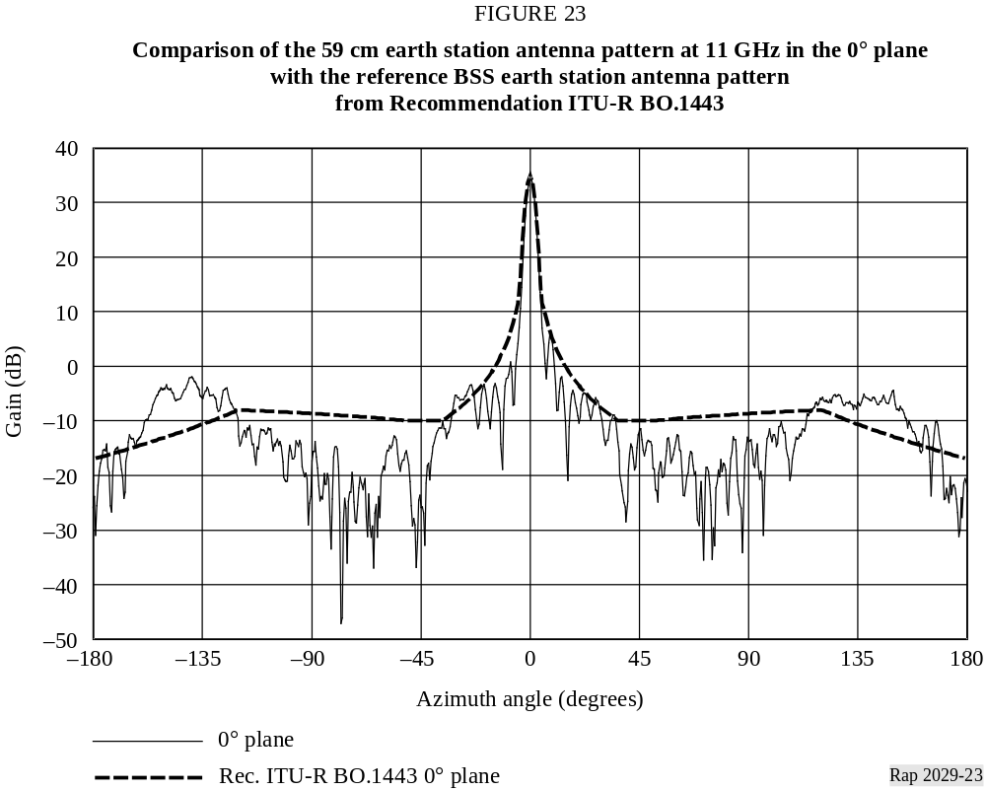

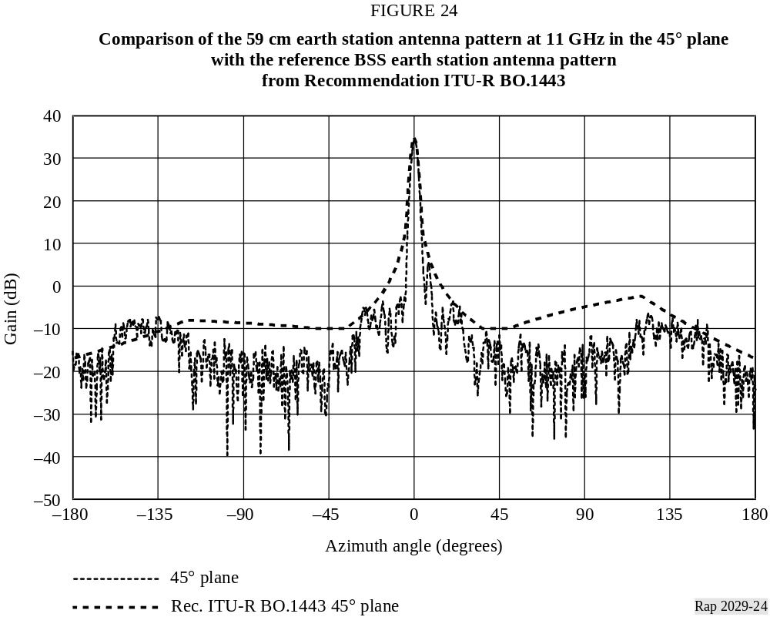
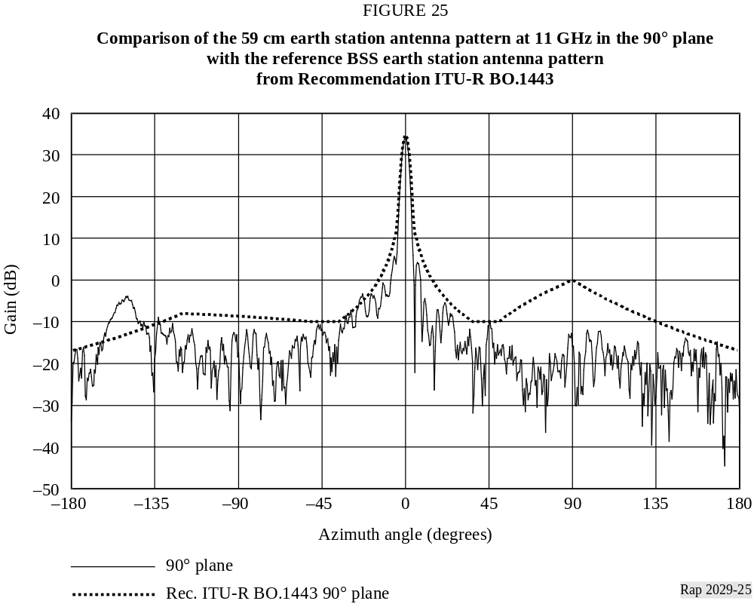

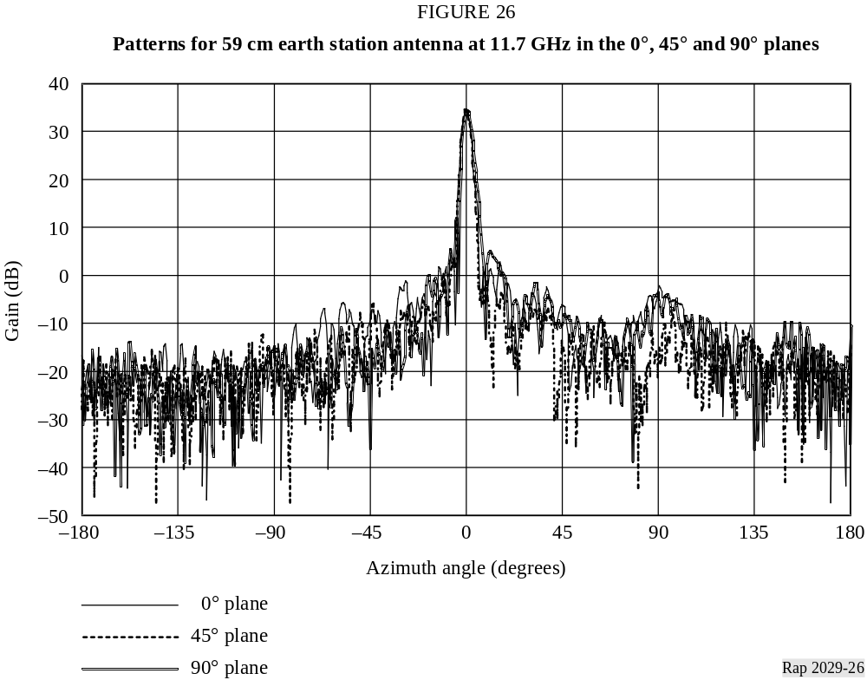
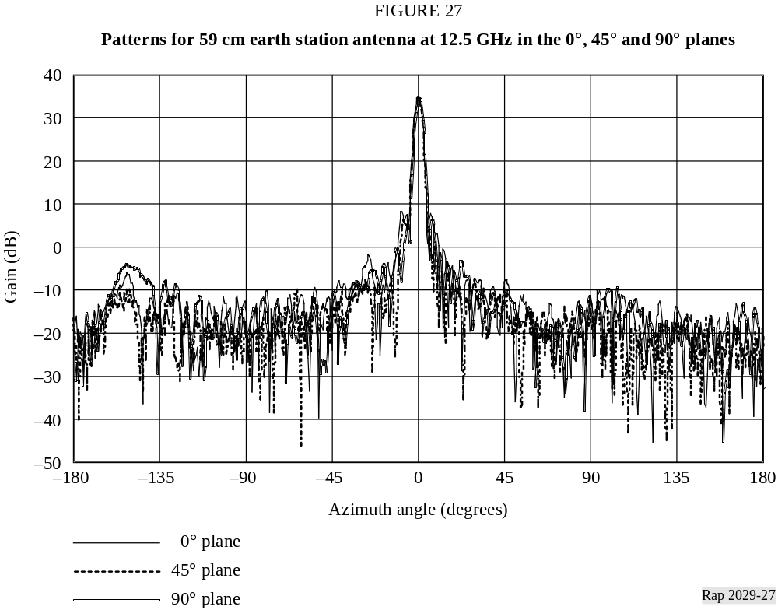

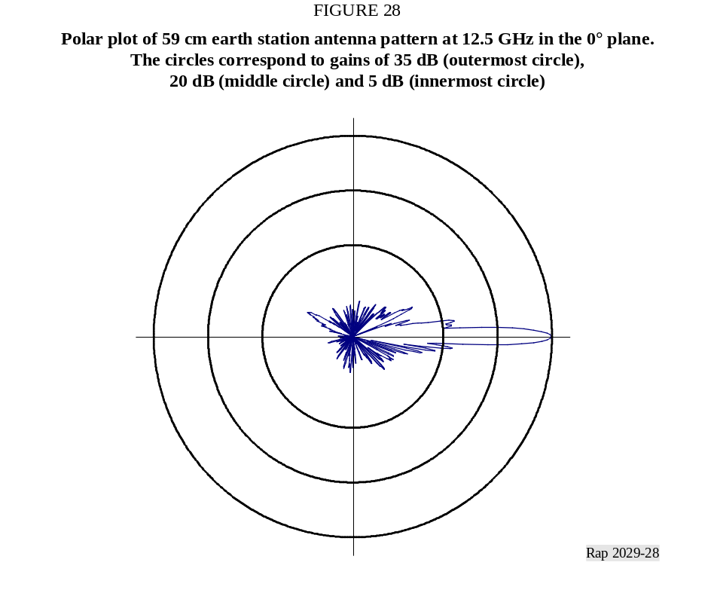
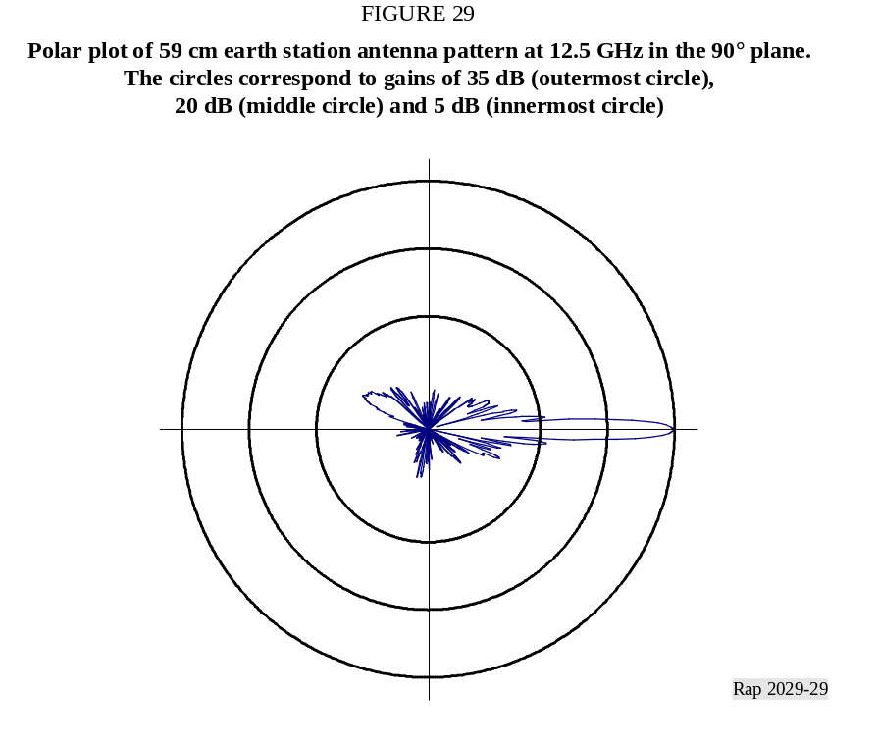

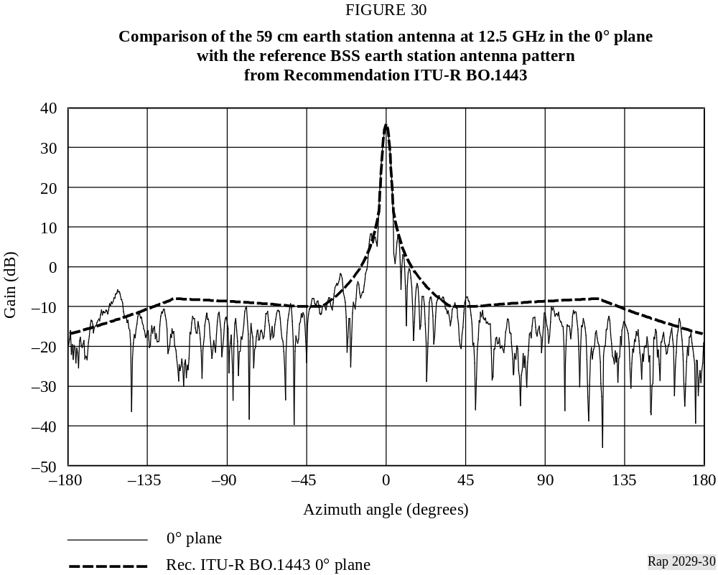
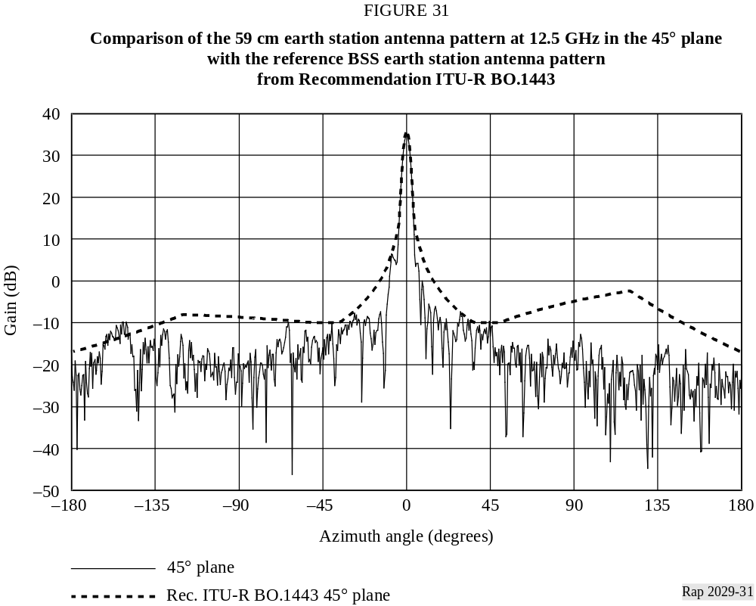
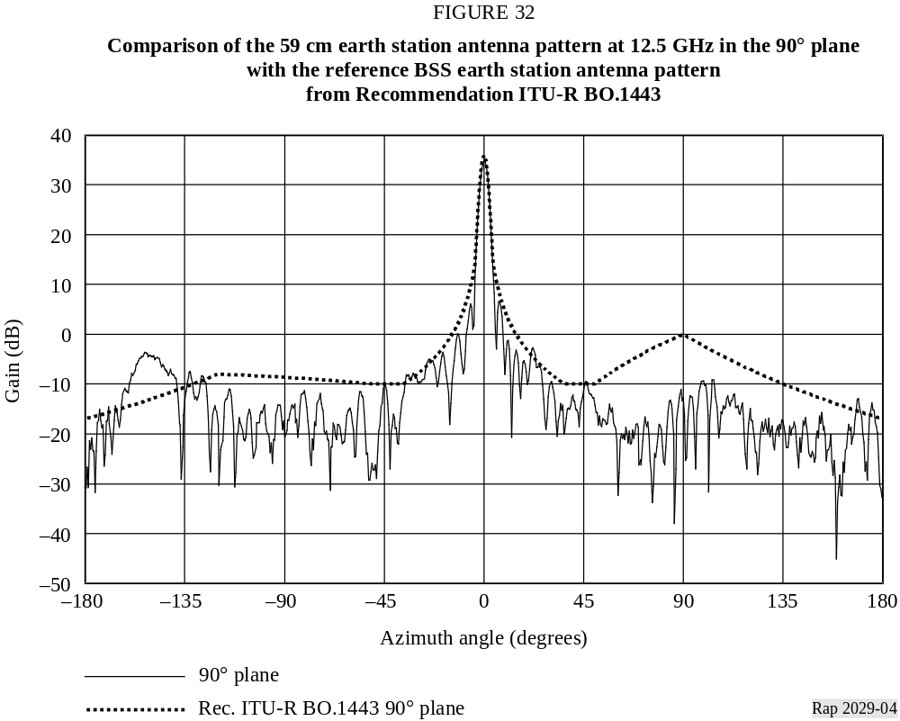

3.3 Antenna pattern analysis
For each antenna, averaging of the radiation pattern sidelobe gain was performed for all eight measured planes and for each measurement frequency. The arithmetic mean is assumed to provide a true representative average sidelobe gain for all sidelobe peaks and troughs falling within a given window. The averaging was performed over a sliding sample window sufficiently small to contain several sidelobe peaks/troughs in order to obtain an overall sidelobe gain representative for all planes, while avoiding distortion of the general behavior of the radiation pattern. This averaging is not shown in the data presented in Section 3.
The following method of averaging was applied to all sidelobes captured within the sample window:
Mean =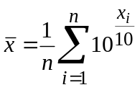 (1)
where:
xi: i-th sidelobe gain sample for a given window
n: total number of samples.
A sample window of 3° was chosen to facilitate calculation of a representative local mean sidelobe gain.

4 Earth station antenna measurements and analyses provided by Telenor

4.1 Antenna measurements summary
Antenna pattern measurements and analyses were performed by Telenor. A total of 21 antennas were measured. One of the antennas, a Norwegian 55 cm high-efficiency dual reflector offset antenna (DTH-14), was used as a reference for the gain measurements. The reason for choosing this antenna as a reference antenna was that it had been very well characterized through previous measurements. Since the 55 cm antenna has a much higher directivity than the standard gain horns normally used for reference purposes, the problem with potential ground reflections was eliminated. This antenna, although in use as a DTH antenna, is no longer commonly marketed in Norway. One antenna, DTH-8, was damaged during transportation, and no valid data was obtained. Since the damage was not discovered until well into the measurement campaign, the numbering was kept unchanged to ensure consistency with earlier acquired data.
Antennas were selected to give a good cross section of the Norwegian and Slovak market. The Norwegian antennas were measured both with a single centre feed and a dual sidemount feed intended to receive signals from the 5° E and 1° W orbital positions simultaneously. Data for both sidemount feeds is presented for some antennas while for others, data for only one feed is provided (since the pattern for the other feed is expected to be similar). One antenna, DTH-6, was equipped with four feeds to simultaneously receive 1° W, 5° E, 13° E and 19.2° E. The Slovak antennas are sold only with a single centre feed. All these antennas are commonly used in their respective markets. The Norwegian antennas are mainly sold with the dual feeds.
Table 1 summarizes the 49 antenna patterns, most with 8 planar cuts.
TABLE 1
Antenna measurement summary
Code | Country/diameter | Type | Feed system | 10.7  GHz | 10.95  GHz | 11.7  GHz | 12.75  GHz
DTH-1 | Norway/70 cm | Single off-set | Centre |  |  |  | 
DTH-1 | Norway/70 cm | Single off-set | Side-feed |  |  |  | 
DTH-2 | Norway/85 cm | Single off-set | Centre |  |  |  | 
DTH-2 | Norway/85 cm | Single off-set | Side-feed |  |  |  | 
DTH-3 | Norway/70 cm | Single off-set | Centre |  |  | 
DTH-3 | Norway/70 cm | Single off-set | Side-feed |  |  | 
DTH-4 | Norway/85 cm | Single off-set | Centre |  |  | 
DTH-4 | Norway/85 cm | Single off-set | Side-feed |  |  | 
DTH-5 | Norway/85 cm | Single off-set | Centre |  | (1), (2)
DTH-5 | Norway/85 cm | Single off-set | Side-feed |  | (1), (2)
DTH-6 | Norway/99 cm | Single off-set | Quattro-feed |  | (1)
DTH-7 | Slovakia/85 cm | Single off-set | Centre |  |  | 
DTH-8 | Antenna damaged during transportation. No valid data obtained
DTH-9 | Slovakia/90 cm | Single off-set | Centre |  |  |  | 
DTH-10 | Slovakia/85 cm | Single off-set | Centre |  | (1), (2)
DTH-11 | Slovakia/96 cm | Single off-set | Centre |  | (1)
DTH-12 | Norway/35 cm | Single off-set | Centre | NA |  |  | 
DTH-13 | Norway/35 cm | Single off-set | Centre | NA |  |  | 
DTH-14 | Norway/55 cm | Dual refl. off-set | Centre |  |  |  | 
DTH-15 | Norway/90 cm | Dual refl. off-set | Centre |  |  | (1), (2)
DTH-16 | Norway/120 cm | Dual off-set | Centre |  |  | (1), (2)
DTH-17 | Norway/150 cm | Symmetrical | Centre |  |  |  | 
DTH-18 | Norway/150 cm | Symmetrical | Centre |  |  |  | 
DTH-19 | Norway/60 cm | Single off-set | Centre |  |  |  | 
DTH-20 | Norway/60 cm | Single off-set | Centre |  |  |  | 
DTH-21 | Norway/50 cm | Single off-set | Centre |  |  |  | 
(1) Azimuth (0°) scan only.
(2) Includes cross polar measurements.
NA: Antenna not capable of operating at this frequency.
“Single off-set” denotes antennas with a single main reflector. “Dual refl. off-set” denotes offset antennas with a main and a sub-reflector. “Symmetrical” denotes a centre-fed antenna.
Sidemount fed antennas have one or more feeds mounted outside the focal point. By appropriately selecting the location of the feeds, one main reflector can be used to simultaneously receive more than one orbital location. The principle is shown in Fig. 33. Since this antenna design deliberately defocuses the antenna, the efficiency of the antenna is reduced. To compensate for this, the antenna diameter is increased somewhat.

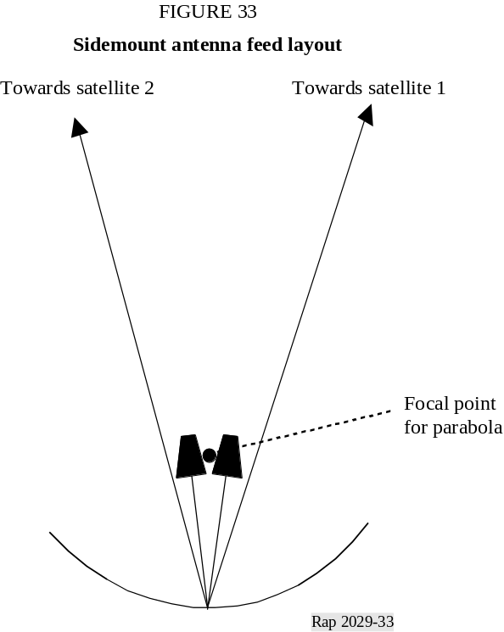
The measured antennas with sidemount feeds were designed to symmetrically receive two satellites with 6° orbital separation, one satellite 3° to each side of the pointing of the reflector itself. For this moderate defocused design, the antennas still showed a behaviour comparable to that of the same antenna with a single centre feed although somewhat distorted. However, it has been observed in other measurements of sidemount fed antennas that both the main lobe and the sidelobe performances are sometimes significantly degraded.
The one antenna with four feeds to simultaneously receive 1° W, 5° E, 13° E and 19.2° E, DTH-6, can be seen to have seriously degraded performance for some of the feeds. Still the antenna can successfully receive TV signals from these four satellite locations.

4.2 Antenna measurement data
The measurements were performed on an outdoor far-field antenna range. The distance between the transmitting antenna and the (receiving) antenna under test was approximately 950 m. The frequency used during the measurements was between 10.7 and 12.75 GHz. All antennas were
measured with the receiver phase locked to the transmitting signal through a reference receiving antenna and with an external harmonic mixer, instead of a regular LNB, to achieve the desired accuracy and dynamic range.
Most measurements were done in eight cuts from –67.5° to 90° at intervals of 22.5°. All measurements were done using azimuth rotation, with the antenna rotated on the mount for the various cuts. Positive rotation angles denote the antenna being rotated on its mount counter clockwise from its nominal position as seen from the antenna towards the transmitter. All measurements were done as cuts through the antenna boresight with an angular resolution of 0.2°. A complete data set describing one antenna at one frequency therefore typically contains a total of eight sets of data measured over about ±100° from antenna boresight for every 0.2°. Measurements pointing the antenna beyond this range were not conducted because the main lobe would have pointed toward buildings located behind the turntable; reflected signals from the buildings could have affected the measured data.
Figure 34 shows the convention used in labelling angles and data sets. In this Figure the eight cuts are illustrated with reference to the antenna aperture orientation. The “Neg.” tag denotes the starting point for each cut, which corresponds to negative angles, or the antenna being pointed to the left of the transmitter when seen from behind the antenna under test. The “Pos.” tag denotes the ending point for each cut, which corresponds to positive angles, corresponding to the antenna being pointed to the right of the transmitter.
This is not the same approach shown in Section 2 of this Report. For example, using the convention is Section 2, θ = 45° corresponds to the –45° plane shown in Fig. 34. Another difference regards the “Pos.” and “Neg.” angles noted in Fig. 34. The convention is again different from Section 2, and there is a flip in sign of the angle (for example, when proceeding from the 67.5° cut to the 90° cut).
From an interference point of view, the most relevant section of the antenna diagram is the part that points over the horizon. This corresponds to the “Pos.” side of cut 0° to 90° and to the “Neg.” side of cut –22.5° to –67.5°. In the presentation of the measured data the upper part of the antenna diagrams is found to the right on cut 0° to 90° and to the left on cut –22.5° to –67.5°.

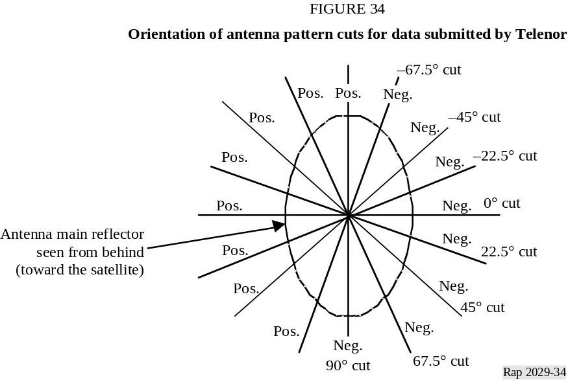
The measured data are provided in Excel workbooks. Each workbook contains the patterns for one feed of one antenna at a specified frequency. Each cut is presented in a separate spreadsheet in the workbook. For example, Sheet 5 corresponds to the elevation cut in each case. Sheet 9 contains the pattern calculated using Recommendation ITU-R BO.1213 and this pattern is plotted together with the measured data. A typical cut is shown in Fig. 35. The relevant information is given in the title of each plot. For most antennas, the initial representation is given for ±100° off-axis with a 10-dB/div. scale.

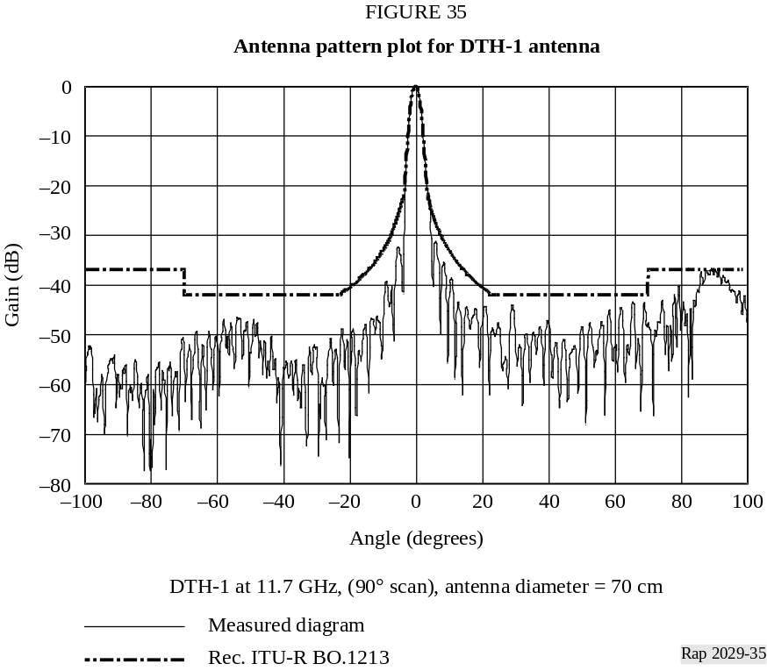
In the elevation-plane cuts, or cuts close to that plane, a distinct lobe was observed at 80°-100° off-boresight. This was recognized as the lobe resulting from the feedhorn looking over the top of the reflector. The sidelobes between this lobe and the main beam appear to be higher than those on the other side of the main lobe, probably because of the higher edge illumination. For cuts further away from the elevation plane, the spillover lobe became lower and moved further out from the main lobe, in most cases outside the measured range. Similar behaviour was seen for practically all antennas. In Fig. 35 the spillover lobe can be seen between 80° and 100°.
In analysing the results, a small but systematic lobe was observed in the 75°-90° off-axis area, especially for the –67.5° and –45° cuts. Investigations showed this corresponded to the spillover lobe at the top of the reflector being pointed toward a nearby steel radio-relay tower. Similar behaviour should be expected when the spillover lobe from the bottom of the reflector is pointed towards the tower, but since this, as is also the case with the main lobe pointing towards the tower, is outside the measured range, it is not observed in the data. This artifact of the antenna range should be disregarded in analysing the measured antenna diagrams. This behaviour is shown for antenna DTH-3 in Fig. 36.
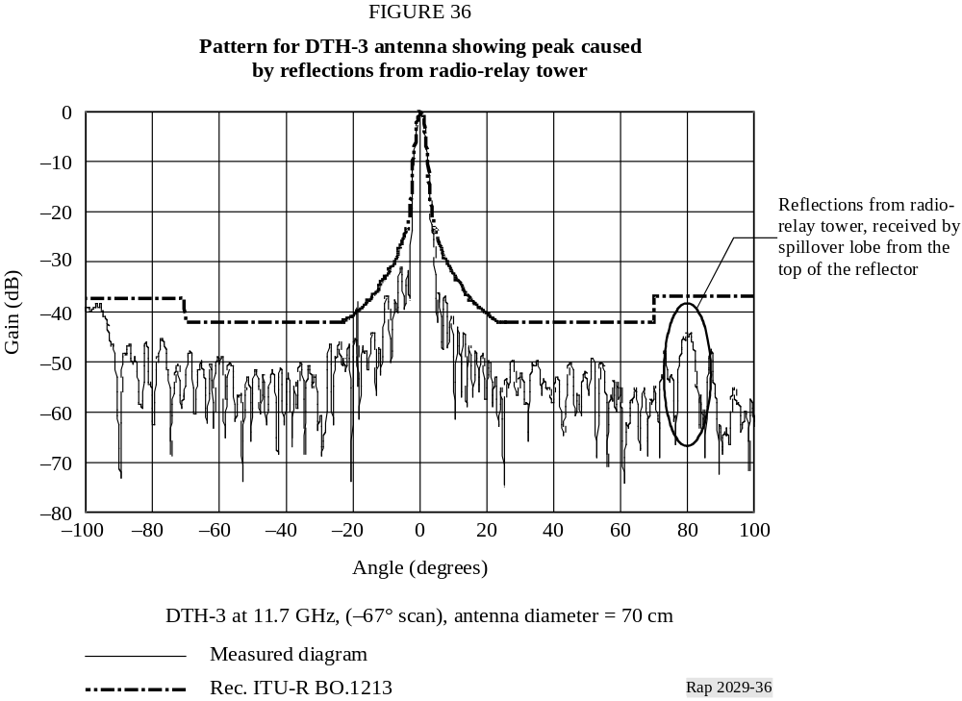

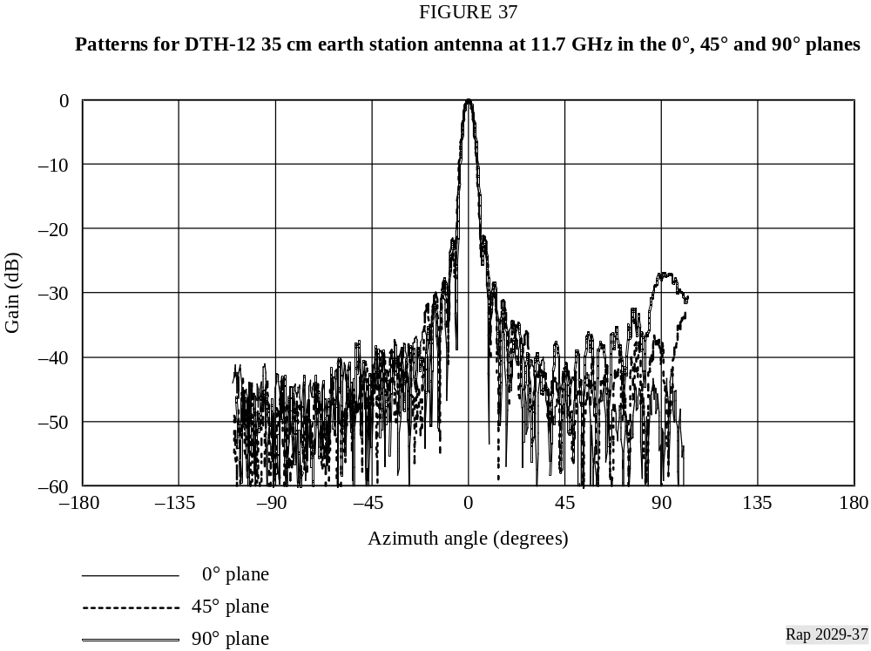
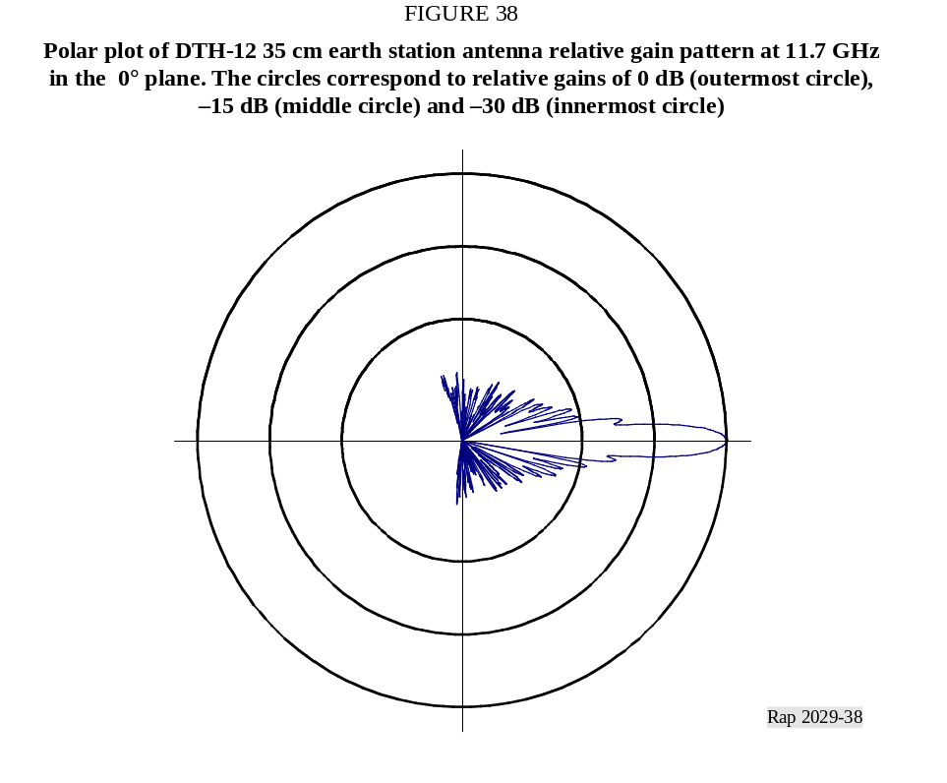

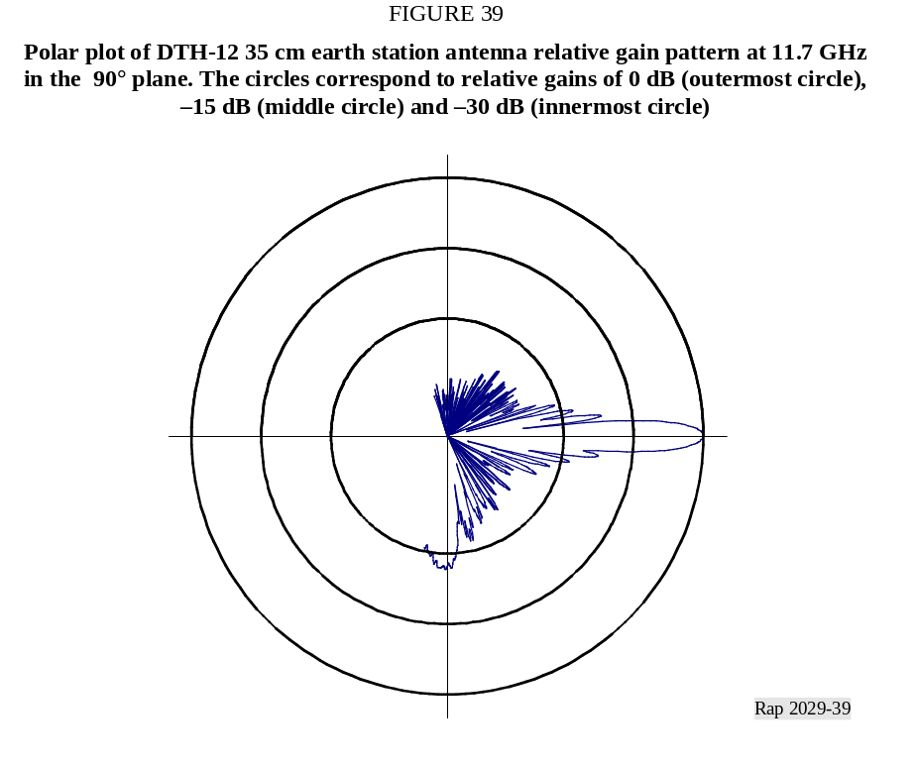
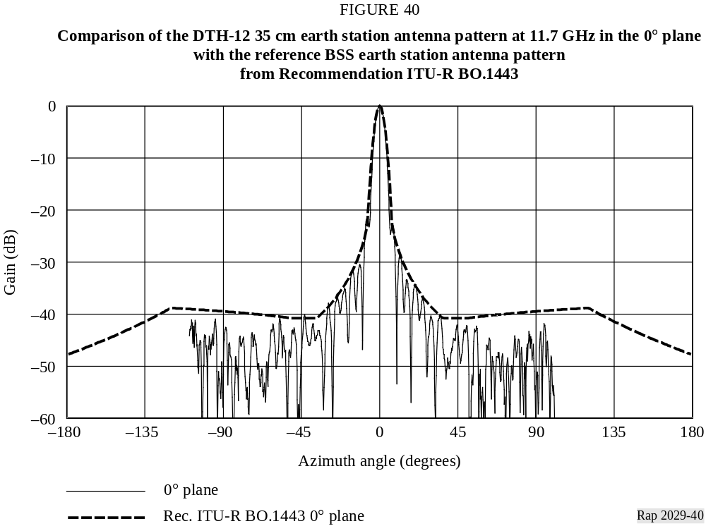

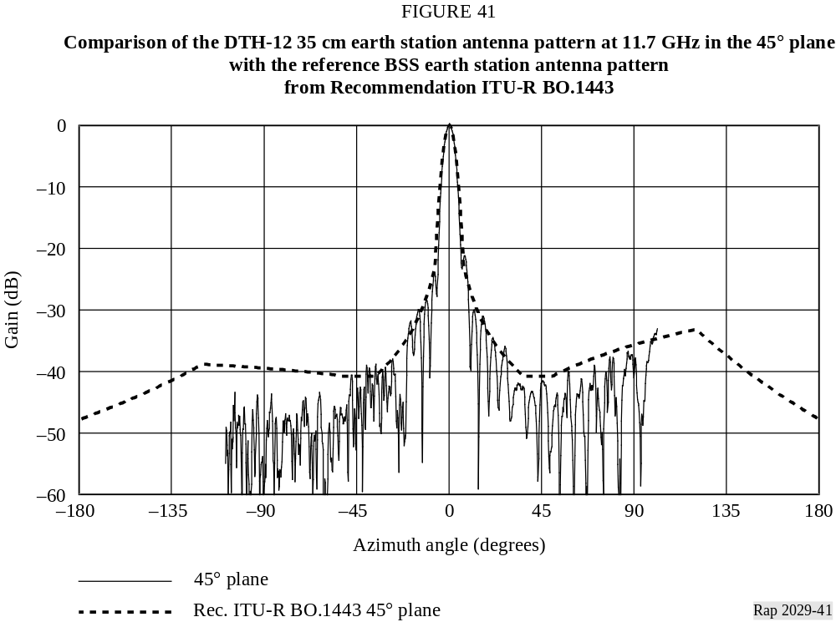
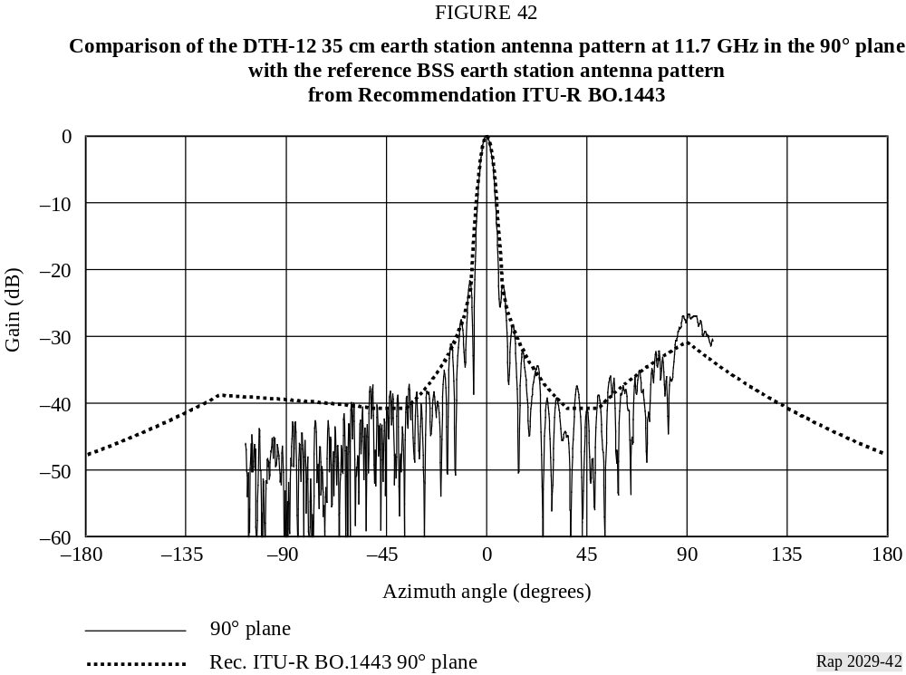

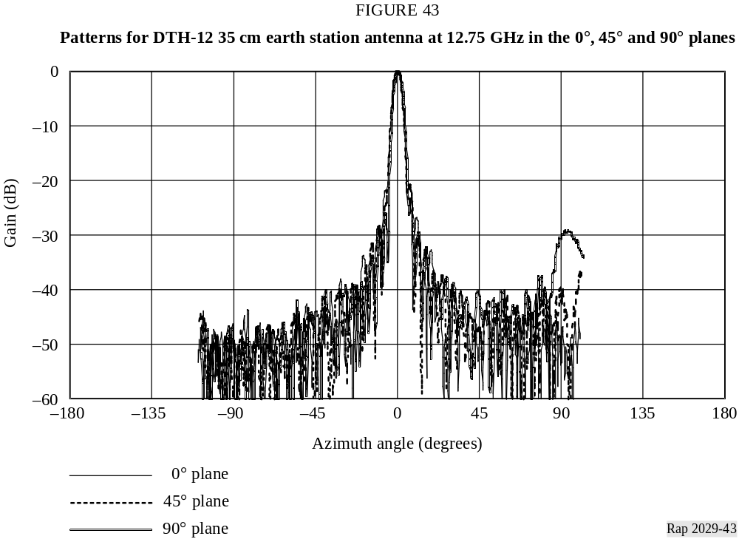
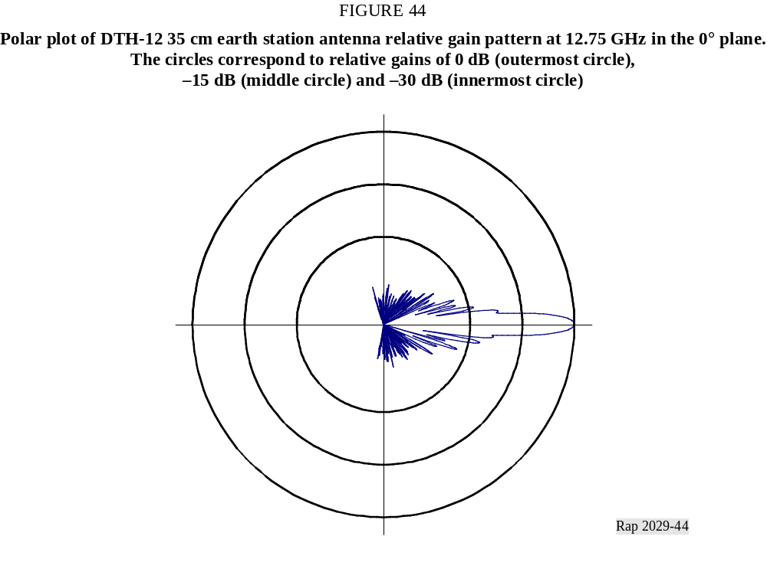

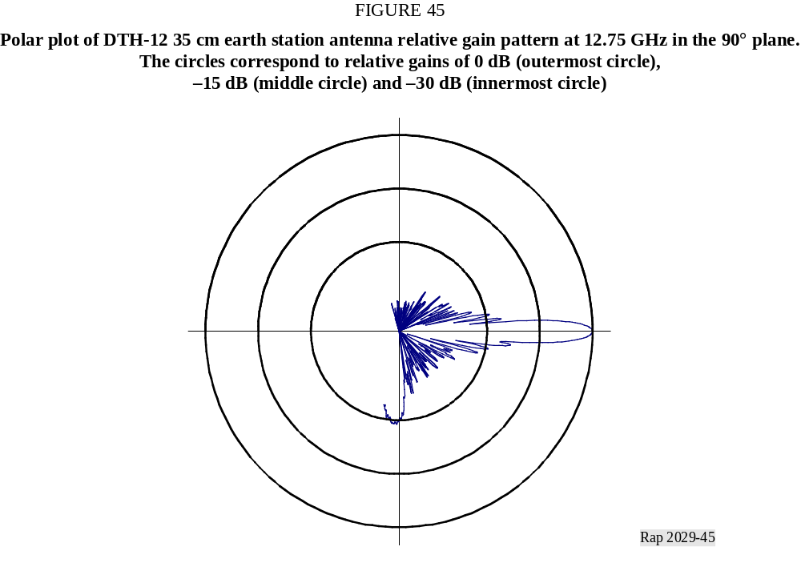
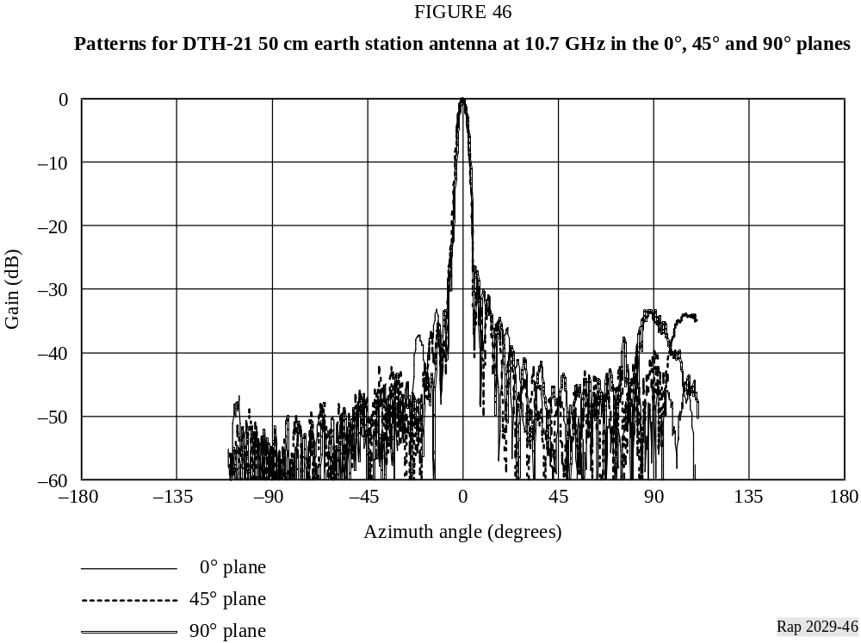

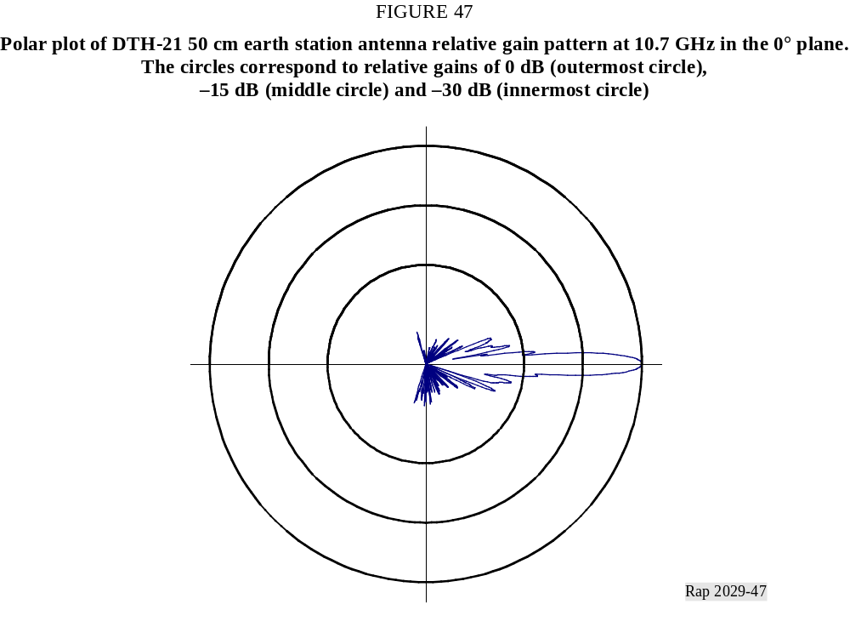
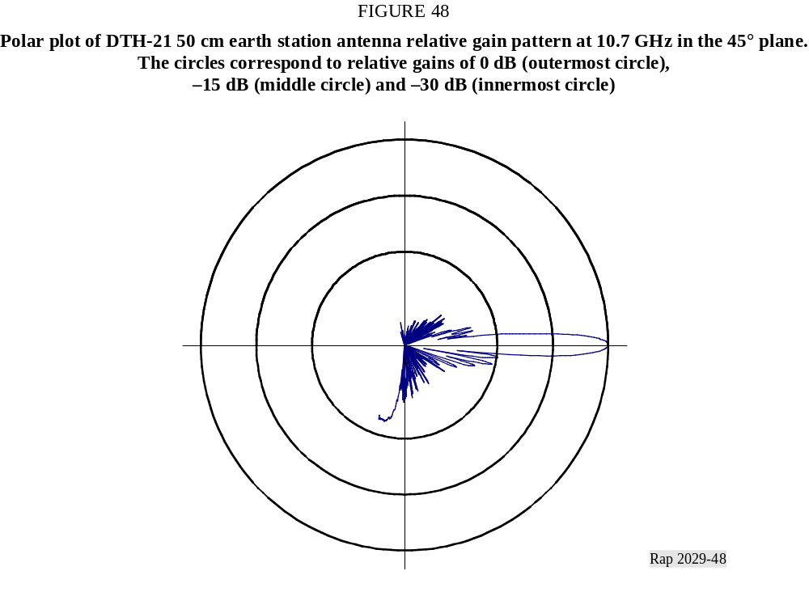

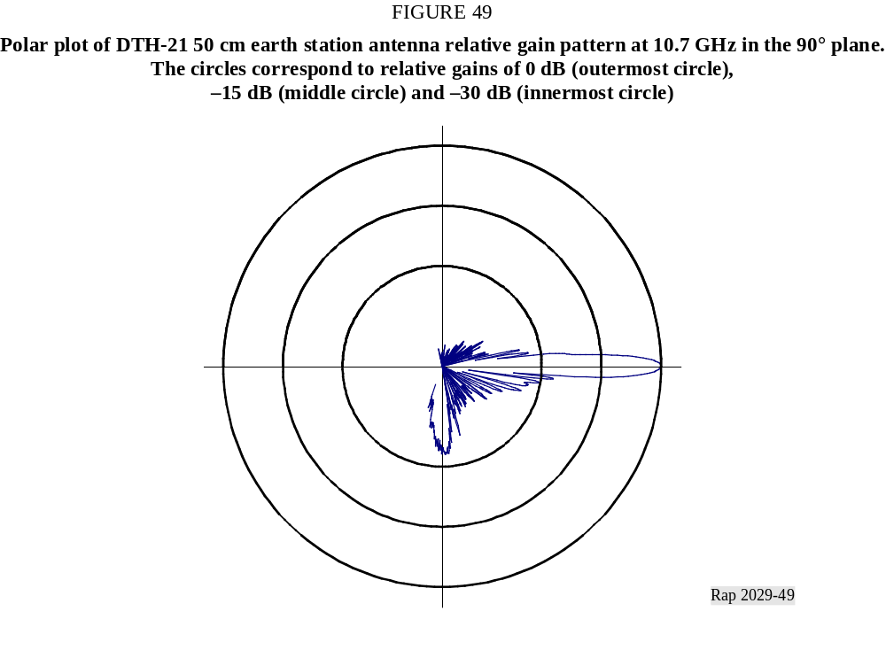
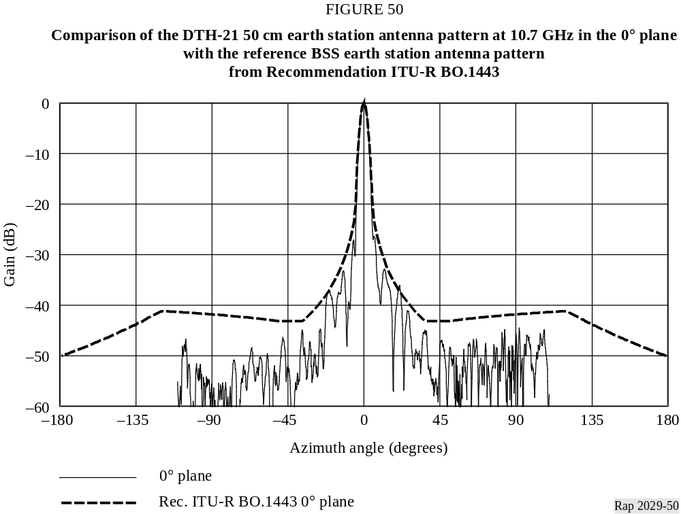

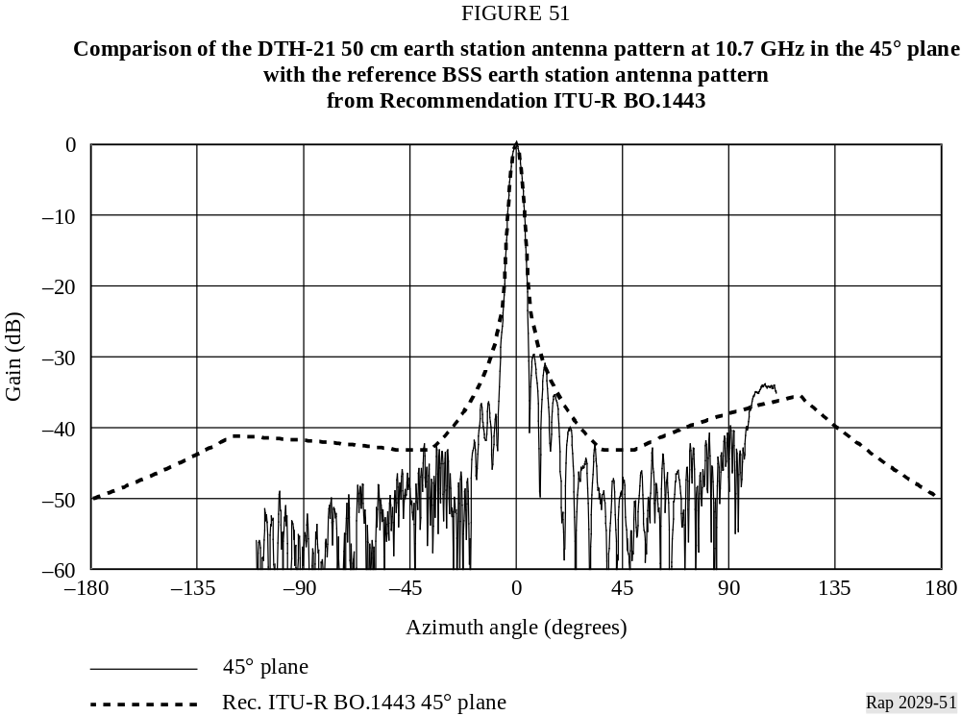
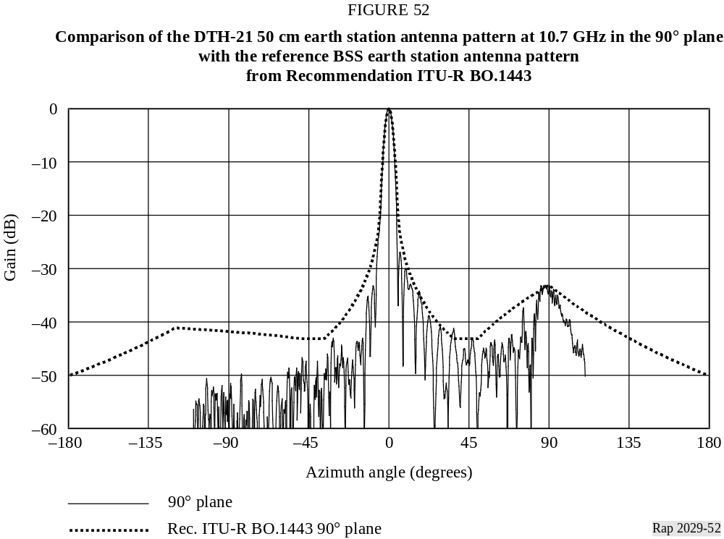

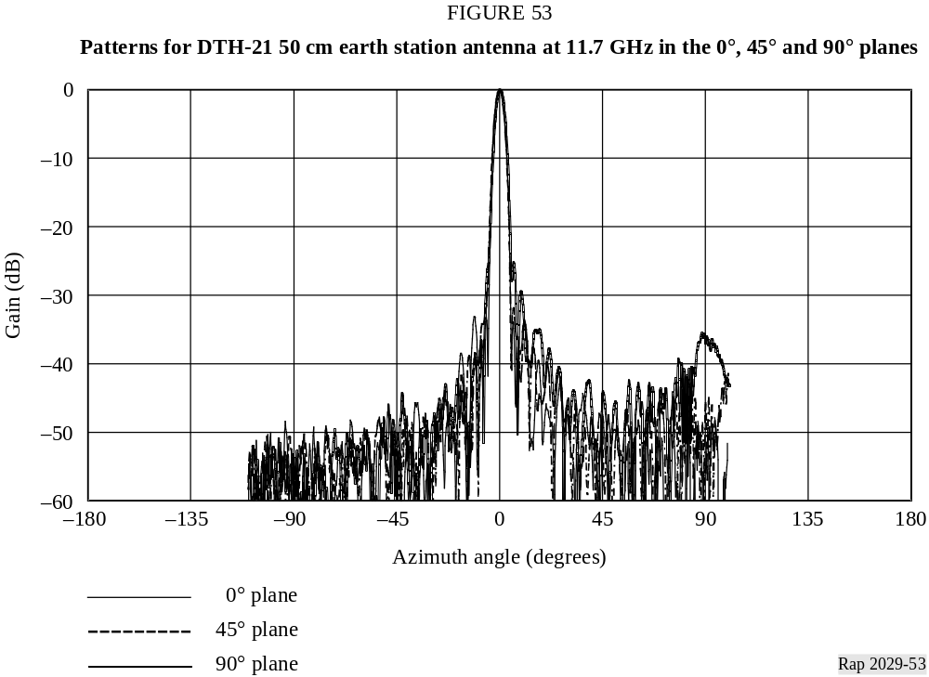
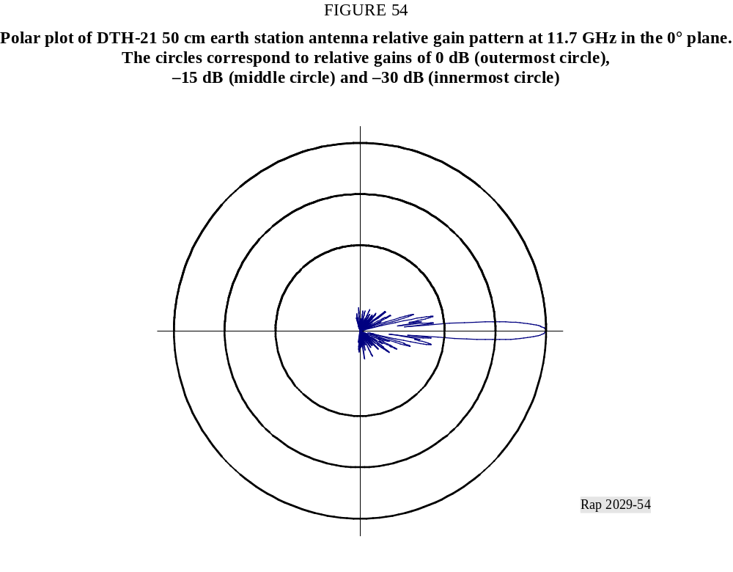

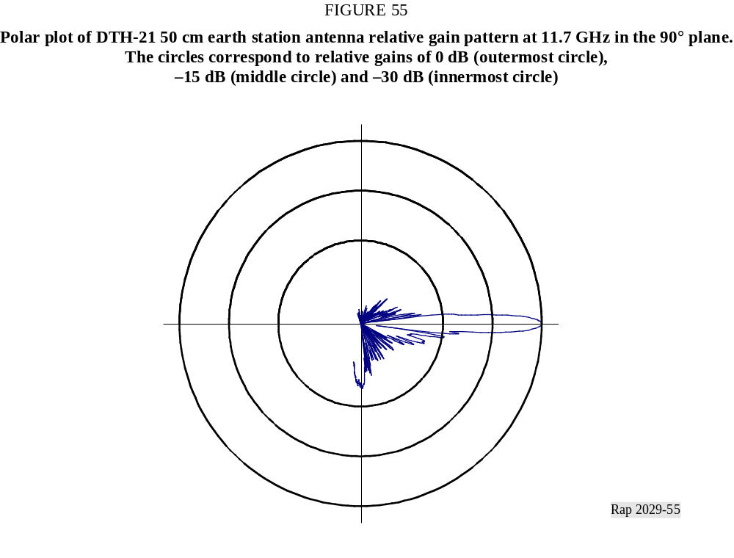
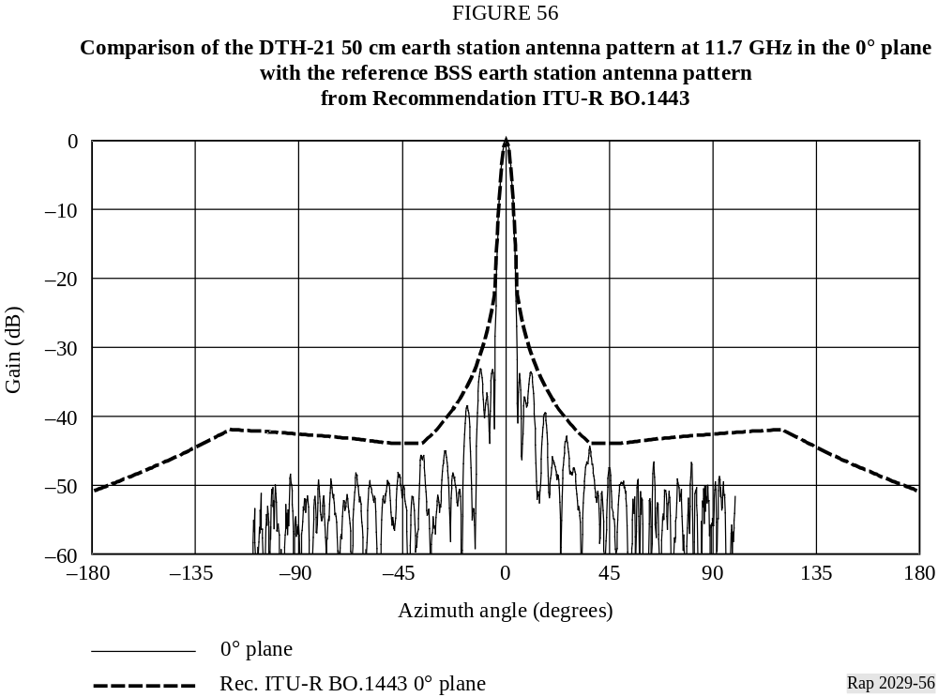

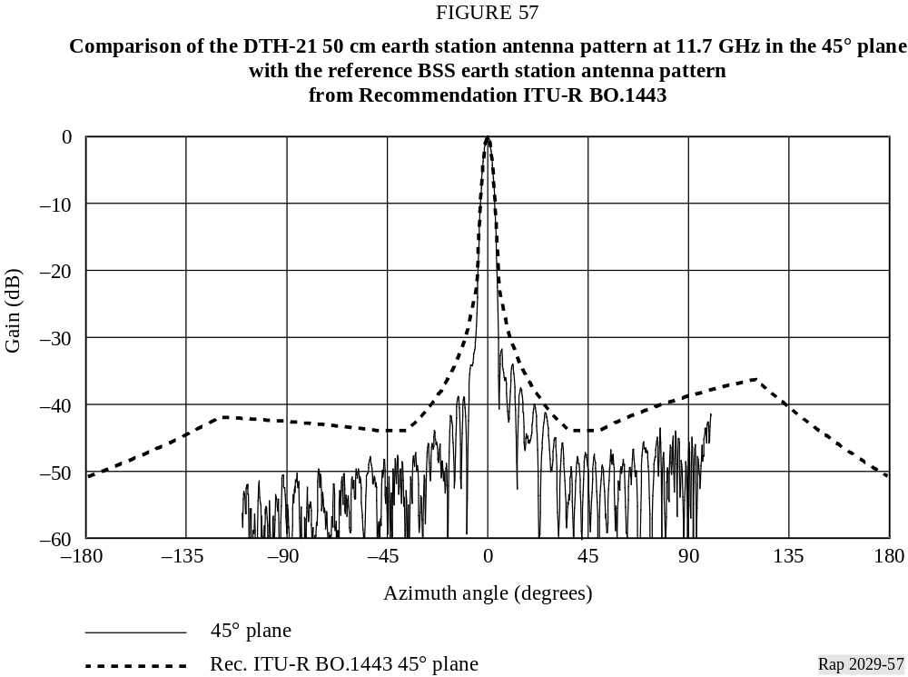
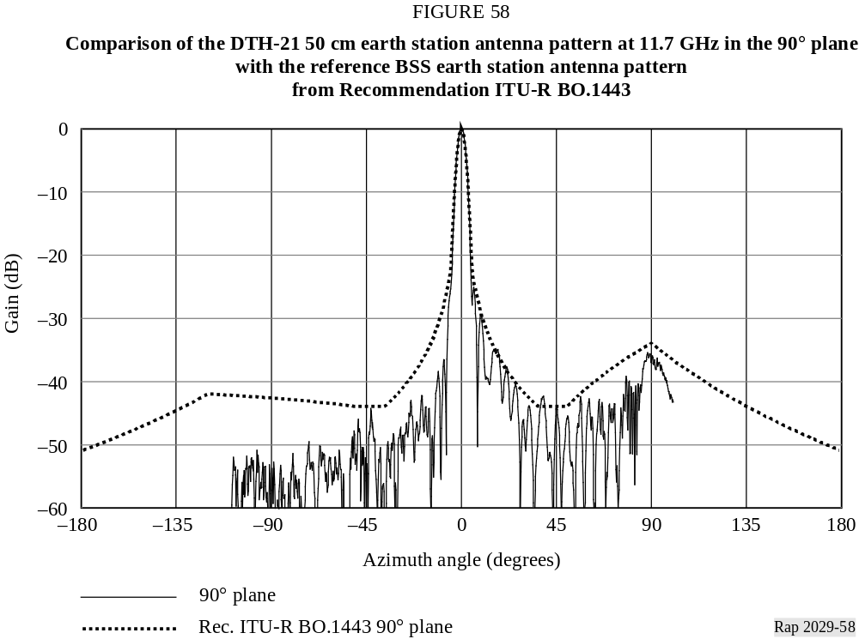

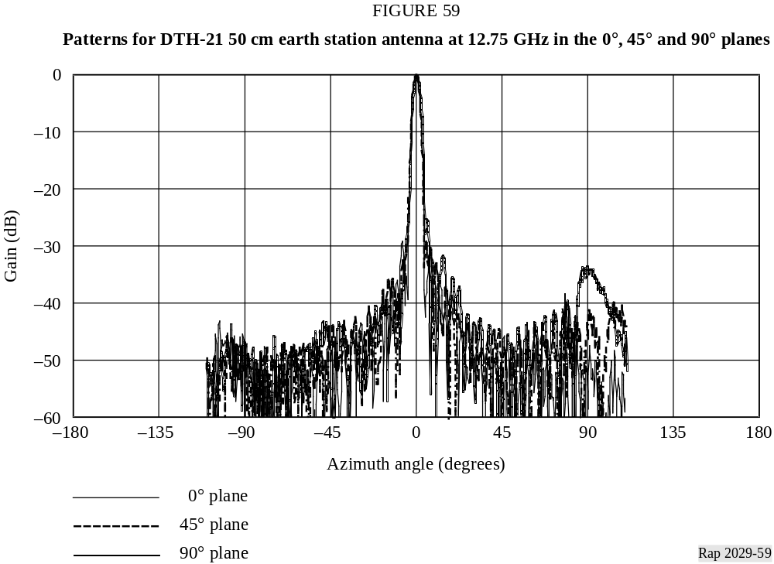
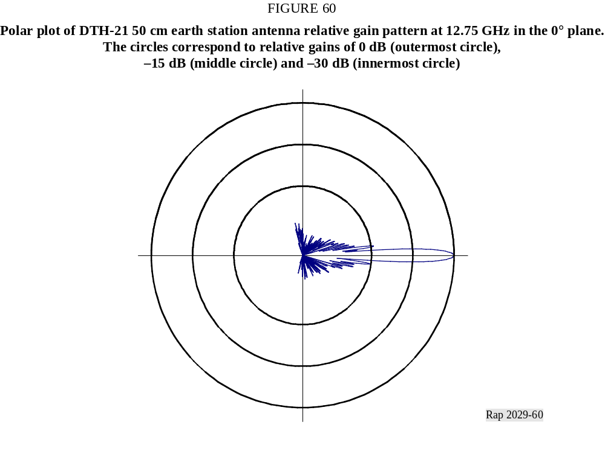

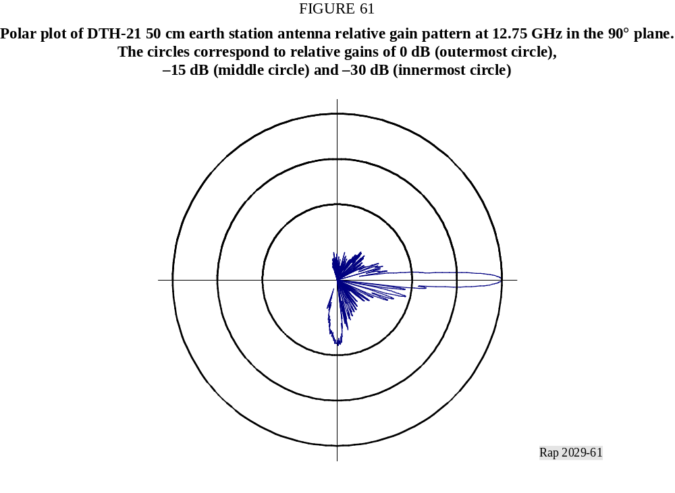
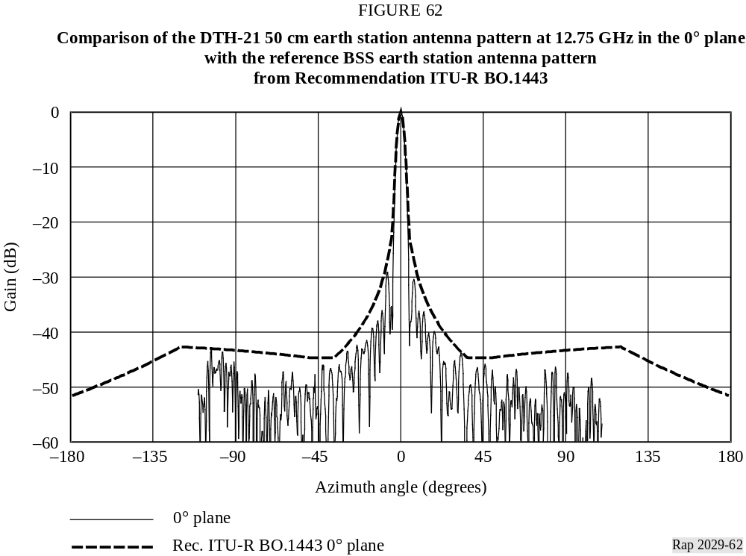

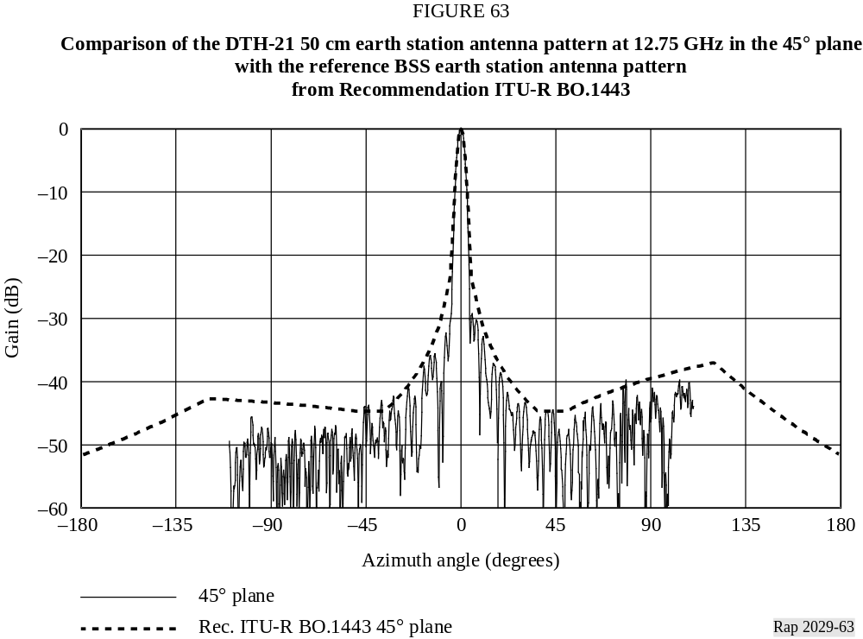
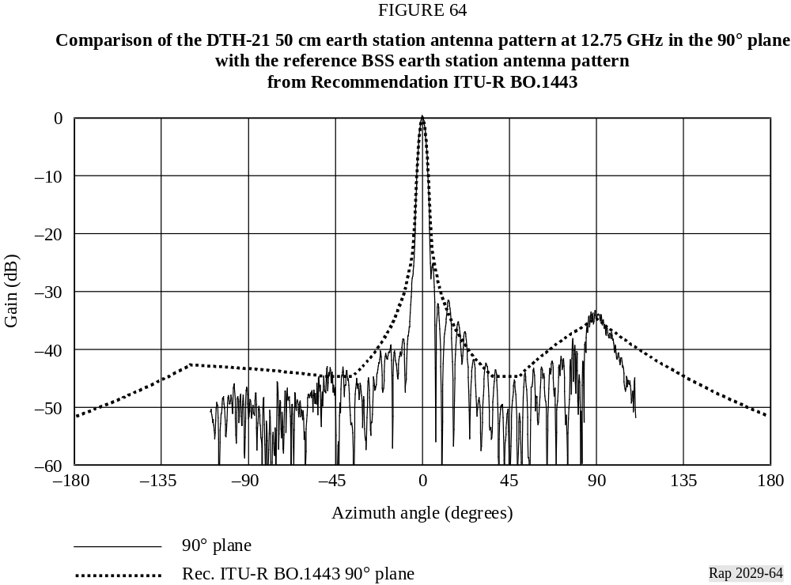

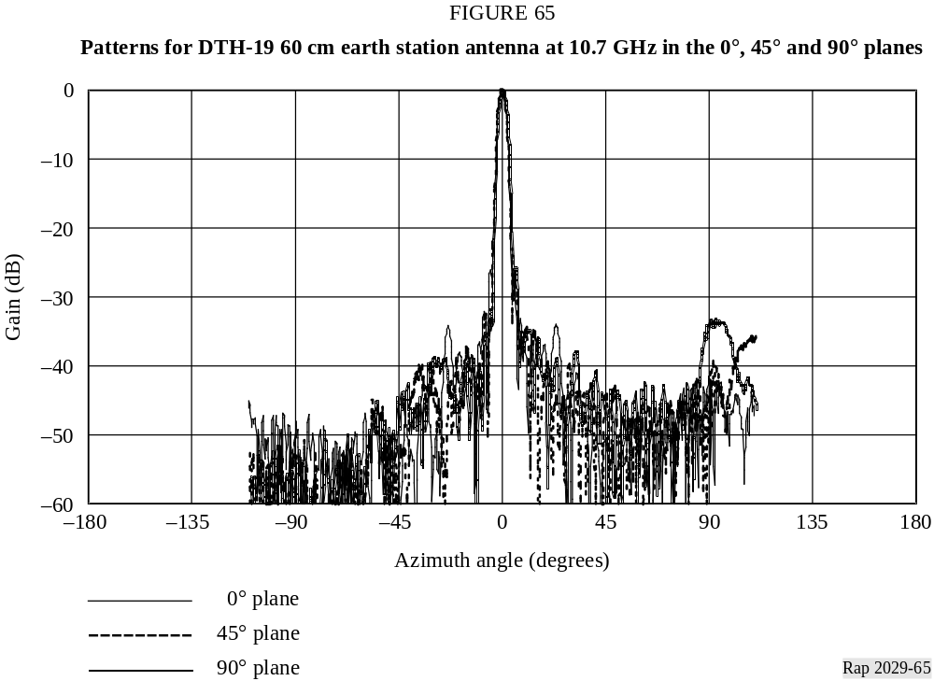
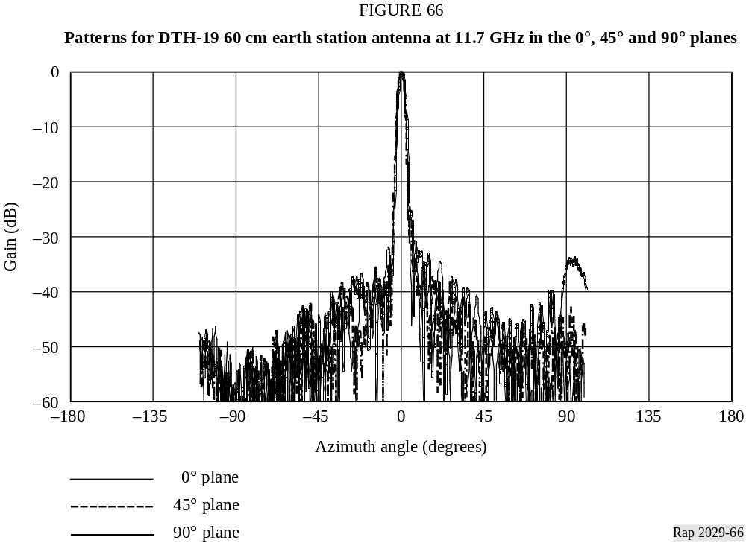

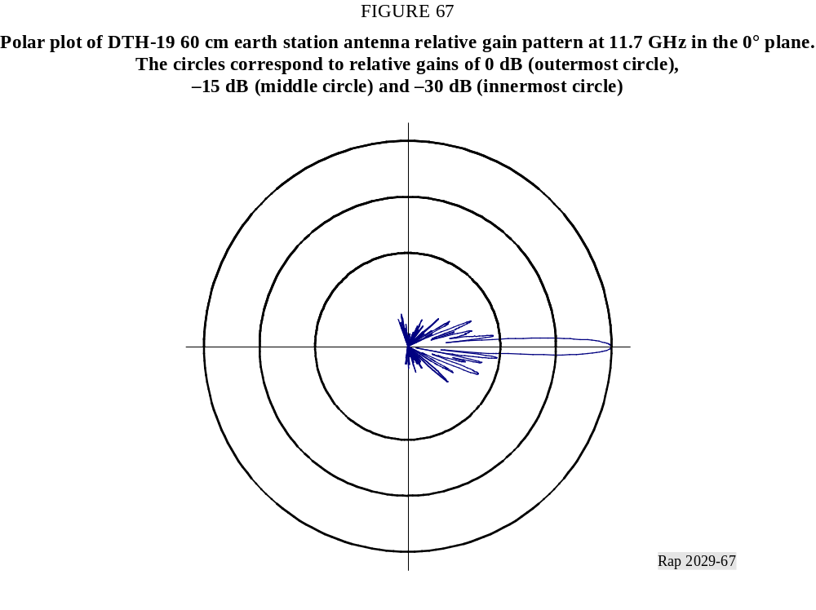
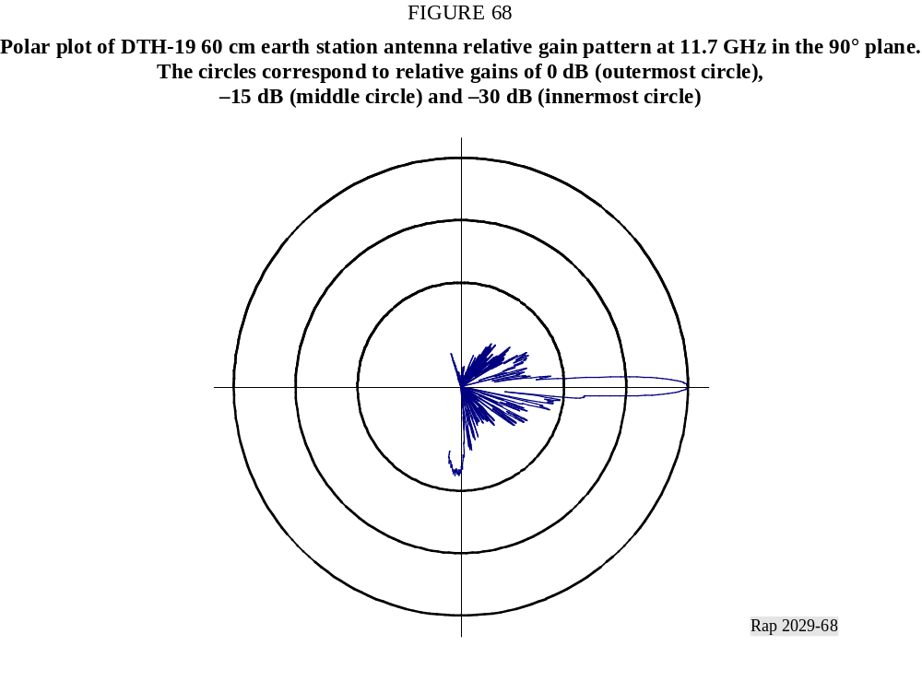

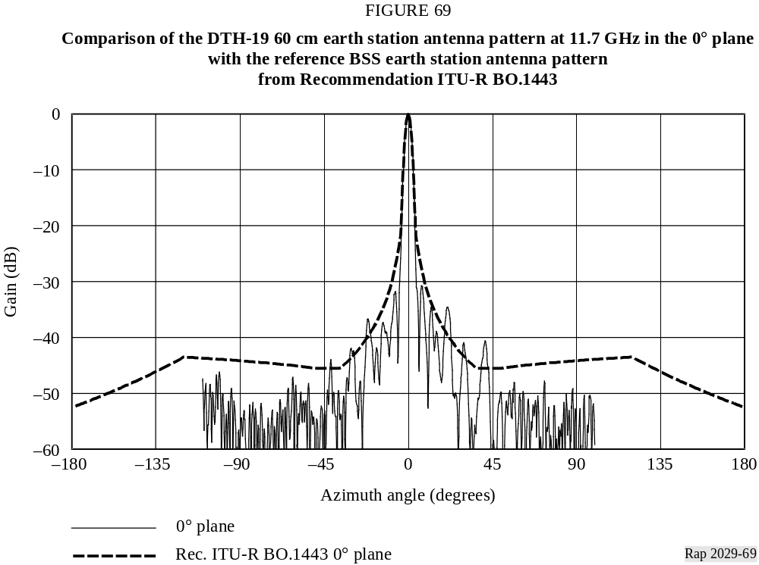
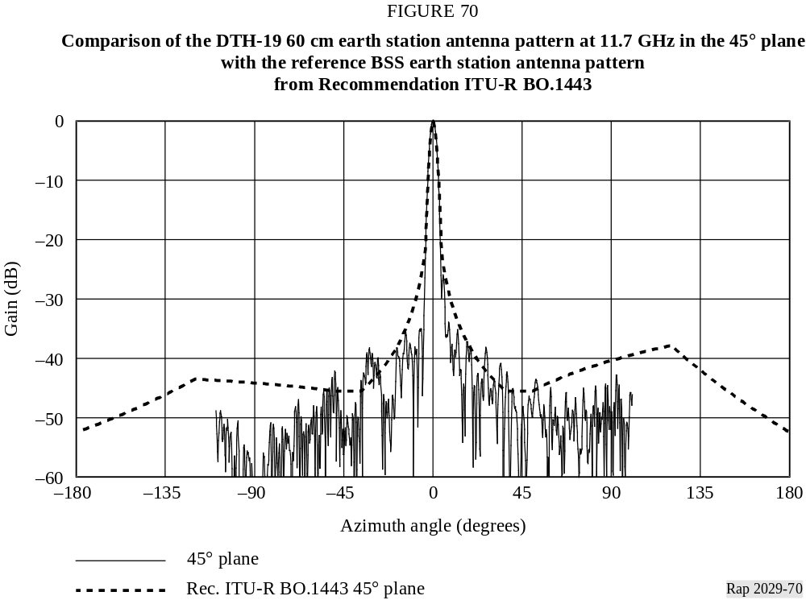

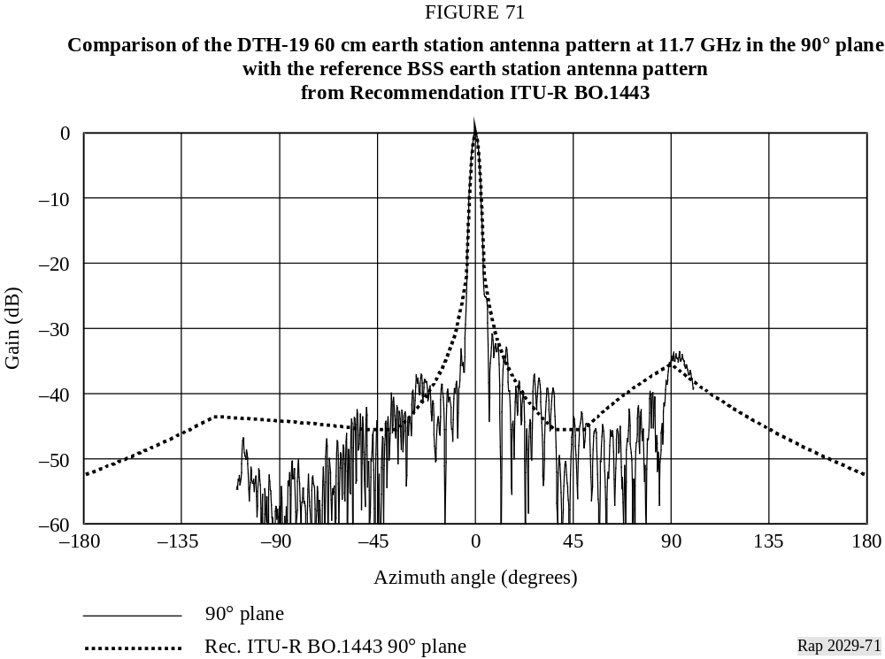
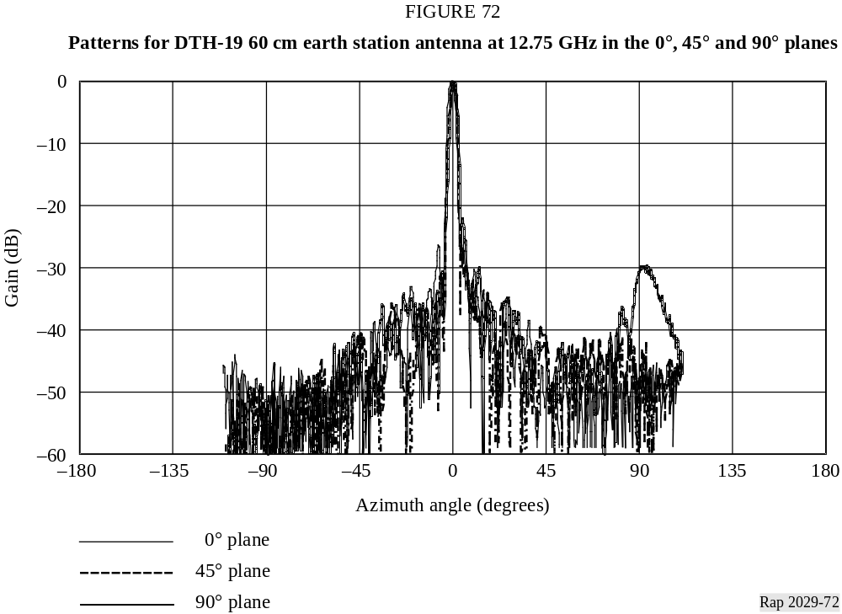

4.3 Antenna pattern analysis
The spillover sidelobe for the small earth station antennas is readily apparent in the x-y graphs and the polar plots. For example, the 0°, 45°, and 90° cuts at 10.7 GHz for the 50 cm antenna in Figs. 46 to 49 clearly show the evolution of the spillover sidelobe as θ varies.
Telenor reported that no significant frequency dependence was observed at the different measured frequencies. It is believed that regular scaling for D/λ between the measured frequencies in the 10.7-12.75 GHz range will give a good estimate of the antenna pattern at various frequencies.

5 Earth station antenna measurements and analyses provided by Canada

5.1 Antenna measurements summary
Measurements of antenna radiation patterns for typical receiving earth station antennas used in Region 2 BSS systems were performed by Canada. Several types of receiving antennas were tested over the 12.2-12.7 GHz Region 2 BSS frequency band. These antennas represent low-cost, consumer-grade receiving antennas which have been or will be deployed in large volume for existing and planned BSS systems in Region 2. The antenna reflectors were made of plastic or metal.
Eight test planes were used to estimate the three-dimensional antenna pattern. All eight planes cut through the antenna boresight axis and were of equal angular spacing of 22.5° between adjacent planes. For each test plane, the antenna pattern was measured over ±180° range in a 0.2° step size,
and repeated over three frequencies, i.e., 12.2, 12.45 and 12.7 GHz. The 0° plane is the horizontal plane and the 90° plane is the vertical plane (and includes the antenna feed arm). This is consistent with the coordinates shown in Section 2.

5.2 Antenna measurement data
The measurements for 10 antennas reported by Canada are summarized in Table 2. Folders and files labelled in this fashion can be found on the CD-ROM.
TABLE 2
Antenna measurement summary
Folder/code | Antenna polarization | Type | 12.2 GHz | 12.45 GHz | 12.7 GHz
1/DS2 | Circular | 45 cm plastic | x | x | x
1/DSS | Circular | 45 cm metal | x | x | x
1/SC | Linear | 60 cm metal | x | x | x
2/DN1 | Circular | 45 cm metal | x | x | x
2/DN2 | Circular | 45 cm metal | x | x | x
2/DN3 | Circular | 45 cm metal | x | x | x
2/HN1 | Circular | 45 cm metal | x | x | x
3/EX1 | Linear | 60 cm metal | 11.7 GHz | 11.95 GHz | 12.2 GHz
3/RC1 | Linear | 60 cm metal | 11.7 GHz | 11.95 GHz | 12.2 GHz
4/46 | Circular | 45 cm metal |  | x
All antennas were offset-fed, single-feed antennas. The measurements were performed using linear polarization, except for 4/46 which used circular polarization.

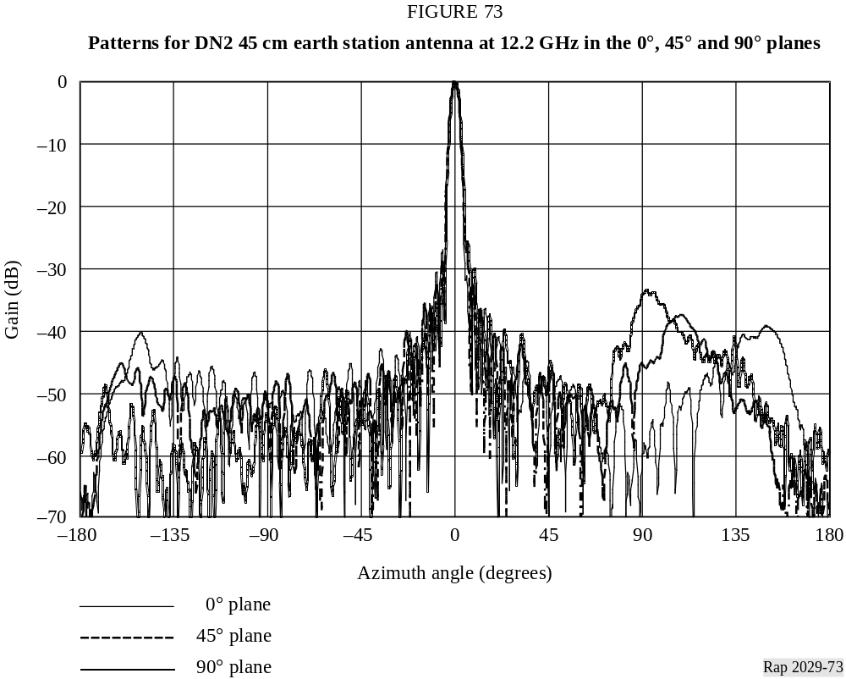

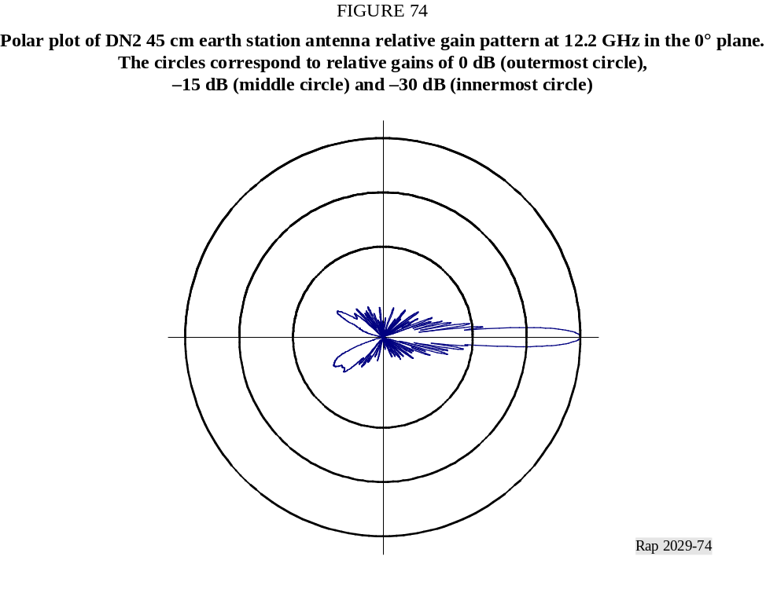
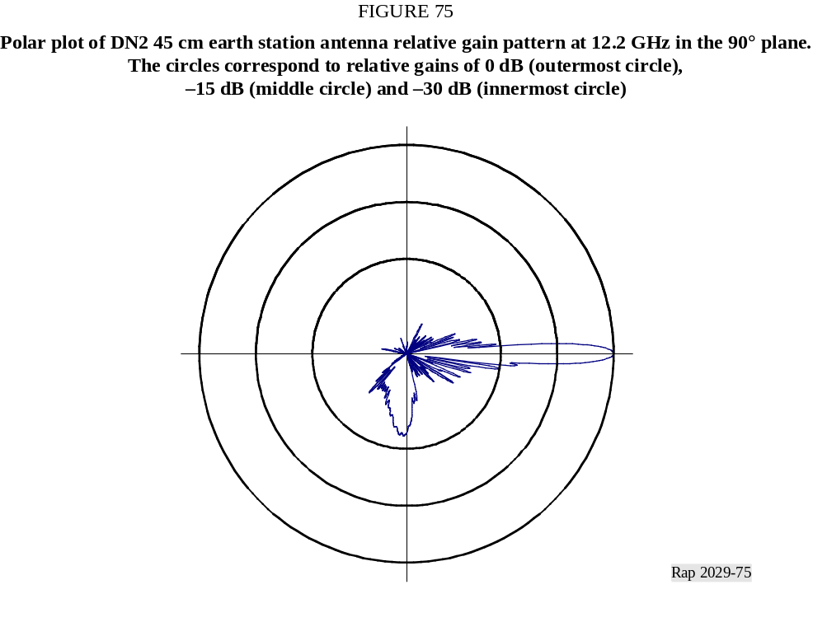

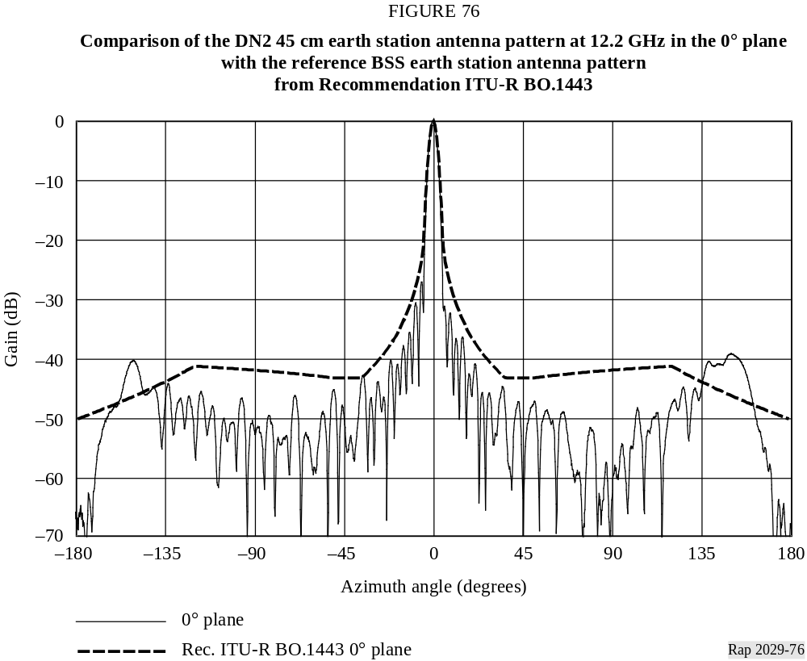
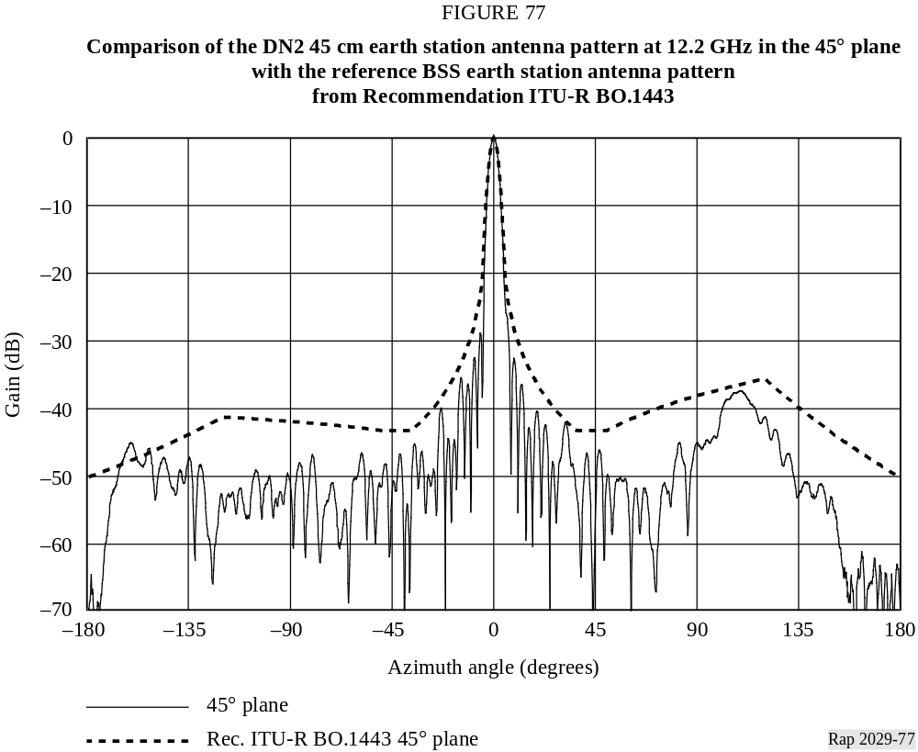
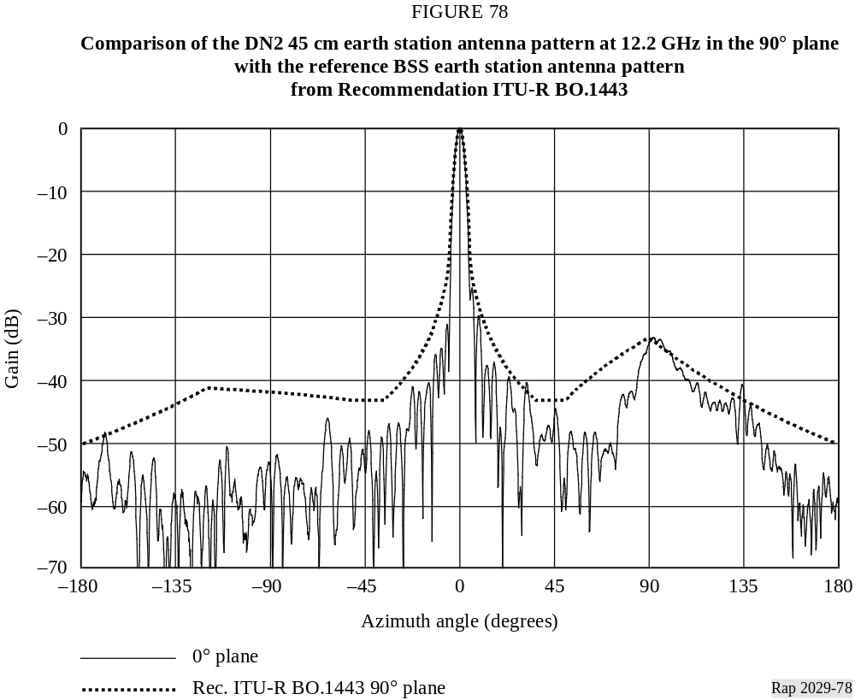
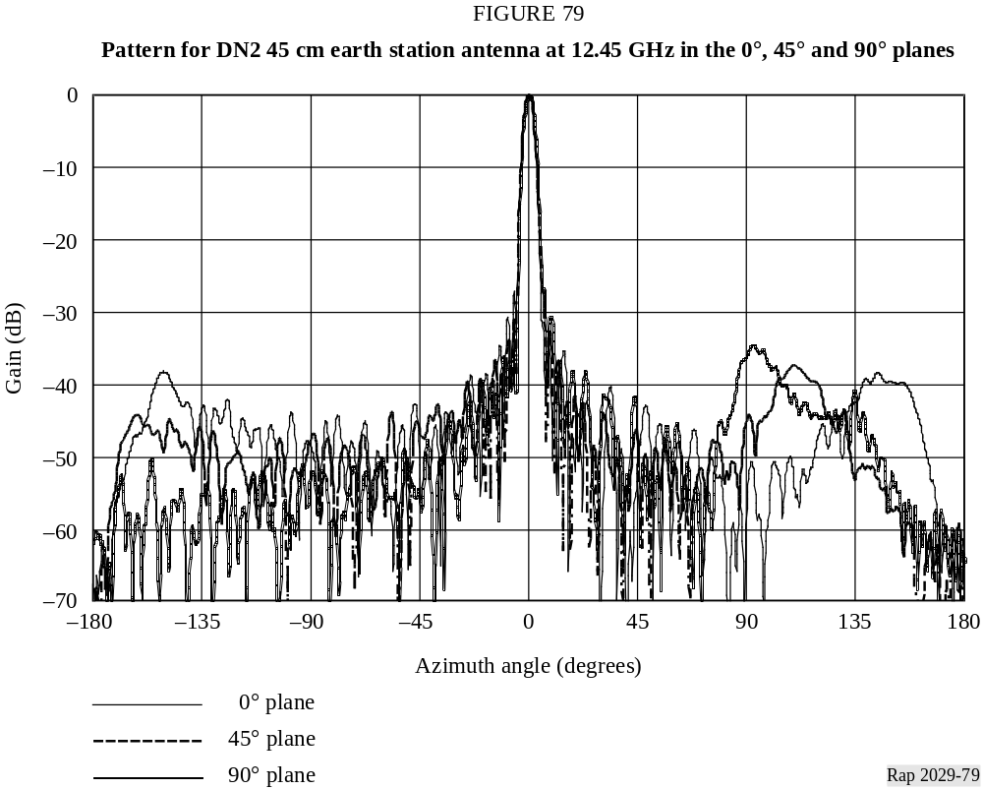
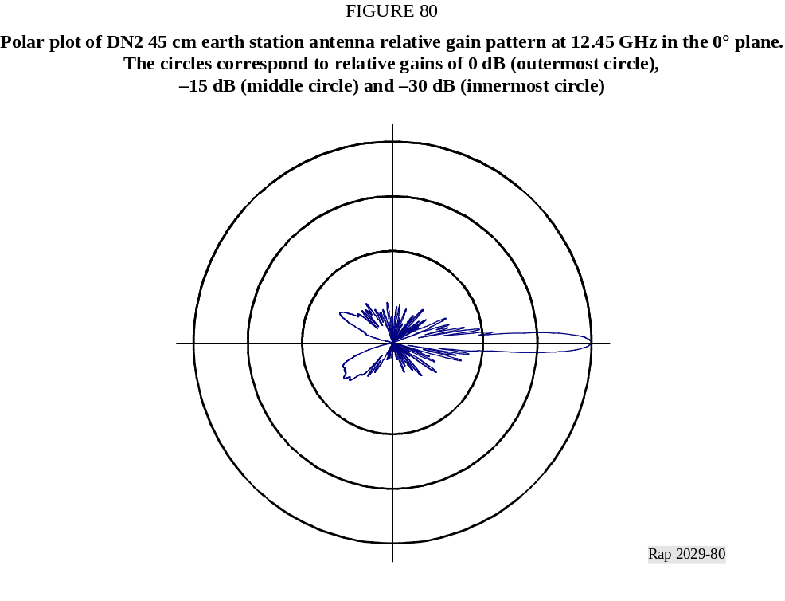
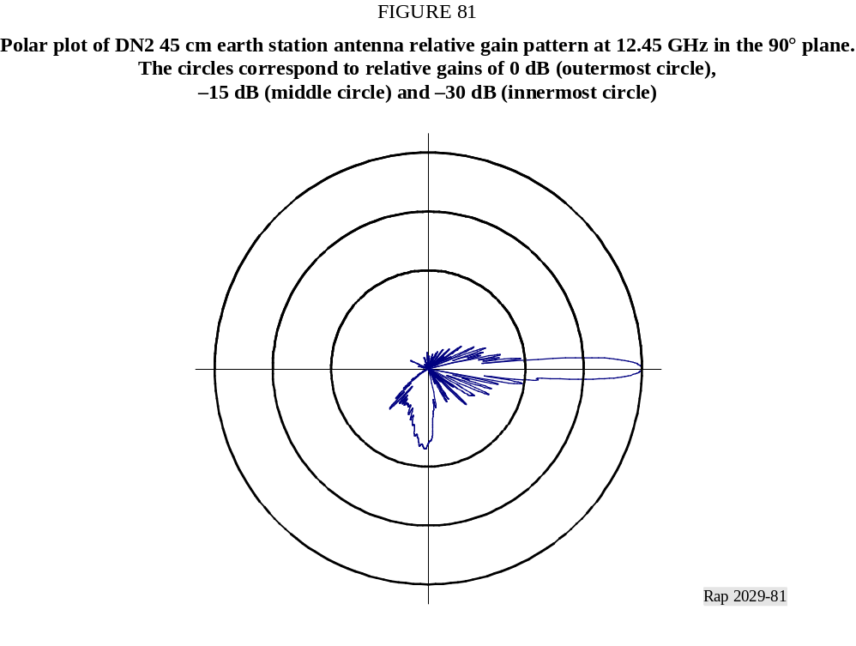

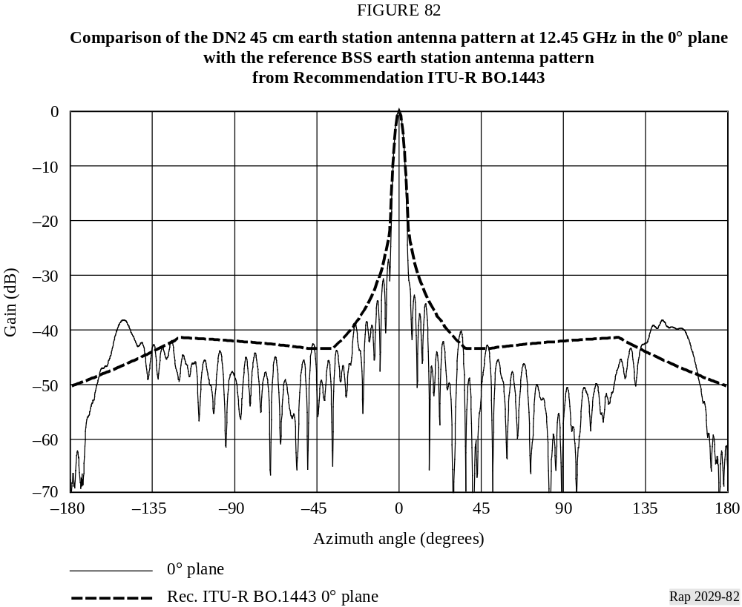
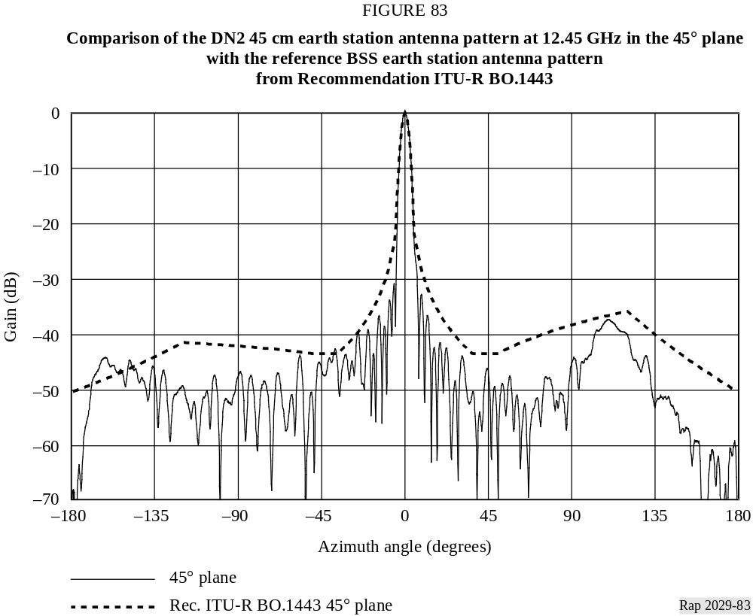
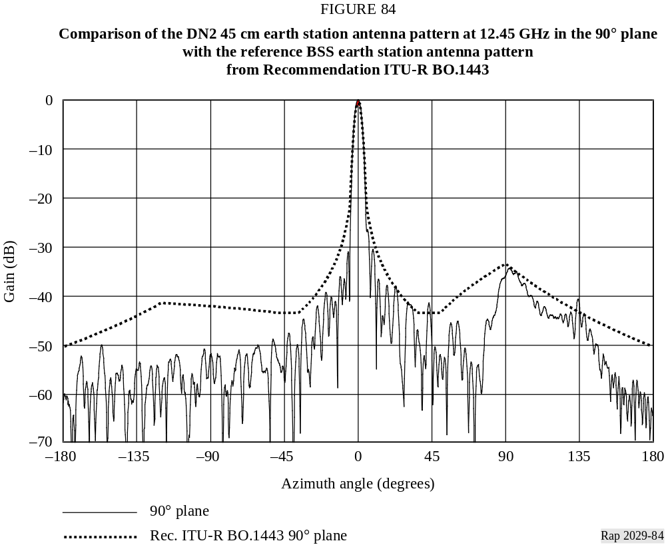
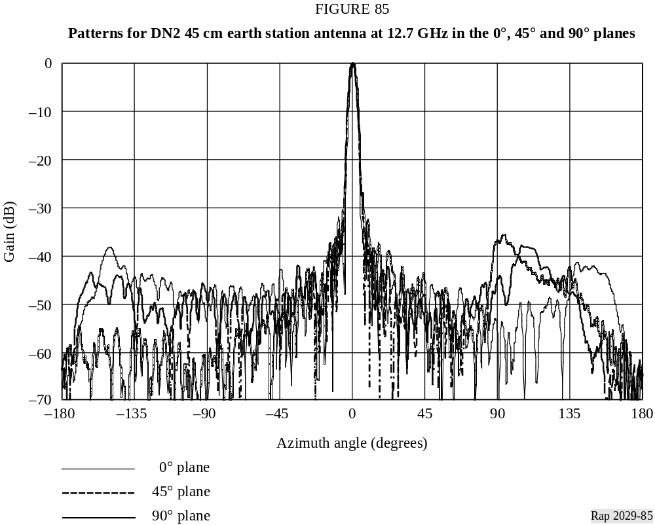

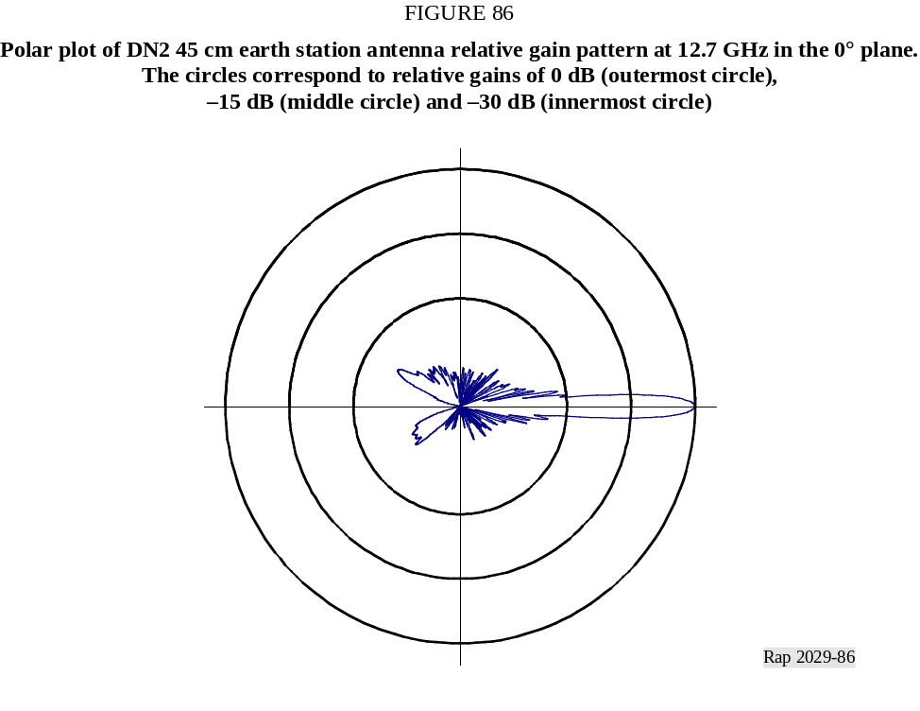
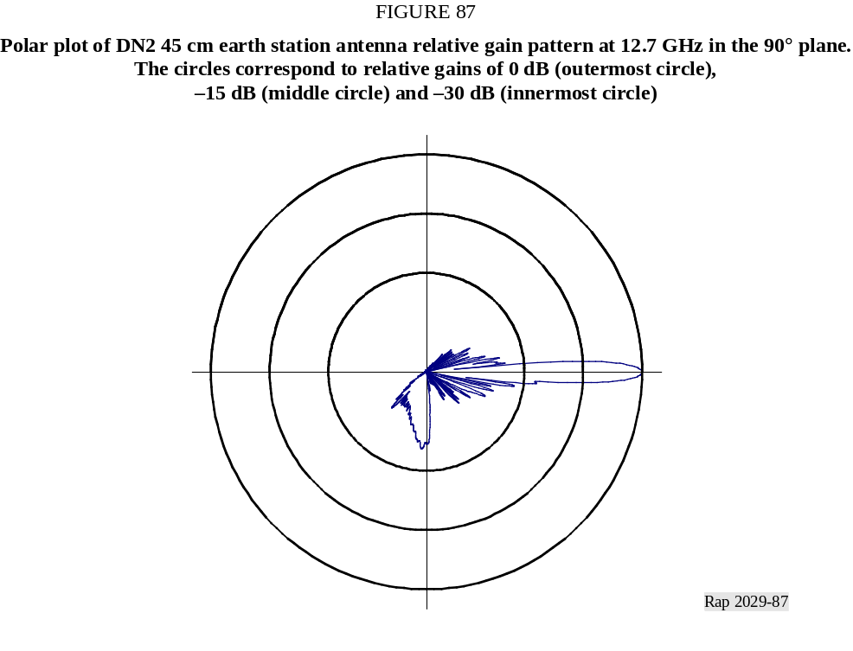

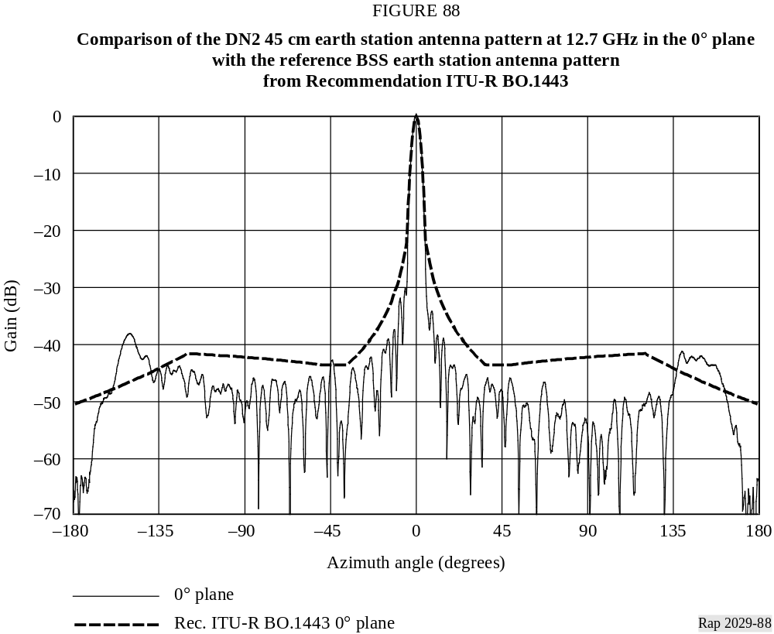
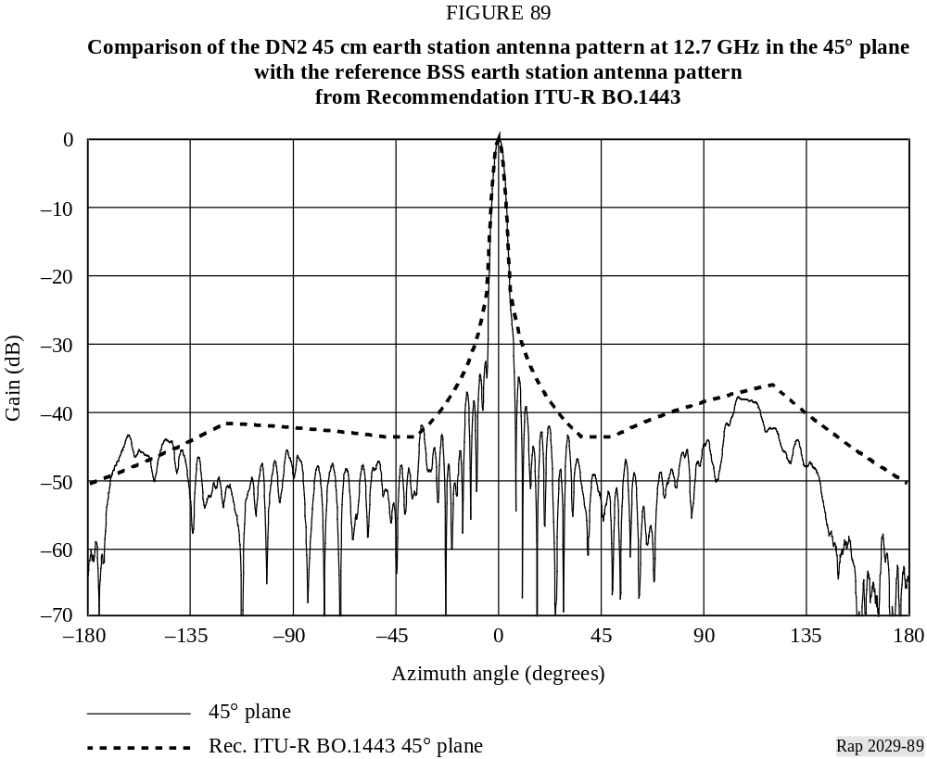
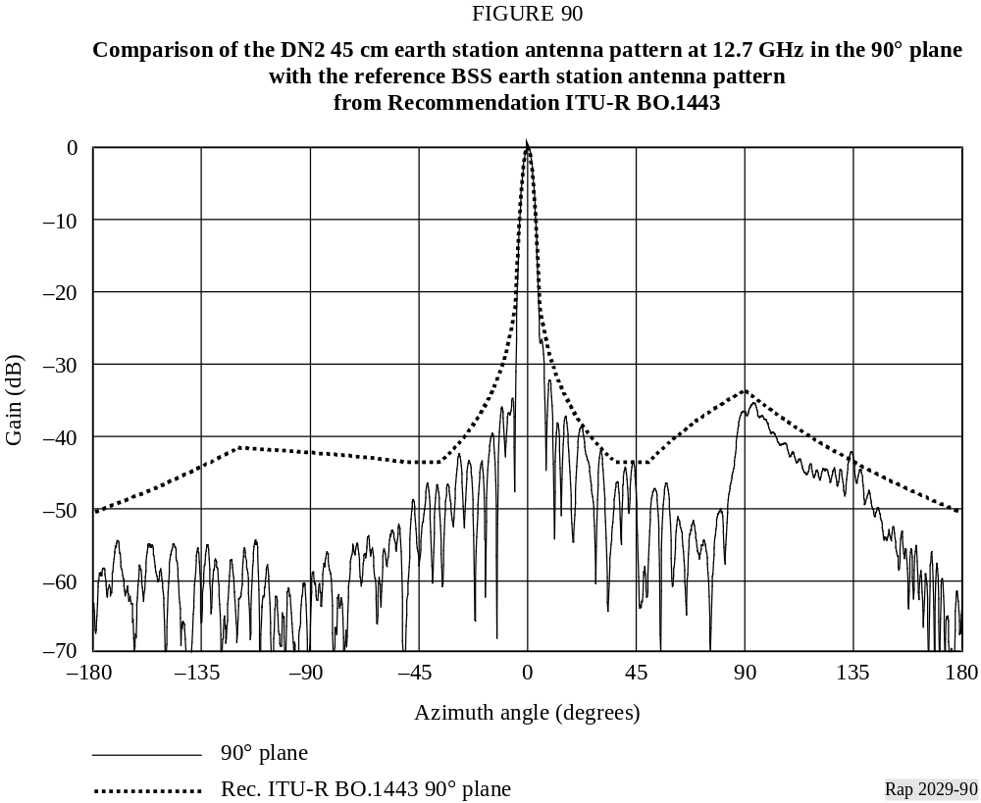
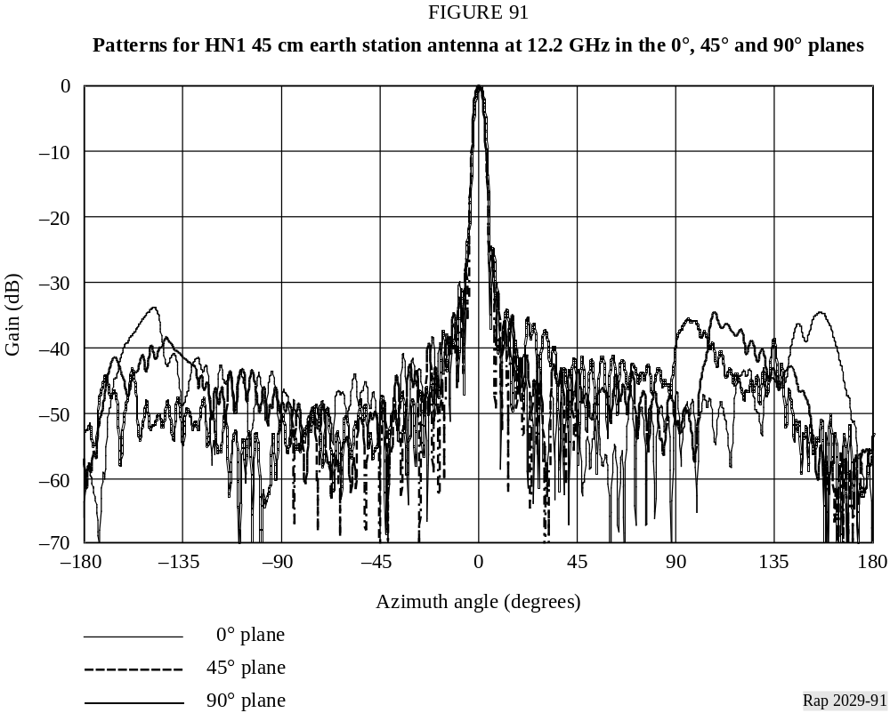
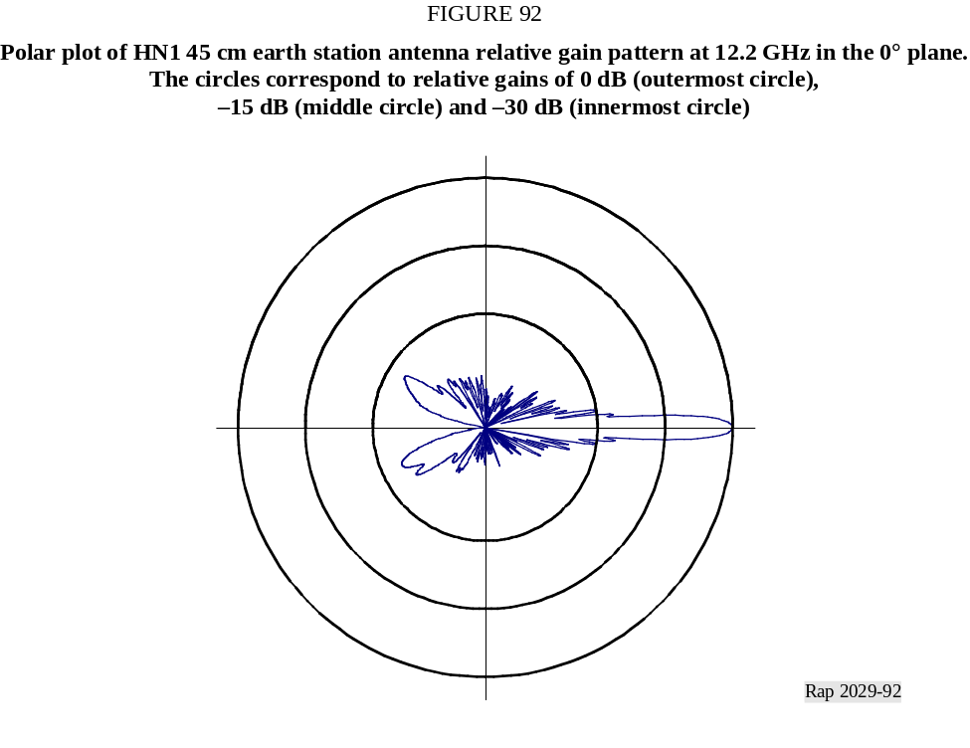
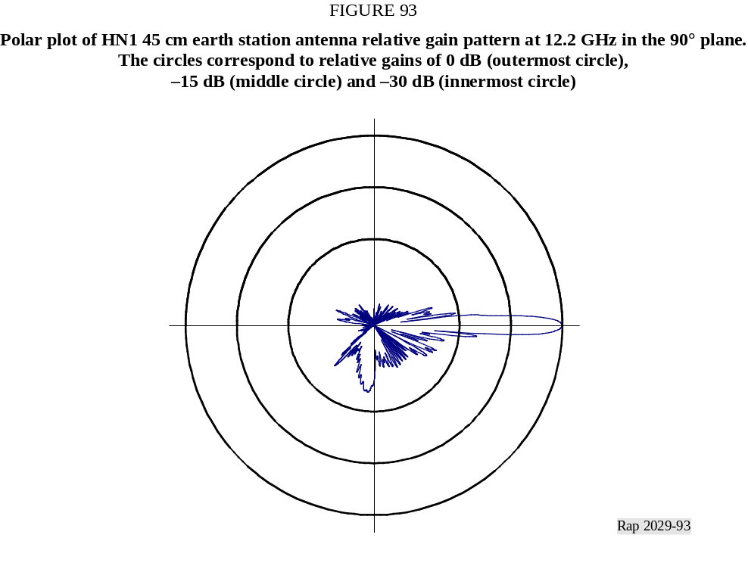

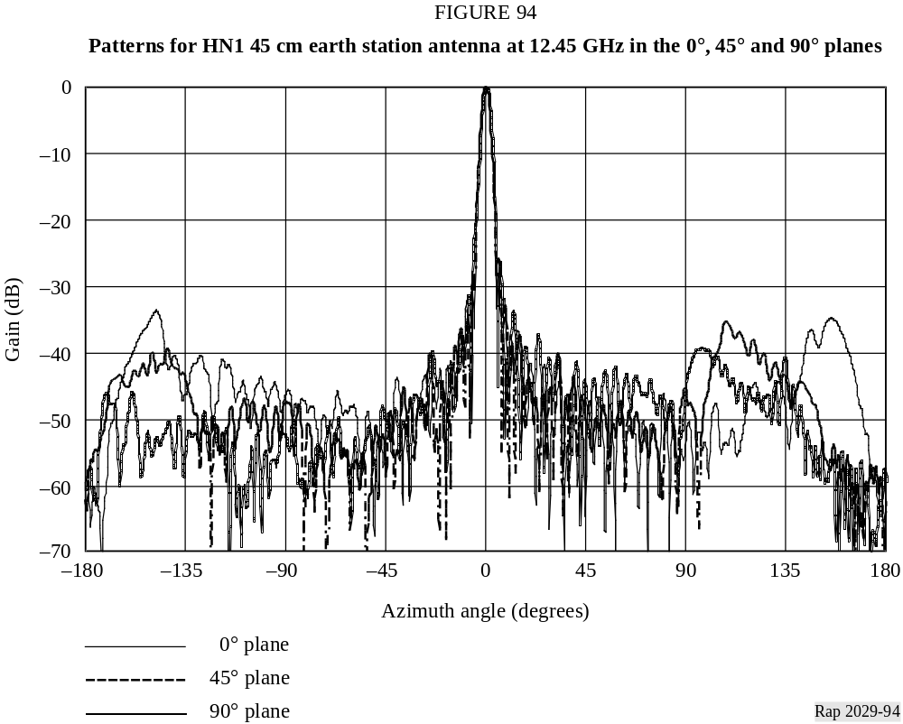
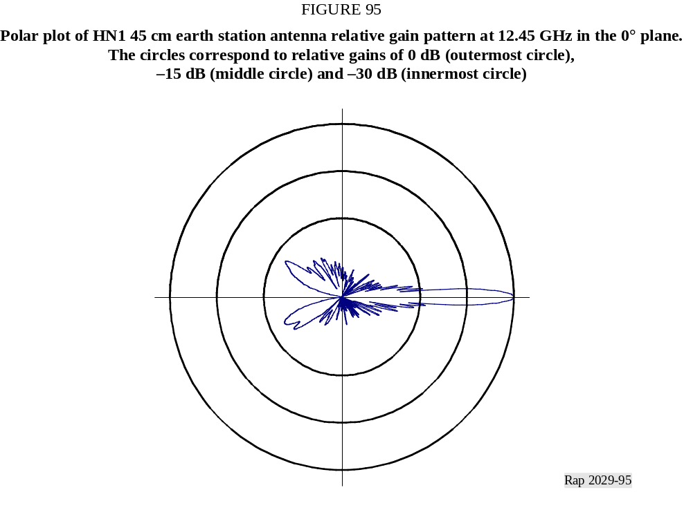

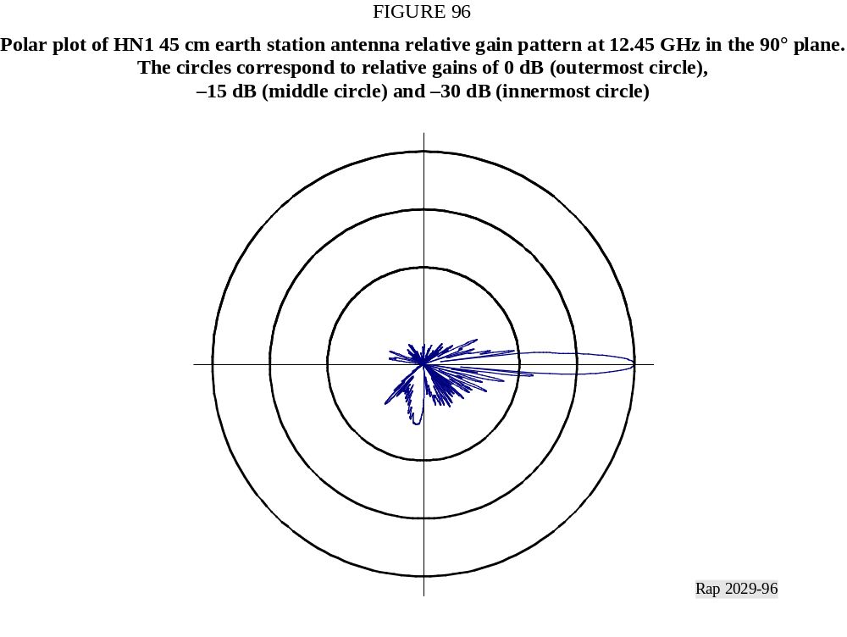
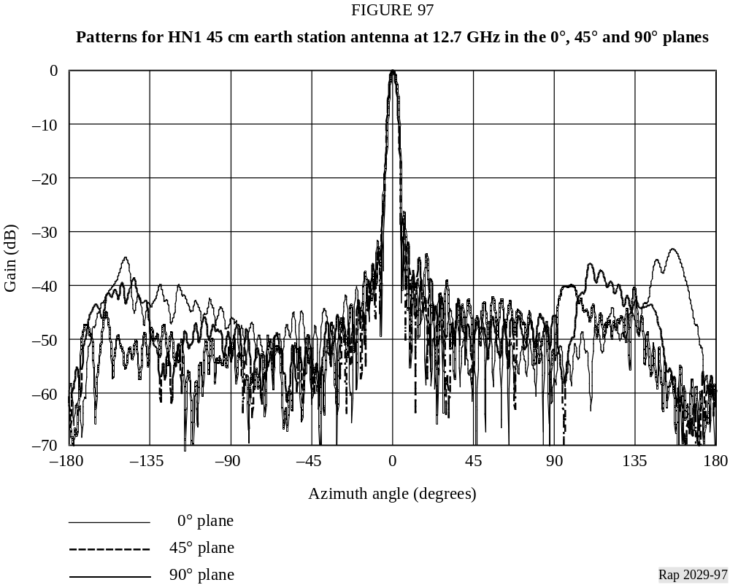

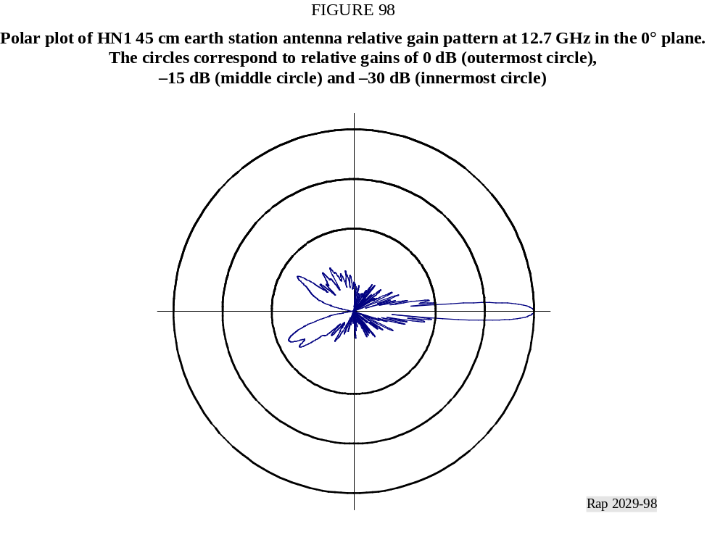
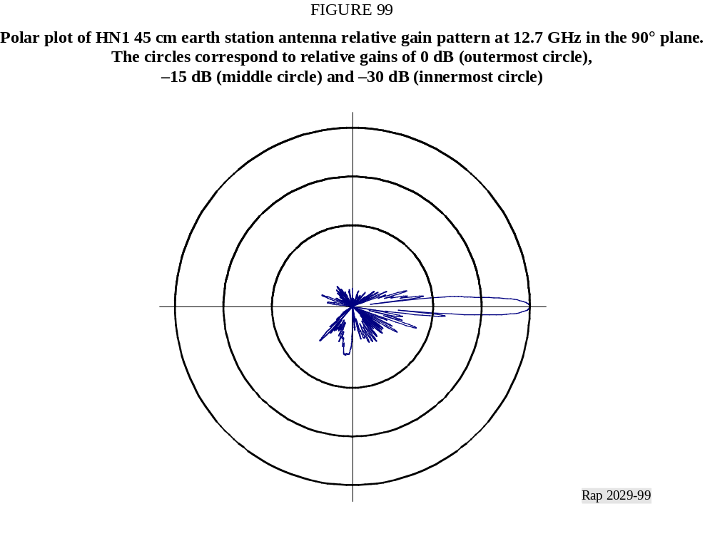

5.3 Antenna pattern analysis
Canada investigated several aspects of these antenna patterns and performed extensive analyses. Techniques have been described to include the patterns from different antennas to create a composite antenna mask that can be scaled for different frequency ranges. This includes a suggested standardized method of data collection and analysis that facilitates combining data from different antennas to create a composite mask. Another issue regards windowing techniques, such as those described in Recommendation ITU-R S.732, that can be used to average the raw measured data to generate an envelope pattern that is suitable for the type of interference of interest. Combining the resulting mask into a piecewise linear pattern over the full angular range is also important.
Geometric conversions that may be used with a three-dimensional antenna model are also described in Annex 2 to Recommendation ITU-R BO.1443.

6 Data and text layout on CD-ROM
The layout of the data and text files on the CD-ROM is shown in Fig. 100. The data is in ASCII text files and Microsoft Excel files. The Report text is in a Microsoft Word file.


