|  |
| --- |
| **Report ITU-R M.2370-0**  **(07/2015)** |
| **IMT traffic estimates  for the years 2020 to 2030** |
| **M Series**  **Mobile, radiodetermination, amateur**  **and related satellite services** |

Foreword

The role of the Radiocommunication Sector is to ensure the rational, equitable, efficient and economical use of the radio-frequency spectrum by all radiocommunication services, including satellite services, and carry out studies without limit of frequency range on the basis of which Recommendations are adopted.

The regulatory and policy functions of the Radiocommunication Sector are performed by World and Regional Radiocommunication Conferences and Radiocommunication Assemblies supported by Study Groups.

# Policy on Intellectual Property Right (IPR)

ITU-R policy on IPR is described in the Common Patent Policy for ITU-T/ITU-R/ISO/IEC referenced in Annex 1 of Resolution ITU-R 1. Forms to be used for the submission of patent statements and licensing declarations by patent holders are available from <http://www.itu.int/ITU-R/go/patents/en> where the Guidelines for Implementation of the Common Patent Policy for ITU‑T/ITU‑R/ISO/IEC and the ITU-R patent information database can also be found.

|  |  |
| --- | --- |
| Series of ITU-R Reports  (Also available online at <http://www.itu.int/publ/R-REP/en>) | |
| **Series** | Title |
| **BO** | Satellite delivery |
| **BR** | Recording for production, archival and play-out; film for television |
| **BS** | Broadcasting service (sound) |
| **BT** | Broadcasting service (television) |
| **F** | Fixed service |
| **M** | Mobile, radiodetermination, amateur and related satellite services |
| **P** | Radiowave propagation |
| **RA** | Radio astronomy |
| **RS** | Remote sensing systems |
| **S** | Fixed-satellite service |
| **SA** | Space applications and meteorology |
| **SF** | Frequency sharing and coordination between fixed-satellite and fixed service systems |
| **SM** | Spectrum management |

|  |
| --- |
|  |

|  |
| --- |
| ***Note****: This ITU-R Report was approved in English by the Study Group under the procedure detailed in Resolution ITU-R 1.* |

*Electronic Publication*

Geneva, 2015

© ITU 2015

All rights reserved. No part of this publication may be reproduced, by any means whatsoever, without written permission of ITU.

REPORT ITU-R M.2370-0

IMT traffic estimates for the years 2020 to 2030

(2015)

TABLE CONTENTS

1 Introduction 2

2 Related ITU-R Recommendations and Reports 3

3 Trends impacting traffic estimation beyond 2020 3

3.1 Drivers 3

3.2 Shifting demography 7

4 Mobile device proliferation 8

4.1 Statistical information 8

4.2 Estimations of global number of mobile subscriptions to 2030 11

5 Global IMT traffic estimations to 2030 15

5.1 Estimation 1 15

5.2 Estimation 2 19

5.3 Estimation 3 20

6 Traffic asymmetry 22

6.1 Description of traffic asymmetry 22

6.2 Examples of traffic asymmetry 23

6.3 Traffic asymmetry volumes in recent years 24

6.4 Traffic asymmetry estimation to 2024 26

6.5 Traffic asymmetry analysis in the space and time domains 29

7 Conclusions 30

Annex 1 – Examples of basic esstimation methods 31

Annex 2 – Country-specific information 32

Annex 3 – Some examples of subscribers’ traffic profiles 40

Annex 4 – Traffic characteristics of future applications supported by IMT 44

# 1 Introduction

Mobile communication has become one of the largest and most significant platforms in history, transforming the way we communicate, experience entertainment and make use of the Internet. In May 2015, over the current world’s population of 7.3 billion, there were about 7.5 billion mobile subscriptions (including machine-to-machine/M2M) worldwide and about 3.7 billion people connected[1]. As many people have multiple subscriptions, the total number of subscriptions is higher than the number of people connected with mobile.

Mobile communications contribute positively to the economic and social developments of both developed and developing countries. The evolution of mobile communications toward mobile broadband (MBB)[2] results in a new opportunity to bridge the gap between Internet-connected and unconnected people. As of September 2014, 2.3 billion (or 30%) of mobile subscriptions were data subscriptions[3]. The spread of smart mobile devices – smartphones and tablets – and the associated innovative mobile broadband applications have resulted in an increase in the volume of mobile data traffic and it is still growing, putting more emphasis on MBB.

ITU-R has developed two documents on traffic, as well as spectrum requirements to 2020, namely:

− [Report ITU-R M.2243-0 (11/2011) – Assessment of the global mobile broadband deployments and forecasts for International Mobile Telecommunications](http://www.itu.int/pub/R-REP-M/publications.aspx?lang=en&parent=R-REP-M.2243).

− [Report ITU-R M.2290-0 (12/2013) – Future spectrum requirements estimate for terrestrial IMT.](http://www.itu.int/pub/R-REP-M/publications.aspx?lang=en&parent=R-REP-M.2290)

Report ITU-R M.2243 reviews both the market and traffic forecasts for IMT that were developed in previous study periods (2000-2007) and assesses the perspectives and future needs of MBB that would be supported by IMT until 2020. In addition, it provides traffic forecasts up to 2015, and in some cases up to 2020, taking into account new market trends and market drivers.

Report ITU-R M.2290 provides a global perspective on the future spectrum requirements estimate for terrestrial IMT. In order to estimate the spectrum requirements for 2020, this Report predicts future traffic growth up to 2020 and derived input parameters representing a possible set of global scenarios of the future mobile traffic growth.

The first Report shows that mobile data traffic has grown dramatically in the recent years; whilst the second Report predicts more growth still to come towards 2020.

Building on the Reports described above, this Report analyses trends impacting future IMT traffic growth beyond the year 2020 and estimates the traffic demands for the period 2020 to 2030. There are many drivers impacting future IMT traffic growth and the characteristics of the traffic that are envisaged to generate this growth are also described in this Report. These drivers are expected to evolve over time, and this evolution will be different in each country due to social/economic differences. This results in a wide variation in national estimates of traffic in the period 2020-2030. Given this high degree of variability, the absence of a complete catalogue of all national estimates, and the inability to collect a broader sample of national estimates, this Report has focused on *global* traffic forecasts for the period 2020-2030.

# 2 Related ITU-R Recommendations and Reports

Report ITU-R M.2243-0 – Assessment of the global mobile broadband deployments and forecasts for International Mobile Telecommunications

[Report ITU-R M.2290-0 – Future spectrum requirements estimate for terrestrial IMT](http://www.itu.int/pub/R-REP-M/publications.aspx?lang=en&parent=R-REP-M.2290)

# 3 Trends impacting traffic estimation beyond 2020

## 3.1 Drivers

There are many drivers influencing the growth of future IMT traffic such as the adoption of IMT‑2020[4] devices with enhanced capabilities that require increased bit-rates and bandwidth, increased video usage, device proliferation and application uptake. Similar drivers increased traffic in the transition from IMT-2000 to IMT-Advanced.

The main drivers behind the anticipated traffic growth are[5]:

*– Video usage*: Usage of video-on-demand services will continue to grow and resolution of these videos will continue to increase. By 2020, it is expected that people will want to watch high-resolution audio-visual content (HD/UHD), regardless of the way the content is delivered. A study by Bell Labs estimates that by 2016 video streaming will account for almost two-thirds of all mobile traffic.

*– Device proliferation*: In 2016, about 1 in 7 people (or about 1 billion) are forecasted to purchase new smartphones. By 2017, more than 1.4 billion smartphones and tablets will ship, becoming the fastest-growing category of consumer electronics[6].

– *Application uptake*: The rate at which applications are being adopted is accelerating.   
The annual global downloading of applications was 102 billion apps in 2013 and will grow to 270 billion in 2017[7] (139, 180 and 225 billion in 2014, 2015 and 2016, respectively). It should be noted that most applications are not used more than once after being downloaded. This mobile application uptake and the usage of those will contribute to increased mobile broadband traffic and, in addition, the amount of regular updates/upgrades to those hundreds of billions applications will also increase mobile broadband traffic.

In addition to these major drivers of data traffic growth, there are other characteristics and trends that are expected to impact the overall traffic demand in 2020-2025 and beyond.

Some of the key ones are illustrated in Fig. 1 followed by some further details:

Figure 1

Drivers for future traffic increase

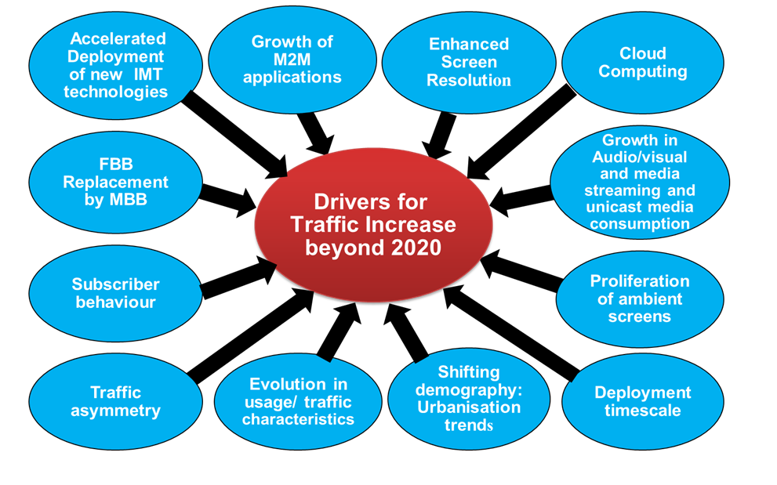

– **Accelerated deployment of new IMT technologies (IMT-2020)**: New technologies will increase the bit-rates and quality of experience (QoE)[8], which will also increase customer demand and decreases the cost/MB. This reduces the price to customers which in turn creates more demand (price/demand elasticity).

– **Machine–to-machine (M2M)** applications and devices are also one of the fastest growing segments for MBB usage and, eventually, increased mobile data demand. Billions more machines will potentially utilise mobile networks to access online services and connect with each other. While most M2M devices will be connected to a smartphone or a car or another connected device for their own communication; each device could have separate charges/subscriptions. The amount of M2M connections could be several orders of magnitude larger than the world population.

– **Enhanced screen resolution/content offering**: Improvements in the resolution (screen) capabilities (e.g. 4K UHD, etc.) and increasing demand for video downloading and streaming leads to more traffic on mobile networks consumed on devices such as smartphones or tablets.

– **Proliferation of ambient screens** or info-bearing surfaces to internet-connected devices for up-to-date information, such as screens in elevators, screens for information, news, etc. in trains will increase traffic more and more.

– **Cloud computing**: The demand for mobile cloud services is expected to grow because users are increasingly adopting more services that are required to be ubiquitously accessible. As the number of users connecting through the mobile network to the cloud increases, the mobile data traffic between mobile terminals, servers and storage in the cloud will continue to grow.

– **Fixed broadband (FBB) replacement by MBB**: In areas and contexts where MBB is used as an alternative to wired broadband, such as copper, cable and fibre, this would contribute to an increase in IMT traffic.

– **MBB penetration** rate is growing faster than FBB penetration rate. This will contribute to increasing IMT traffic

– **The continued growth of audio-visual media streaming**: People use their mobile devices more and more for streaming entertainment, with increased unicast media consumption due to time shift (expansion of cloud/network DVR), space shift (availability of content anywhere) and device shift (multi-screen, switch to mobile/portable devices). The DigiWorld yearbook 2014 from IDATE[9] indicates that linear TV still represents 90% of the world audio‑visual services market, growing 4.2% from the previous year; while OTT[10] (over-the-top) represents 4.4% of the market, growing 37%. Most of OTT traffic is delivered via non‑IMT networks. However, the part delivered by IMT is expected to increase in the future.

– **The shifting demography/migration to cities and increased urbanisation trend**: Given that 600 cities of the world are producing 60% of the global gross domestic product (GDP), much of the global population are, or will be, urban migrants, moving to cities particularly in emerging markets as detailed in § 3.2.

– **The evolution in usage and traffic characteristics** of the current (web-browsing, voice, streaming, etc.) and emerging services changing the utilisation rates, active bit rates, and, hence, the net average up and down link traffic per device.

– **Overall average traffic asymmetry** ratio (UL/DL), which is currently dominant (from 1/4 to 1/9) in favour of downlink (DL) and is expected to increase in favour of DL (from 1/7 to 1/10) or more, in future.

– **The (time and space) subscriber behaviour** including the subscriber’s geographical distribution, moving behaviour and application usage behaviour: It will impact on the space- and time-domain traffic behaviour, leading to non-uniformly distributed traffic volume and traffic asymmetry.

– **Actual deployment timescale** to make mobile broadband available to all potential users.

Furthermore, as indicated in Table 1, the following approaches can be considered to cope with increasing traffic growth:

TABLE 1

Approaches to cope with traffic increase[11]

|  |  |
| --- | --- |
| **Spectrumavailability** | Amount of spectrum used by radio interface. |
| **Technicalenhancements** | Migration to innovative, more efficient techniques such as new radio interfaces, codec improvements, use of multicast and reduction in energy consumption. |
| **New network structure/topology** | Number of radio sites and smaller cell sizes. |
| **Offloadingtraffic** | Off-loading of traffic onto licence-exempt frequencies frees up capacity in the macro network layer. |

– **Spectrum availability**: The increased mobile traffic demand is driving the development and deployment of MBB technologies such as IMT. However, the identified IMT spectrum is currently not fully made available in many countries, which limits IMT usage in those countries.

Sufficient and suitable spectrum resources are key factors to facilitate the development of innovative services and applications and stimulate competition in mobile broadband landscape.

– **Technical enhancements**: Along with the efficient radio interface technologies, video codec improvements with more efficient compression methods will facilitate better handling of traffic. For example, usage of H.265 instead of MPEG4 will reduce the amount of traffic.

As the number of users and connected devices grows, energy consumption might become a limiting factor to traffic growth, reaching an unsustainable level of cost of operation and greenhouse gas emissions[12]. The energy consumption of wireless networks in 2011 was estimated to be 17 kWhr/year/user (excluding device consumption). With 5.9 billion users in 2011, this amounts to about 100 TeraWatt-hour/year, which is 0.5% of the electrical energy consumption in the world. Therefore, improvements in energy efficiency are needed to keep traffic increase affordable.

– **New network structure/topology**: Network densification such as applying new network structure/topology also improves the network capacity. For example, the number of radio sites as well as the usage of the small cell sizes is important elements for capacity increase. The highest traffic demand occurs in dense urban centers at peak times. As a result, it is urban hotspot sites that require additional capacity. However, in these areas networks are already extremely dense today, and locations for new sites are hard to find.

Smaller cells are likely to be used to increase capacity without a need of tower based radio sites. Femtocells can also provide capacity increase in many applications, for example domestic environments.

– **Offloading traffic**: Off-loading of traffic onto licence-exempt frequencies (e.g. using Wi-Fi or LAA[13]) frees up capacity in the macro network layer.

The volumes of off-loaded traffic are significant. For example, Cisco estimates that in the UK, 40% of cellular traffic was off-loaded in 2010 and was expected to increase to 42% in 2015. Advanced mobile networks have the ability to handle multiple applications and device types with different network requirements, traffic load on the network, and levels of profitability. A service provider can select (using Wi-Fi or LAA) to off-load traffic to license-exempt spectrum depending on the required quality of service (QoS), off‑loading at various locations, over secured or open license-exempt access points.

## 3.2 Shifting demography

### 3.2.1 Migration to cities and increased urbanisation trend

An ever increasing number of people are living in cities. Every hour the global urban population grows by 7 500 people, due to migration and natural population growth – that is more than 5 million new city residents every month – driving the geographical expansion of cities. Already, the top 600 cities of the world are producing 60% of the total global GDP, with only 20% of the population. Up to 60% of current mobile broadband data traffic is generated by the 30% of the global population that lives in cities with a population density of more than 1 000 people per square kilometre[14]. Therefore, investments in infrastructure, including telecommunications, are essential to cope with this expected migration.

Cities will evolve, and future policies being applied to communication networks operations, including the necessary spectrum regulation, to a great extent, will be defined by the large cities.

City planners need to address environmental issues, climate change, poverty and illiteracy. In addition, there is a need to provide intelligent transport solutions, and speed up the flow of people, goods and services which will in turn reduce fuel consumption. Smart grids can increase energy efficiency, enable more renewable energy sources and support the widespread deployment of electric cars. All of these can be supported by the deployment of broadband mobile telecommunications networks.

The challenges vary from city to city, dependent on local and national circumstances, while noting that emerging-market cities also have unique opportunities, and can choose to “leapfrog” stages of development; emerging market cities can create solutions that are more efficient than those in many developed urban areas as they would not have to cope with legacy infrastructure. Broadband investments can have a strong impact, both direct and indirect, as mobile broadband spurs new consumer and producer behaviours, functionalities and businesses acting as a platform.

In conclusion, future mobile broadband traffic growth is likely to be driven by the growth of large cities.

### 3.2.2 Connected society

Connectivity in the context of digital economy implies all types of communications channels, including e-mails, chatting, tweets, social networks, Instagrams, video calls, etc. An increase in the number of channels and devices per person will result in traffic growth.

At the time of approval of this Report in 2015, about 28,000 GB of internet traffic is generated every second by, amongst other things, 2 400 000 emails, 9 400 Tweets, 2 200 Instagram photo uploads, 1 800 Skype calls, 2 000 Tumblr posts, 49 000 Google searches and 103 000 YouTube videos[15].

These data imply that the digital economy is evolving quickly across all parts of the world, creating huge efficiency gains, but also enormous upheaval and disruption to traditional business.

Moreover, increased use of mobile to replace face-to-face activities and other traditional forms of communication should also be taken into account. These can include the following:

– Online shopping overtaking traditional way of purchasing items in real time.

– An increase in online education as a complement to classrooms.

– Paperless billing and electronic payments overtaking paper bills/checks through the mail.

– More video and audio conferencing taking the place of face-to-face meetings, etc.

Since all these services will be accessible by mobile devices, and eventually will contribute to improvements in social welfare; they will also generate significant additional mobile traffic.

# 4 Mobile device proliferation

## 4.1 Statistical information

The growth in smartphone subscriptions has been extensive in recent years. From 2010 to 2013, the global number of smartphone subscriptions grew 280% from 0.5 billion to 1.9 billion. Also, in the same timeframe, as can be seen from Fig. 2, mobile PCs and tablets increased from 150 million to 300 million.

Figure 2

Statistics on global smartphone and tablets subscriptions

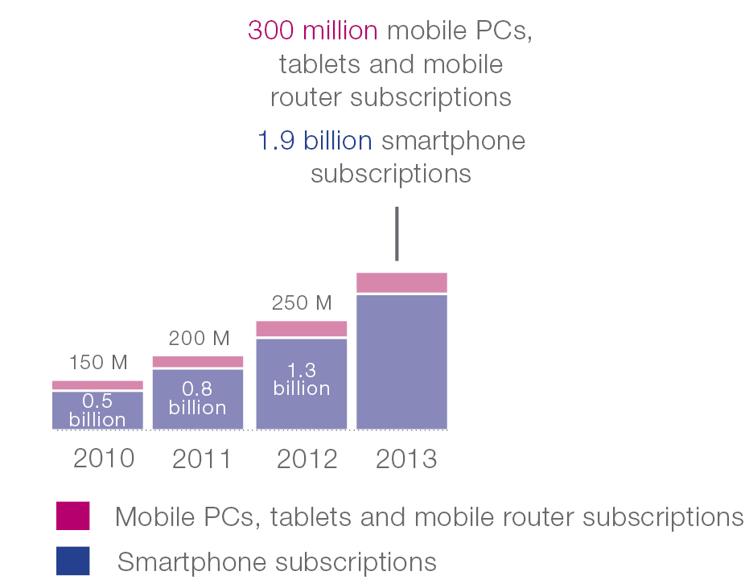

Statistical information figures from the ITU ICT statistics web-page (reproduced in Table 2 below) also show an increase in the growth rate of MBB subscriptions. From 2007 to 2014, global MBB subscriptions numbers climbed by 764% and growth in developing countries was extensive; from 43 million to 1 265 million, which is nearly 3 000%.

TABLE 2

MBB subscriptions from the ITU ICT Statistics(1)

|  |  |  |  |  |  |  |  |  |
| --- | --- | --- | --- | --- | --- | --- | --- | --- |
| Active mobile-broadband subscriptions (millions) | | | | | | | | |
| Years | 2007 | 2008 | 2009 | 2010 | 2011 | 2012 | 2013 | 2014(2) |
| Developed | 225 | 336 | 450 | 554 | 707 | 828 | 939 | 1 050 |
| Developing | 43 | 86 | 165 | 253 | 475 | 726 | 991 | 1 265 |
| World | 268 | 422 | 615 | 807 | 1 182 | 1 554 | 1 930 | 2 315 |

|  |  |  |  |  |  |  |  |  |
| --- | --- | --- | --- | --- | --- | --- | --- | --- |
| Active mobile-broadband subscriptions – Penetration rate (%) | | | | | | | | |
| Years | 2007 | 2008 | 2009 | 2010 | 2011 | 2012 | 2013 | 2014(2) |
| Developed | 18.5 | 27.5 | 36.6 | 44.7 | 56.8 | 66.4 | 75.1 | 83.7 |
| Developing | 0.8 | 1.6 | 3.0 | 4.5 | 8.3 | 12.4 | 16.8 | 21.1 |
| World | 4.0 | 6.3 | 9.0 | 11.5 | 16.7 | 21.7 | 26.7 | 32.0 |
| NOTE 1 – Key ICT indicators for developed and developing countries and the world <http://www.itu.int/en/ITU-D/Statistics/Documents/statistics/2014/ITU_Key_2005-2014_ICT_data.xls> .  NOTE 2 – Projection. | | | | | | | | |

On the other hand, statistical information figures from the ITU ICT statistics web-page (reproduced in Table 3 below) show a decline in the growth rate of (global) mobile-cellular subscriptions. From 2005 to 2006 and from 2013 to 2014, global subscription numbers climbed by 24.5% and 3.8%, respectively. In developed countries, the growth from 2013 to 2014 was 1.7%.

TABLE 3

Global mobile-cellular subscription from the ITU ICT statistics (3)

|  |  |  |  |  |  |  |  |  |  |  |
| --- | --- | --- | --- | --- | --- | --- | --- | --- | --- | --- |
| Number of global mobile-cellular telephone subscriptions (millions) | | | | | | | | | | |
| Years | 2005 | 2006 | 2007 | 2008 | 2009 | 2010 | 2011 | 2012 | 2013 | 2014(4) |
| Developed | 992 | 1 127 | 1 243 | 1 325 | 1 383 | 1 404 | 1 411 | 1 447 | 1 490 | 1 515 |
| Developing | 1 213 | 1 618 | 2 125 | 2 705 | 3 257 | 3 887 | 4 453 | 4 785 | 5 171 | 5 400 |
| World | 2 205 | 2 745 | 3 368 | 4 030 | 4 640 | 5 290 | 5 863 | 6 232 | 6 662 | 6 915 |

|  |  |  |  |  |  |  |  |  |  |  |
| --- | --- | --- | --- | --- | --- | --- | --- | --- | --- | --- |
| Global mobile-cellular telephone subscriptions – Penetration rate (%) | | | | | | | | | | |
| Years | 2005 | 2006 | 2007 | 2008 | 2009 | 2010 | 2011 | 2012 | 2013 | 2014(4) |
| Developed | 82.1 | 92.9 | 102.0 | 107.8 | 112.1 | 113.3 | 113.5 | 116.0 | 119.2 | 120.8 |
| Developing | 22.9 | 30.1 | 39.1 | 49.0 | 58.2 | 68.5 | 77.4 | 82.1 | 87.6 | 90.2 |
| World | 33.9 | 41.7 | 50.6 | 59.7 | 68.0 | 76.6 | 83.8 | 88.1 | 93.1 | 95.5 |
| NOTE 3 – Key ICT indicators for developed and developing countries and the world  <http://www.itu.int/en/ITU-D/Statistics/Documents/statistics/2014/ITU_Key_2005-2014_ICT_data.xls> .  NOTE 4 – Projection. | | | | | | | | | | |

Table 4 shows statistical information for mobile subscriptions with different terminal types, which comes from the Cisco VNI White Papers[16] published in 2012 to 2015.

TABLE 4

Mobile subscriptions with different terminal types in the CISCO VNI White Paper

|  |  |  |  |  |
| --- | --- | --- | --- | --- |
| Mobile subscriptions with different terminal types (Million) | 2011 | 2012 | 2013 | 2014(5) |
| Non smartphone (Feature phone) | 5007 | 4727 | 4688 | 4542 |
| Smartphone | 804 | 1339 | 1681 | 2120 |
| Laptops | 144 | 126 | 175 | 189 |
| Tablets | 14 | 41 | 47 | 74 |
| M2M | 227 | 224 | 329 | 494 |
| NOTE 5 – Projection. | | | | |

**Feature phones:** The number of non-smartphones (feature phones) peaked in 2011, since then their number has been dropping. Given that smartphones are more appealing to customers, it can be expected that the numbers of feature phones will continue to decrease as they are gradually replaced by smartphones. However, unless forced by external triggers (regulatory or network operational) such devices could still be present for an extended period of time.

**Smartphones:** There is a strong growth in the number of smartphones. One relevant factor is the substitution of a feature phone by a smartphone.

The development of mobile communications and electronic component technologies, better user experience and lower price of smartphones will also contribute to this growth. Recently, new terminal category called “phablets” have emerged which is considered as smartphone with a screen having an intermediate size between a tablet and a smartphone. Therefore, Table 4 above includes phablet numbers as part of smartphones.

**Laptops:** For laptops with IMT subscription, there was a trend to replace them by tablets, therefore their number was dropping until 2012. However, recently due to advent of lightweight laptops and their popularity, the number of subscriptions is increasing.

**Tablets:** The number of tablets has increased significantly in recent years. As of the year 2014 only 18% of tablets had a subscription (i.e. active SIM card), but it is estimated to increase to 31% by 201916.

With IMT broadband networks becoming increasingly robust and IMT-Advanced increasingly deployed, many tablets without subscription will be connected to IMT networks via the tethering mode of smartphones. These tablets contribute to increased IMT traffic (i.e. IMT traffic from smartphones).

The development of mobile communications and electronic component technologies, better user experience and lower prices contribute to an increase of the number of tablets.

**M2M:** Table 4 shows the number of M2M subscriptions remained flat until 2012. However, since then a significant growth trend can be observed.

## 4.2 Estimations of global number of mobile subscriptions to 2030

### 4.2.1 Estimation 1[17]

Concerning global mobile subscriptions, this estimation method consists of statistical data collection, estimation of the increase of global mobile subscriptions through curve fitting. In addition, estimation model used and parameters were based on the power function fitting (e.g. of curve fitting as depicted in Annex 1) to estimate the year on year growth until 2030, and then calculate the mobile subscriptions every year. In this estimation, statistical information was based Table 5 below.

TABLE 5

Statistical information used in the estimation

|  |  |  |  |  |  |  |  |  |  |
| --- | --- | --- | --- | --- | --- | --- | --- | --- | --- |
| Years | 2005 | 2006 | 2007 | 2008 | 2009 | 2010 | 2011 | 2012 | 2013 |
| Global mobile subscriptions (Million) | 2 205 | 2 745 | 3 368 | 4 040 | 4 640 | 5 320 | 5 962 | 6 411 | 6 835 |

The differences between Table 3 and Table 5 are due to the fact this estimation uses some other consultant companies’ data with different statistic metrics.

Figure 3 below depicts estimation of global mobile subscriptions and shows that they will grow rapidly between 2020 and 2030.

Estimation of global mobile subscriptions

The number of global mobile subscriptions has already reached 6.7 billion in 2013. As a result of the system performance improvements, widely used new device types and applications, the number of global mobile subscriptions will increase significantly in the future. It was estimated that the number of global mobile subscriptions could be 13.8 billion in 2025 and 17.1 billion in 2030.

Estimation of global mobile subscriptions of each type of terminal

The estimation method used for mobile subscriptions of each type of terminal was based on the curve fitting approach and revised through normalization method based on the estimated result of global mobile subscriptions. Based on power function fitting (an example of curve fitting) to estimate the year on year growth of each type of terminal separately, the mobile subscriptions of each type of terminal every year can be calculated.

One assumption is that the number of feature phone subscriptions will reduce gradually and the feature phone will be substituted by other types of terminal around 2025. The estimated result was finally revised through normalization method based on the estimated result of overall global subscriptions (with the assumption that the proportion of each type of terminal obtained from respective curve-fitting results is unchanged). The statistical information used in this estimation was based on Table 6 below.

TABLE 6

Statistical information used in the estimation

|  |  |  |  |  |
| --- | --- | --- | --- | --- |
| Mobile subscriptions with different terminal types (Million) | 2010 | 2011 | 2012 | 2013 |
| Non smartphone (feature phone) | 5 365 | 5 276 | 5 350 | 5 528 |
| Smartphone | 645 | 698 | 1 177 | 1 507 |
| Tablet and other smart devices | 144 | 241 | 267 | 348 |

Based on the estimation method described above, Fig. 4 provides estimation of global mobile subscriptions with different categories from 2020 onwards.

FIGURE 4

Estimation of global mobile subscriptions with different categories

With the development of mobile communications and electronic element technologies, better user experience and lower price of devices will accelerate the growth rate of penetration of tablets between 2020 and 2030. It is estimated that the number of global subscriptions of smartphone could be 10 billion in 2025 and 12 billion in 2030. The number of global subscriptions of tablets and other smart devices could be around 3 billion in 2025 and 5 billion in 2030. However, the number of non-smartphone (feature phone) subscriptions will decrease rapidly during the same period.

Estimation of global M2M subscriptions

*Estimation methods and procedures*

Estimation methods used were based on the following steps:

a) Statistical data collection on global population, M2M connections and penetration ratio,

b) Estimate the increase of global population,

c) Estimate the penetration ratio of global M2M connections to global population through  
S-curve (see Annex 1),

d) Calculation of the number of M2M connections by global population and the penetration  
 ratio of global M2M connections.

*Estimation models and parameters*

Global M2M subscriptions were based on S-Curve method to estimate the penetration ratio of global M2M subscriptions to global population until year 2030 as depicted in Fig. 5. Such penetration ratio is 0.03 in year 2010. One assumption is that the most rapidly development period of M2M industry and terminals will be around year 2020, and this industry will become saturated no earlier than 2030.

Figure 5

Estimation of global M2M subscriptions

The estimated result of global population comes from the estimation report of UN[18]. Moreover, this estimate of M2M connections was based on the statistical information of M2M subscriptions as depicted in Table 7 below.

TABLE 7

Statistical information of global M2M subscriptions

|  |  |  |  |  |
| --- | --- | --- | --- | --- |
| Years | 2010 | 2011 | 2012 | 2013 |
| Global M2M subscriptions (Million) | 213 | 324 | 376 | 422 |

Based upon Fig. 5, the market of M2M is expected to grow between year 2020 and 2030. It is estimated that the number of mobile connected M2M devices will be around 7 billion in 2020, which is almost equivalent to the global population in January 2015. By 2030, this number could reach 97 billion, which would be more than ten times the estimated human population at that time.

### 4.2.2 Estimation 2[19]

In the future, advanced connectivity will provide new ways of innovating, collaborating and socializing. However, already today, more than 60% of the global population has access to mobile communications, and in a few years from now more than 90% of the population will benefit from IMT-based mobile broadband coverage. The mobile broadband traffic will be dominated by video content carried by smartphones and other devices. As the time-frame for estimations extends further into the future, it becomes increasingly challenging to forecast future subscriptions and mobile traffic growth accurately. Consequently, by portraying scenarios, some discussion points (or assumptions) are included to address the various aspects of the estimates.

As shown in Fig. 6, there are three scenarios of growth that can be assumed – one which is conservative (“flat”), the second which is growth-accentuated (“high”) and the third which includes assumptions of strong contributions from machine-to-machine (M2M) communication, and also the integration of road-side and vehicular-to-vehicular communication, but most of all a strong impact of the introduction of devices containing future IMT (IMT-2020) capabilities suggesting that all devices that need to communicate will communicate (“very high”). Under these conditions, the number of global subscriptions could be of the order of 10 billion, 15 billion or 20 billion around the year 2025 (shown on the right hand side of Fig. 6).

Figure 6

Estimations of global mobile subscriptions (2020-2025)



# 5 Global IMT traffic estimations to 2030

## 5.1 Estimation 1[20]

The following section describes this global mobile traffic estimation.

*Estimation methods and procedures*

a) Statistical data collection on total global mobile traffic per month (including M2M) and the average mobile traffic per device per month (several types of terminals were estimated separately, including feature phone, smartphones, M2M devices, tablets and other devices).

b) Estimate the increase of global mobile traffic (including M2M) through curve fitting,

c) Estimate the average mobile traffic per device per month in the future through curve fitting, several types of terminals were considered separately.

d) Calculate the total mobile traffic per month for each type of terminal based on the average mobile traffic per device per month (see step c) and the mobile subscriptions of such type of terminal and revised through normalization method based on the estimated result of global mobile traffic (including M2M, see step b).

e) Calculate the total mobile traffic (not including M2M).

*Estimation model and parameters*

Global mobile traffic (including M2M): based on power function fitting (an example of curve fitting) to estimate the year on year growth until year 2030, then calculated the mobile traffic every year. Table 8 shows the statistical information used in the estimation.

TABLE 8

Statistical information used in the estimation

|  |  |  |  |  |  |  |  |  |
| --- | --- | --- | --- | --- | --- | --- | --- | --- |
| Years | 2005 | 2006 | 2007 | 2008 | 2009 | 2010 | 2011 | 2012 |
| Mobile traffic (PB/Month) | 0.9 | 4 | 15 | 38 | 92 | 256 | 597 | 885 |

Figure 7 below shows an estimation of global traffic through 2030.

Figure 7

Estimations of global mobile traffic from 2020 to 2030 (M2M traffic not included)

This Figure shows that mobile traffic (without M2M traffic) is estimated to grow at an annual rate of around 54% in 2020-2030.

The global mobile traffic per month is estimated to 543EB in 2025 and 4 394EB in 2030.

Figure 8 below shows mobile traffic (including M2M traffic) growing at an annual rate of around 55% in 2020-2030. The global mobile traffic per month would then be estimated to reach to 607 EB in 2025 and 5 016 EB in 2030.

Figure 8

Estimations of global mobile traffic in 2020-2030 (M2M traffic included)

Estimation of mobile traffic by different service types

This section includes the estimated results of mobile traffic by different service types for the years 2020‑2030. Video, non-video, M2M and other types of services are considered.

Both subscriber behaviour and service characters, especially future new services, are very important factors impacting the estimation of traffic volume. Other information such as business model, operation model and accounting rule are also helpful.

*Estimation methods and procedures*

Estimation methods and procedures were based in the following steps:

a) Statistical data collection on total global mobile traffic per month (including M2M) and the mobile traffic by service types per month (several types of services are estimated separately, including video, non-video and M2M).

b) Estimate the increase of global mobile traffic (including M2M) through curve fitting.

c) Estimate the mobile traffic of each type of service separately, and revise through normalization method based on the estimated result of global mobile traffic (including M2M, see step b).

*Estimation models and parameters*

Mobile traffic by service type: based on power function fitting (an example of curve fitting) to estimate the year on year growth, different services were estimated separately and revised through normalization method based on the estimated result of global mobile traffic as seen in Fig. 9 (with the assumption that the proportion of each type of service obtained from respective curve-fitting results unchanged). Table 9 shows the statistical information used in the estimation.

Figure 9

Estimation of mobile traffic by different service types globally

TABLE 9

Statistical information used in the estimation

|  |  |  |  |  |
| --- | --- | --- | --- | --- |
| Service Type (TB/Month) | 2010 | 2011 | 2012 | 2013 |
| Non-Video | 111 272 | 266 387 | 406 124 | 669 249 |
| Video | 117 943 | 307 869 | 455 216 | 858 026 |
| M2M | 7 462 | 23 009 | 23 566 | 49 973 |

Mobile internet traffic and M2M traffic will grow dramatically after year 2020. Video traffic will be 4.2 times than non-video in 2025 and 6 times in 2030. The traffic volume consumed by M2M services will be 7% of the total in 2020 and 12% of the total in 2030.

Estimation of mobile traffic per subscription

Estimation 1 provided some figures using a method based on the estimated results of global mobile traffic divided by global mobile subscriptions (M2M traffic was not included).

Figure 10 shows estimation of average global mobile traffic per subscriptions per month from 2020 to 2030.

Figure 10

Estimations of global mobile traffic per subscriptions per month from 2020 to 2030

(M2M not included)

The popularity of large-screen smart, high resolution devices is still a key driver of the growth of mobile data traffic. As the convenient and high performance smart devices like smartphones and tablets are widely used around world, in addition to the growth of mobile subscriptions, the mobile traffic volume consumed by each user will increase continually. It is estimated that each subscriber will consume 39.4 GB of data traffic per month in 2025 in average and this amount will be around 257 GB in 2030.

## 5.2 Estimation 2[21]

One of the estimates as indicated in Fig. 11 covers a period of 2020-2030, building on the estimates done in Report ITU-R M.2243.

Figure 11 shows one possible scenario of mobile traffic growth in ZB[22]/year between the years 2020 and 2030. Note that this is called a scenario, not a forecast, because it is based on a set of assumptions which, if changed could lead to a different scenario.

The main assumptions for this possible scenario are a continued growth in penetration of smartphones, tablets, etc. – in many regions limited (for smartphones) by population as penetration approaches 100% – and a continuous growth in traffic by each device/user which assumes continuous evolution of screen resolution and increasing viewing times for video which are the main contributors to traffic volumes. Each smartphone, as of the year 2013, generates 600 MB/month of traffic based on a global average, noting that this figure varies considerably among countries. While the current growth rate in mobile internet traffic is 30%, based on estimates of historical development of internet traffic and consideration of dilution by less-affluent subscribers in the later years, our reasoning is that the per device traffic will gradually decline from the current 30% to 15% through the year 2030.

Another assumption is that the resolution of pictures and video content will be raised significantly; in addition, screen sizes will also be larger. The screens referred to are phones, tablets and PCs (not TVs), for example sizes for smartphones/tablets could grow from 5½ inches to 8 inches. The screen resolution is also expected to increase while it is true that codec efficiency increases might compensate, the screen resolution will grow faster, so the effective data-rate will increase.

Other assumptions are increased mobile enterprise connectivity; increased M2M traffic – but these may, or may not, be excessively high; we have therefore applied a moderate level in this scenario. The model is considered robust, as it is built on well-known and well-observed mechanisms. It does not take into account any significantly disruptive forces, nor is it exhaustive in its approach where all possible scenarios are examined. Rather, if the traffic grows as it does today – with new applications similar to Facebook, Twitter, YouTube, etc. – the scenario presented above is one possibility of what the traffic will look like in the years 2020–2030.

Figure 11

Scenario of global mobile traffic growth in ZB/year between 2020 and 2030

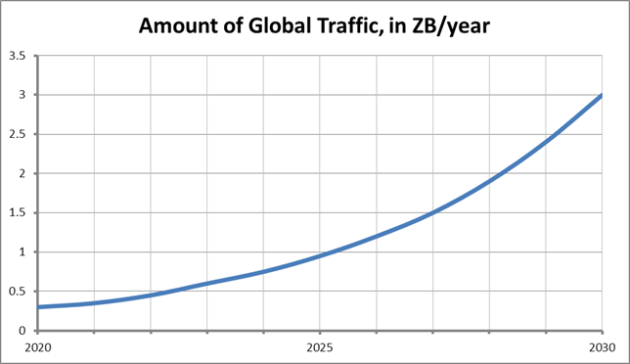

## 5.3 Estimation 3[23]

Figure 12 shows another study forecast as a combined plot of the actual and forecasted global mobile data traffic growth for the time periods 2010–2013 and 2014–2030, respectively. The cumulative compound annual growth rate (CAGR) relative to 2010 was depicted. For the time period 2010–2018 the actual and forecasted CAGR values provided in the “CISCO Visual Networking Index: Global Mobile Data Traffic Forecast Update” white papers are shown in the bar plots16.

Figure 12

Forecast from a study for global mobile broadband traffic growth for the period 2010 – 2030

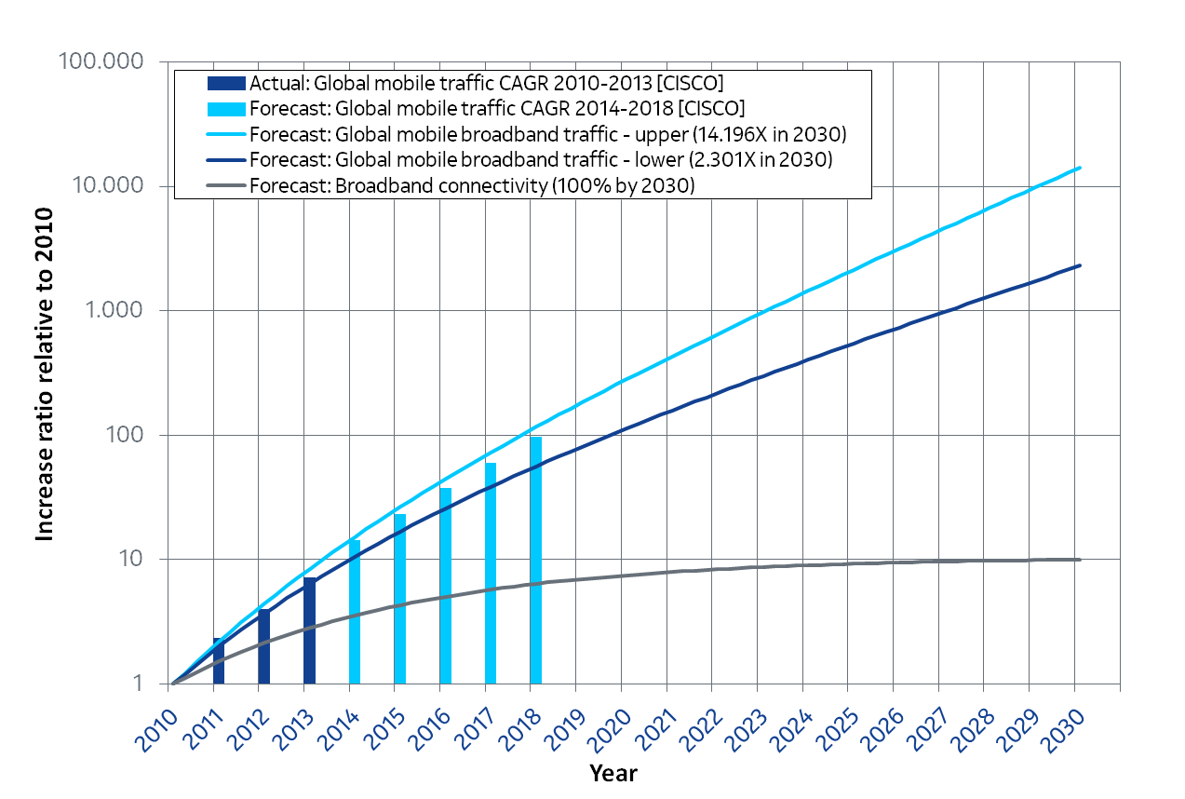

The forecast model used in this study for mobile broadband traffic for the entire time period 2010‑2030 (blue lines) were based on the combination of three factors:

– total subscription base (includes broadband and voice/SMS subscriptions) growth of 15% for ‘upper’ (light blue line) or 5% for ‘lower’ (dark blue line) forecast per year;

– broadband connectivity penetration in the subscription base to reach 100% by 2030 (grey line); and

– subscription traffic growth of 25% per year (not shown, but incorporated in the blue lines).

In this forecast, the broadband connectivity penetration models the uptake of broadband services (i.e. switch to a broadband subscription) relative to the total number of subscriptions and mathematically is modelled with an S-curve. The 100% broadband connectivity penetration reached by 2030 corresponds to a growth of 10-times in number of broadband subscriptions compared to 2010. The constant 25% per year growth in broadband traffic per subscription is motivated by the observed general (not only wireless) technological evolution during the past decades. Therefore the total number of broadband subscriptions is given by the multiplication between the broadband connectivity penetration curve (grey line) and the 5% or 15% per year subscriber base growth.

The resulting traffic forecasts indicate a global growth between 2 300-times or 14 000-times from 2010 to 2030. The ‘lower’ and ‘upper’ forecasts assumed the possible scenarios without and with machine type communication included, respectively.

Figure 13 shows the same study forecasts for mobile broadband traffic growth as in Fig. 12, only for the time period 2020 – 2030 (relative to 2020) and indicates a global growth between 26-times and 70-times from 2020 to 2030.

Figure 13

Forecasts from the same study for global mobile broadband traffic growth for the period 2020–2030

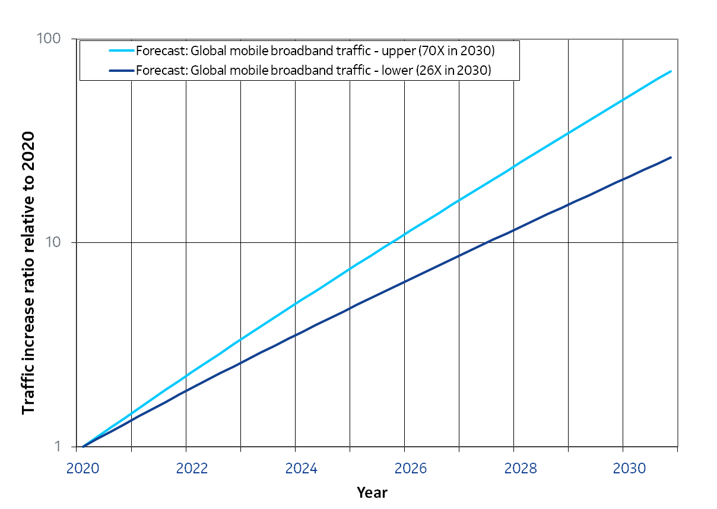

Annex 2 provides country-specific information concerning both mobile subscriber estimations and mobile traffic forecasts for certain country.

# 6 Traffic asymmetry

## 6.1 Description of traffic asymmetry

Asymmetry is the difference between the average amount of traffic in the uplink and the downlink direction. Average traffic asymmetry is dependent upon a range of factors including the:

− nature of each application (web-browsing, voice, streaming, etc.) in terms of average up and down link traffic;

− average mix of applications according to each category of device (mobile, smartphone, tablet, laptop) and subscription generation;

− mix of device type per generation (i.e. IMT-2000 smart phone vs. IMT-Advanced smart phone.

Furthermore, all of these factors are expected to evolve over time and will be strongly dependent upon cultural differences between different countries, the impact of operator tariffing strategy on subscriber behaviour, migration toward next generation technologies, macro-economic factors impacting ability to pay for advanced end-user devices and subscription packages, etc. These factors are expected to result in a wide range of observed traffic asymmetry rates across different countries, radio access technology generations and over time.

In recent years the uplink-downlink asymmetric usage of the mobile service has increased significantly. The introduction of mobile broadband has made it possible for users to apply the same behaviour as they did with fixed broadband. This has resulted in many asymmetric applications finding their way into the mobile networks.

The DL dominates with around 80-90% of data traffic while UL contributes around 20-10%. This is based on the lowest traffic asymmetry ratio where UL/DL is 1/4 that corresponds to 80% (DL) = 4x20% (UL) over 100% traffic with UL+DL. As video content increases, it is estimated that the proportion of DL content will grow even further in the near future.

When considering traffic asymmetry, applications can be grouped into different categories, such as:

− **Bi-directional**: point-to-point (P2P) applications (file sharing, P2P media), email, instant messaging, voice-over-IP (VoIP), video conferencing, etc. These applications generate, on average similar amounts of uplink and downlink traffic volumes: emails and instant messages are both sent and received; shared files are both uploaded and downloaded, etc. The high UL/DL ratio of unknown traffic hence implies that most of this traffic probably comes from either P2P applications or VoIP and videoconferencing applications.

− **Request-response**: social networking, web browsing, etc. These applications have a typical request - response communication pattern where requests (uplink) are typically much smaller than responses (downlink). It is interesting to note the significantly higher uplink traffic ratio for social networking. Social networking is not only focused on viewing existing content, but users also actively contribute to create content; therefore average "request" sizes are larger than for web browsing.

− **Download dominated**: software update and download, online video, online audio, web TV, etc. These applications are practically download only. The 2-3% uplink ratio is mainly due to TCP ACK packets in uplink direction as well as small requests in uplink preceding software or media downloads.

## 6.2 Examples of traffic asymmetry

Figure 14 shows the ratio of the uplink traffic to total traffic. The colour changes indicate a range, based on actual measurements, with the darkest portion indicating the average split amongst the measured networks. For example, looking at “file sharing”, the ratio (of uplink traffic to total) could vary between less than 15% to over 30%, depending upon the network measured. It should be noted that the measurements are made at the IP layer, not the radio layer.

Figure 14



Also Tables 10 and 11 depict the UL/DL traffic distribution for specific types of applications.

TABLE 10

UL/DL traffic distribution over different applications[24]

|  |  |  |
| --- | --- | --- |
| Services | % downlink | Source |
| Web browsing/e‑mail | 80%  90% | [25], [26] |
| Video | 98%  80-92% | 25, 26 |
| VoIP and IM | 50% | 25 |
| File sharing | 80% | 25 |
| Other | 60% | 25 |
| Interactive service[27] | 72% | 26 |

TABLE 11

Traffic distribution over different applications[28]

|  |  |  |  |
| --- | --- | --- | --- |
| Services | Year | Value in PB/month | % of global traffic  in 2014 |
| Video | 2014 | 1 400 | 43% |
| Other | 2014 | 540 | 17% |
| Social networking | 2014 | 420 | 13% |
| Web browsing | 2014 | 290 | 9% |
| Encrypted | 2014 | 210 | 6% |
| Software download & update | 2014 | 200 | 6% |
| File sharing | 2014 | 130 | 4% |
| Audio | 2014 | 70 | 2% |

## 6.3 Traffic asymmetry volumes in recent years

Data continues to be a major area of growth for mobile operators as emphasized in Report ITU‑R M.2038, which says that “in broadband multimedia communications, asymmetric traffic is envisaged to be dominant”. A GSMA Report[29] confirms this trend, saying that in September 2013, 75% of the data traffic of one of the major mobile network operators in Europe was video streaming and internet browsing.

Table 12 shows the data traffic volume measured in Japan in September 2014[30].

TABLE 12

Statistics on mobile network traffic in Japan (data only, December 2014)

|  |  |  |  |
| --- | --- | --- | --- |
| Measured traffic data rate | Uplink | Downlink | UL/DL ratio |
| Average data traffic rate counted on GGSN/EPC per month (Increase from the last year) | 114.3 Gbps  (+75%) | 757.5 Gbps  (+45%) | 1/6.6 |
| Average data traffic rate per subscription per month (Increase from the last year) | 693.9 bps  (+57%) | 4 599 bps  (+31%) | 1/6.6 |

These values are averages per month over all hours.

Data for China[31] shows traffic asymmetry ratios of between 1/4 and 1/6 in favour of DL. It should be pointed out that the uplink-downlink traffic asymmetry ratio given in Table 12 is data only, voice traffic is not included. This range is similar for particular operators in different countries (USA, Japan and Europe) in 201024.

An additional example comes from a study provided by one European Operator[32] as depicted in Fig. 15. The Figure shows specifically how the ratio between uplink and downlink in a LTE network has evolved in recent years. It is important to note that in only two years (from 2012 to 2014), the difference between the uplink and downlink traffic has increased from 1/2 to 1/10. As in Table 12, here again only data traffic is considered, voice traffic is not included, except for VoIP in applications such as Viber, Skype, etc. This operator claims that for other markets, the development of traffic is similar, but the timing (year/week) can differ slightly.

Figure 15

Examples: Asymmetry in the mobile network in Sweden from 2012 to 2014 (week 37)

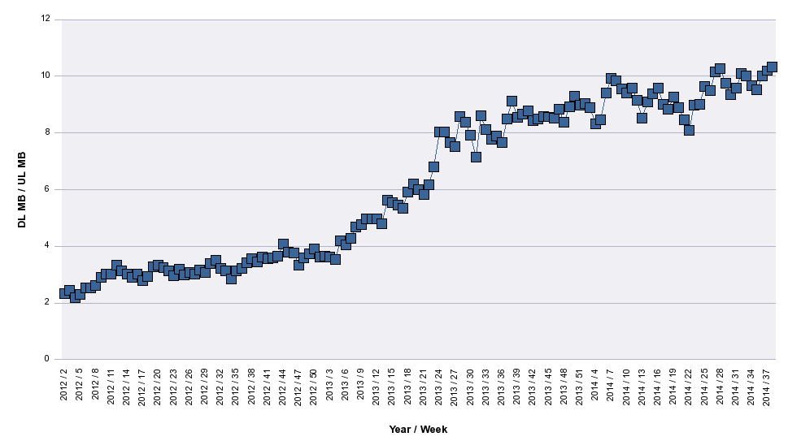

In summary, the ratios provided by different sources are more or less similar.

## 6.4 Traffic asymmetry estimation to 2024

The following Figures depict this trend for the period to 2024 and confirm that the traffic asymmetry value is in the range of 1/7-8 in favour of DL[33].

The results are based on a long term network growth model which uses the assumption that devices and user behavior may be modeled as a set of three profiles (“simple”, “smart” and “large”)[34] and that the evolution in device type mix and migration between successive generations is driven by a combination of statistical information and a given country’s macro-economic data. The results are provided here for information and should not be considered to be indicative of any particular operator.

Figure 16 shows the expected migration of the subscription base and the corresponding change in device-type mix, reflecting the tendency for high-end device owners to migrate more rapidly to next generation systems, Figs 17A and 17B show the corresponding estimate for per user traffic in down and up link directions; and, finally, Fig. 18 shows the corresponding estimate for UL/DL traffic asymmetry ratio.

It has to be noted that Fig. 16 gives the distribution of the subscriber per device type and generation with respect to the year, which is combined with a corresponding set of traffic models to derive the overall uplink and downlink as depicted in Figs 17B and 18. It should also be noticed that traffic curves stopping in 2016 for GSM correspond to specific modelling data for the example operator.

Figure 16

Example operator subscriptions migration and corresponding device type mix

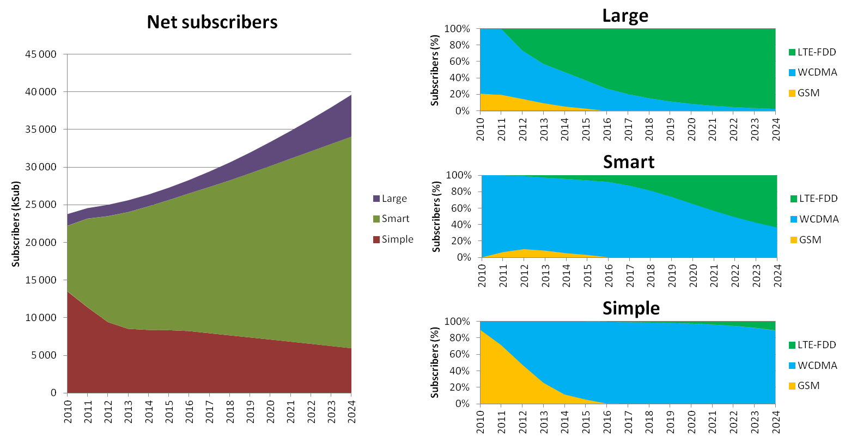

Figure 17A

Example operator per user average busy hour downlink traffic (bit-rate in kb/s)

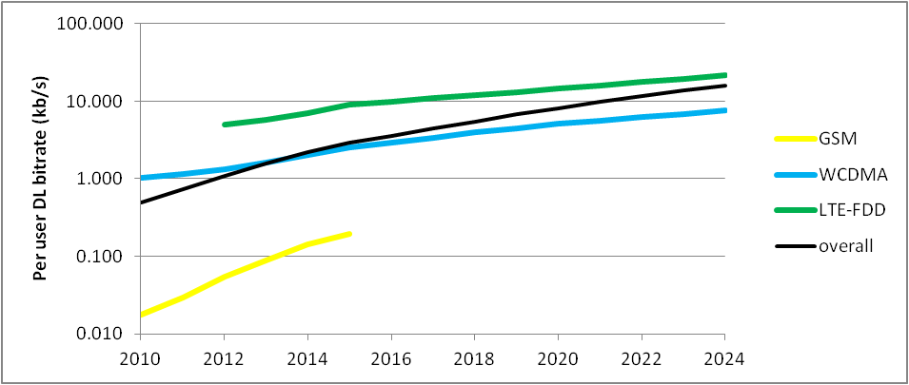

Figure 17B

Example operator per user average busy hour uplink traffic (bit-rate in kb/s)

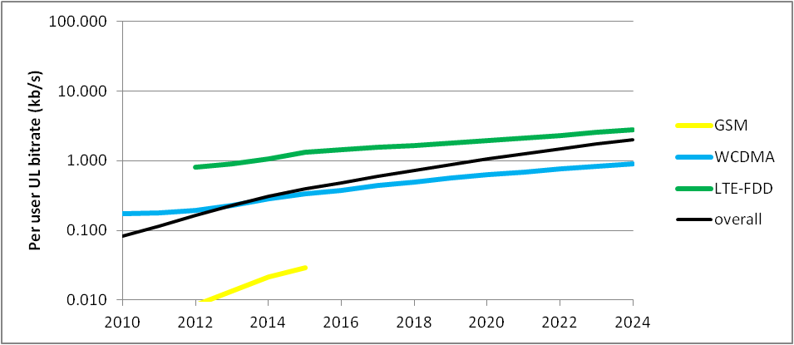

Figure 18

Example operator average traffic asymmetry

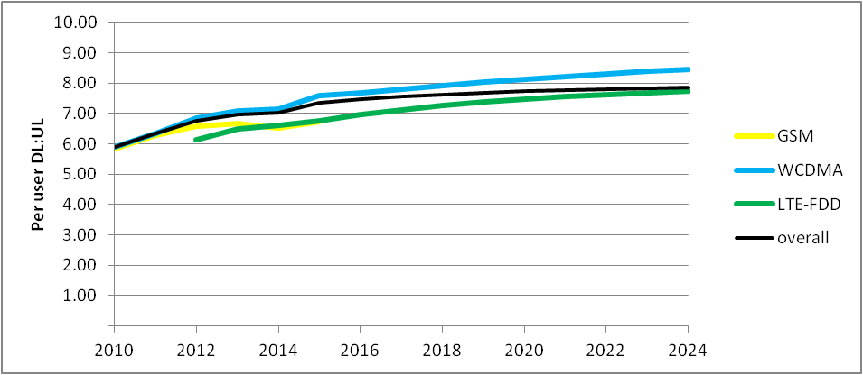

## 6.5 Traffic asymmetry analysis in the space and time domains

The behaviour of traffic asymmetry in the space and time domains needs to be well understood as well, which refers to the distribution of traffic asymmetry in the space and time domains. It has two aspects:

− The traffic asymmetry distribution in the space domain refers to the traffic asymmetry ratio at different geographical regions.

− The traffic asymmetry distribution in the time-domain refers to the traffic asymmetry ratio at a specific region in different time instances.

Since the traffic asymmetry would be highly dependent on the specific application employed by a subscriber as shown in Fig. 14, it is foreseen that the space and time domain behaviour of traffic asymmetry would be impacted by the subscriber behaviour significantly, whereas the subscriber behaviour includes the geographical distribution of the subscribers, subscriber’s mobility behaviour and application usage behaviour, etc.

It is noted that the total traffic asymmetry ratio in a specific region is defined by the ratio of the summation of each subscriber’s DL traffic relative to the summation of their UL traffic in that region. Therefore the traffic asymmetry in different geographical regions is related to the subscriber geographical distribution (namely the subscriber density in the specific region) and the subscriber’s application behaviour which defines the traffic asymmetry of each subscriber. In current networks, subscribers are distributed unevenly in the network coverage. It implies that in any given region, the subscriber density would be different. On the other hand, different subscribers would have different application usage behaviours, which indicates that at one time instance; different subscribe will invoke different applications, implying different traffic asymmetry for each subscriber. By observing these two aspects of subscriber behaviour, it is foreseen that the total traffic asymmetry ratio in different regions would be different, which suggests non-uniform distributed traffic asymmetry in the space domain.

Further, it is likely that the subscribers are in motion. This implies that the subscriber geographical distribution is uneven at one time instance, and will change in another time instance. In this case the total traffic asymmetry ratio in a specific region would change at different time instances, leading to varying traffic asymmetry distribution in the time domain.

In the forecast, it is foreseen that new applications with more diverse traffic asymmetry would be the case. And the subscriber’s application usage behaviour will become more diverse due to the emergence of many more types of applications. As well, it would be increasingly likely that the subscribers use their applications on the move. By recognizing these factors, it is forecast that the traffic asymmetry distribution would be more uneven both in the space and time domain in the forecast period.

Some examples of subscribers’ traffic profiles are given in Annex 3.

# 7 Conclusions

This Report investigates the trends in the growth of IMT traffic from 2020 to 2030. It describes the many drivers influencing the growth of future IMT traffic such as the adoption of devices with enhanced capabilities that require increased bit-rates and bandwidth, increased video usage, device proliferation and application uptake. Similar drivers increased traffic in the transition from IMT‑2000 to IMT-Advanced.

These drivers are expected to evolve over time, and this evolution will differ between countries due to social and economic differences. These drivers and other trends which impact traffic growth are detailed in the Report.

This Report contains global IMT traffic estimates for the years 2020 to 2030 from several sources. These estimates anticipate that global IMT traffic will grow in the range of 10-100 times over this period. Note that the variations in the forecasted traffic are due to different assumptions used in these studies. Moreover, the Report includes an estimate of national traffic growth of between 50 and 100 times over this period, as depicted in Annex 2.

Traffic asymmetry aspects for this period are also presented in this Report. It is observed that the current average traffic asymmetry ratio of mobile broadband is in favour of the downlink, and this is expected to increase due to growing demand for audio-visual content.

List of acronyms and abbreviations

|  |  |
| --- | --- |
| CAGR | Compound annual growth rate |
| CEE | Central and Eastern Europe |
| DVR | Digital video recorder |
| FBB | Fixed broadband |
| HSPA | High speed packet access |
| IMT | International Mobile Telecommunications |
| LAA | Licensed assisted access |
| LTE/LTE-Advanced | Long term evolution/long term evolution-advanced |
| MBB | Mobile broadband |
| M2M | Machine-to-machine |
| NAR | North American Region |
| OTT | Over-the-top |
| QoE | Quality of experience |
| RAT | Radio Access Technology |
| TCP ACK | Transmission control protocol acknowledgment |
| UL/DL | Uplink/downlink |
| UHD | Ultra high definition |
| UN | United Nations |
| VoIP | Voice-over IP |
| WCDMA | Wideband –CDMA |
| WE | Western Europe |

Annex 1  
  
Examples of basic estimation methods

Some of the estimations used in this Report use a methodology which rests on a combination of analyst projections, in-house estimates and forecasts, and direct data collection. The main statistical data comes from operators, Cisco VNI White Paper and some international consultant companies. Based on historical data and a group of common curve fitting methods, the final results can be estimated.

**Curve fitting:** This method constructs a curve, or a mathematical function, which can best fit a group of data points, possibly subject to constraints. Curve fitting can involve either interpolation, where an exact fit to the data is required, or smoothing, in which a "smooth" function is constructed that approximately fits the data. The fitted curves can be used as an aid for data visualization, to infer values of a function where no data is available, and to summarize the relationships among two or more variables.

**S-curve:** This method describes a sigmoid function, which is a mathematical function that produces a sigmoid, or "S"-shaped, curve. It is mostly presented in the classification assessment model or logistic regression model, which is the common method of empirical analysis in sociology, biostatistics, clinical, quantity psychology, marketing and other statistics.

Annex 2  
  
Country-specific information

## A2.1 China

### A2.1.1 Personal device forecast for China

Section 4.2 of this Report includes a global estimation by different terminal types. In this Annex, China-specific information is given. Estimation methods of mobile subscriptions of each terminal type in China was based on the curve fitting and then revised though normalization method based on the estimated result of total mobile subscriptions. Each type of terminal is estimated through S‑curve method separately, with some assumptions on market trends (maximum annual growth of penetration ratio and saturated penetration ratio). The estimated result was finally revised through normalization method based on the estimated result of overall mobile subscriptions in China (with the assumption that the proportion of each type of terminal obtained from respective curve-fitting results is unchanged), see Fig. A2.1. Statistical information provided from current networks of Chinese operators.

Figure A2.1

Estimation of mobile subscriptions in China with different terminal types (2020-2030)

This Figure shows that the number of mobile subscriptions for smartphones in China is estimated to be 2 billion in 2025 and 2.3 billion in 2030. The number of subscriptions for tablets and other smart devices in China is estimated to be 0.7 billion in 2025 and 0.8 billion in 2030. The number of feature phone subscriptions in China is estimated to decrease rapidly between 2020 and 2030.

### A2.1.2 M2M Subscriptions in China

Section 4.2 describes M2M subscriptions on a global basis and provided estimations of M2M subscriptions through 2030. This section again gives similar information for China only. Estimation methods and procedures as well as estimation models and parameters followed the same steps as described in § 4.2, using Chinese population figures instead of global population figures.

M2M subscriptions in China was based on S-Curve method to estimates the penetration ratio of Chinese M2M subscriptions to Chinese population by year 2030, with some assumptions on market trends (maximum annual growth of penetration ratio and saturated penetration ratio).

Statistical information provided by current networks of Chinese operators as depicted in Table A2.1.

TABLE A2.1

|  |  |  |  |
| --- | --- | --- | --- |
| Years | 2011 | 2012 | 2013 |
| M2M subscriptions in China (million) | 20 | 34 | 50 |

Figure A2.2 shows the estimates of M2M subscriptions in China in 2020-2030.

Figure A2.2

Estimation of M2M subscriptions in China

It is estimated that the number of M2M subscriptions in China will be 1.5 billion in 2020 and 22.7 billion in 2030.

### A2.1.3 Estimates of mobile subscriptions in China

For the estimation of mobile subscriptions in China, the estimation method and procedures were similar to what was provided above for global estimations in the previous sub-section, using Chinese population. Estimation model and parameters exploited the statistical information provided by China Statistical Yearbook[35], as depicted in Table A2.2. The total number was estimated through S-curve method, with some assumptions on market trends (maximum annual growth of penetration ratio and saturated penetration ratio).

TABLE A2.2

|  |  |  |  |  |  |  |  |  |
| --- | --- | --- | --- | --- | --- | --- | --- | --- |
| Years | 2005 | 2006 | 2007 | 2008 | 2009 | 2010 | 2011 | 2012 |
| Penetration ratio of mobile subscriptions in China | 30.1% | 35% | 41% | 48% | 56% | 64% | 73% | 83% |

Figure A2.3 illustrates the estimation of mobile subscriptions in China in 2020-2030.

Figure A2.3

Estimation of mobile subscriptions in China

### A2.1.4 Mobile traffic estimations in China

China provided mobile traffic estimation results in a similar way as described in § 5.1 based on the methodology described in the same section.

Statistical information (Table A2.3) was provided by statistical report of MIIT, China.

TABLE A2.3

|  |  |  |  |  |
| --- | --- | --- | --- | --- |
| Years | 2010 | 2011 | 2012 | 2013 |
| Mobile traffic in China(TB/Month) | 32628 | 44837 | 62778 | 96369 |

The growth rate of mobile traffic in China is estimated to be higher than the global average growth rate. It is foreseen that the mobile traffic will be 118EB per month in 2025 and 1187EB per month in 2030 as depicted in Fig. A2.4.

In addition Fig. A2.5 provides estimations of mobile traffic from 2020-2030 with the M2M traffic.

Figure A2.4

Estimation of mobile traffic in China in 2020-2030 (M2M traffic not included)

FIGURE A2.5

Estimation of mobile traffic in China in 2020-2030 (M2M traffic included)

The growth rate of mobile traffic (including M2M traffic) in China was estimated to be higher than the rate of global average. It was estimated that the mobile traffic will be 133 EB per month in 2025 and 1380 EB per month in 2030 as depicted in Fig. A2.5.

Similarly, Fig. A2.6 shows the Chinese case for the estimation of mobile traffic consumed per subscription per month using the same methodology as described above using Chinese mobile subscriptions and mobile traffic values in China without M2M.

Figure A2.6

Estimation of mobile traffic consumed per subscriptions per month in China in 2020-2030  
(M2M not included)

This Figure shows that mobile data traffic consumed per subscription per month in China is estimated to reach 42.8 GB in 2025 and 390.7 GB in 2030.

### A2.1.5 Mobile traffic estimation in large cities or hot-spot areas

Concerning mobile traffic in big cities, estimation method provided by China was based on historical statistics coming from Chinese operators’ networks in several typical big cities, such as Shanghai and Beijing. The exponential function was selected as the fitting curve to get the estimated result. Statistics of Shanghai are given as an example, as seen in Table A2.4.

TABLE A2.4

|  |  |  |  |  |  |  |
| --- | --- | --- | --- | --- | --- | --- |
| Year | 2008 | 2009 | 2010 | 2011 | 2012 | 2013 |
| Mobile traffic in Shanghai, China (TB/month) | 229.1 | 608.8 | 1216.5 | 1785.6 | 2794.0 | 3393.2 |

Mobile traffic in hot-spot areas:

1) Statistical data collection on typical hotspots like Xidan[36] Area in Beijing, historical data provided by current networks of Chinese operators.

2) Estimate the subscriber density in Xidan area from 2020 to 2030 with assumption on the [annual growth rate](http://dict.cn/annual%20rate%20of%20growth).

3) Adopt the estimated result of mobile traffic consumed per subscriptions per month in China (see § 4.1).

Estimate the mobile traffic in Xidan area with some assumptions of BHA (busy hour aggregating ratio) and other parameters (based on the experience of 2G and 3G network in China).

It was estimated that with the mobile traffic of typical large cities like Shanghai, China will increase 125 times from year 2020 to 2030. With the mobile traffic consumed within typical hot-spot area traffic like Xidan, Beijing will increase 154 times from year 2020 to 2030, as depicted in Fig. A2.7.

Figure A2.7

2020-2030 mobile traffic growth factor comparison in typical city and district

## A2.2 Republic of Korea

### A2.2.1 Impact of IMT-Advanced on traffic growth

In recent years, mobile markets have become highly competitive and subscribers expect a high quality user experience, as well as continuous enhancements to their services. Mobile network capabilities are the key enabler to support the required factors such as user experience and the increase in mobile data traffic. This section provides an overview of the present mobile market and its statistical data such as subscriptions and traffic by deployment of IMT-Advanced networks.

Since ITU-R approved two technologies, LTE-Advanced and Wireless MAN-Advanced, as IMT‑Advanced technologies in 2012, mobile operators have been accelerating the deployment of LTE and LTE-Advanced networks to fulfill the rapidly growing demands by their customers for mobile data services. In general, IMT-Advanced connections today are generated by smart devices supporting a higher average data usage. Moreover, higher data rates encourage the adoption and usage of wide bandwidth applications, such that smart devices over IMT-Advanced networks are likely to generate nearly three times more traffic than the same model smart devices over IMT-2000 networks as explained in the following sub sections.

Likewise, the increase in mobile data traffic and in the connected number of devices shows a steady growth and is now challenging the capacity of existing IMT networks. With respect to the trends of mobile market caused by IMT-Advanced networks, it is important to take into account the impact of future IMT technologies before estimating the IMT traffic in the future. For instance, the following sub sections show the mobile trends based on the real and historical data in one country.

### A2.2.2 Mobile subscriptions by technologies

Figure A2.8 shows the accumulated mobile subscription data by deployed network systems from 2009 to present (as of Oct. 2014) in Korea[37]. Total mobile subscriptions in 2014 are around 57 million so that the mobile penetration reached 116 percent in 2014.

Figure A2.8

Mobile subscriptions by technologies in Korea (Million)

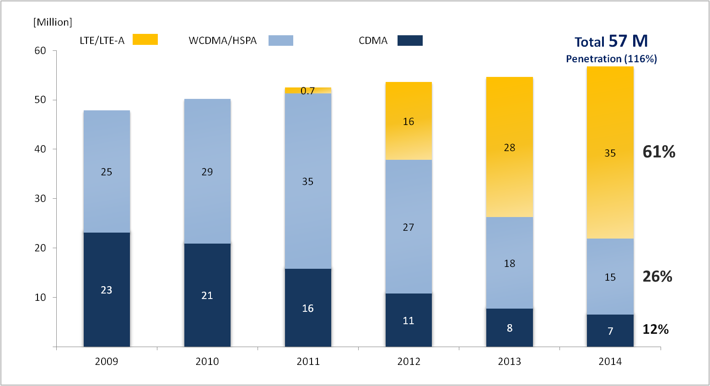

Since firstly launched in 2011, the share of LTE/LTE-Advanced in yellow continues to grow rapidly and has reached 61% of total mobile subscriptions in 2014. However, for WCDMA/HSPA (in light blue) the net number of subscribers has continued to decrease after the year 2011 when LTE was launched. At the same time, the number of CDMA subscriptions has shrunk steadily.

### A2.2.3 Mobile traffic by technologies

Figure A2.9 below shows total monthly mobile data traffic in Korea. It depicts a trend of LTE/ LTE‑Advanced data traffic growth with a goodly portion of the total traffic while depicting a decrease in the portion of WCDMA/HSPA. Total data traffic in 2014 marked around 230 times more than in 2009.

Figure A2.9

Mobile traffic by technologies in Korea (TB/month)

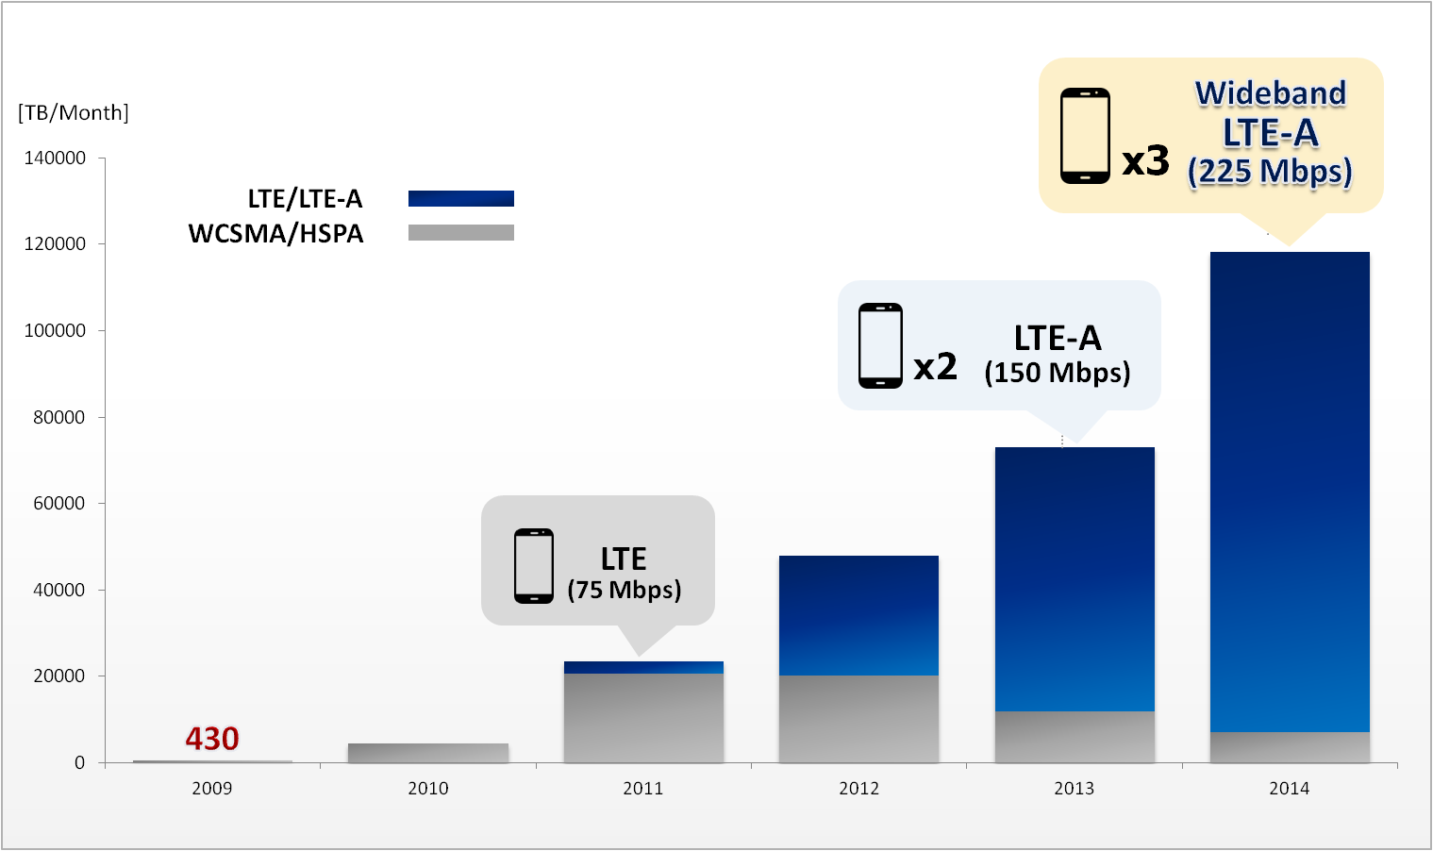

As mentioned in the previous section, the mobile operators launched LTE networks in July 2011. Operators have sequentially deployed advanced LTE networks, so called LTE-Advanced (150 Mbps) and Wideband LTE-Advanced (225 Mbps) in terms of Korean market, in June 2013 and June 2014 respectively in order to meet user demands.

In addition, the deployment of these advanced networks has resulted in an increase in the average monthly traffic volume per smartphone subscriber as shown in Fig. A2.10.

Figure A2.10

Average traffic volume per smartphone subscriber by technology in Korea (MB/month)

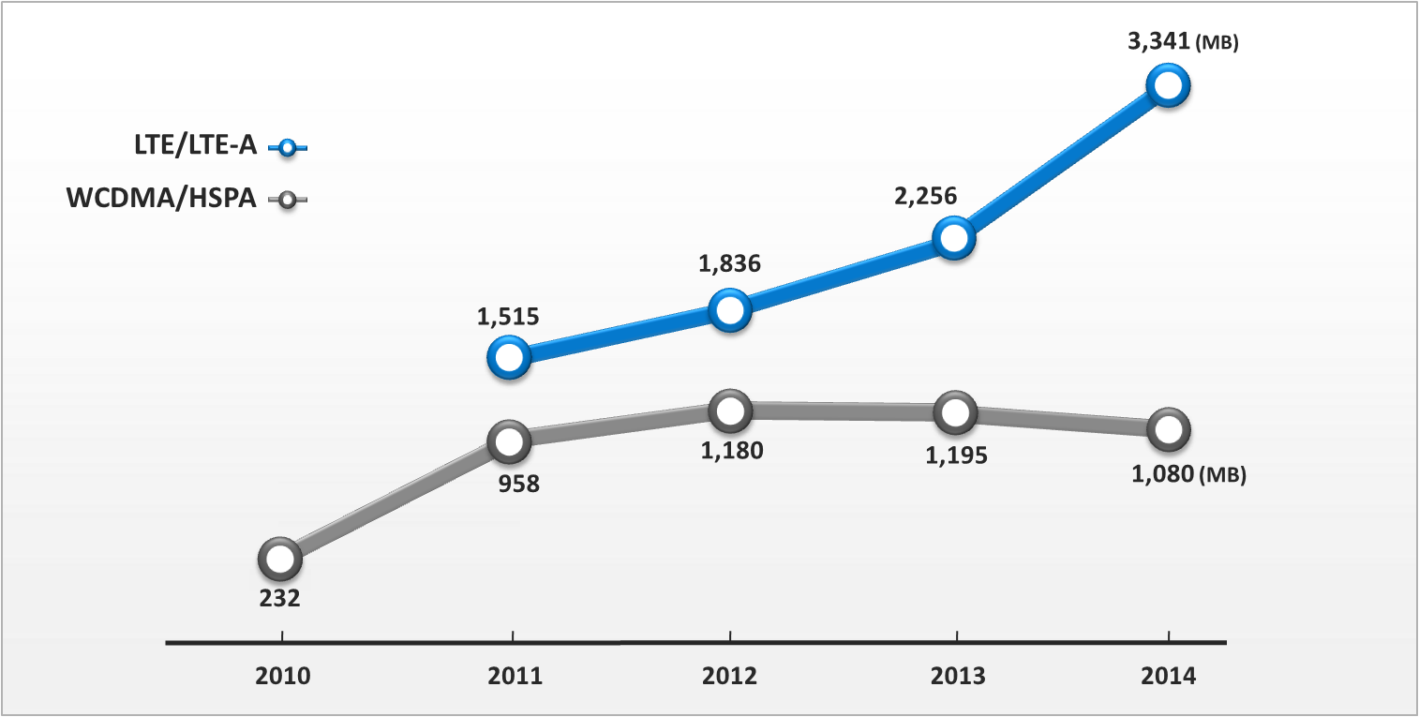

At the end of 2014, the average traffic volume per smartphone subscriber reached 2.1 GB per month. At that time, a 4G smartphone subscriber consumed around 3.34 GB per month while a 3G‑smartphone subscriber consumed 1 GB. By analogy with Fig. A2.10, LTE/LTE-Advanced connections supporting higher data rates than WCDMA/HSPA networks encourage the adoption and usage of wide bandwidth applications and the subscribers enjoy more time connected with their devices. With IMT-Advanced (LTE/LTE-Advanced) networks becoming widely available, the gap between IMT‑2000 (WCDMA/HSPA) and IMT-Advanced is likely to widen in the future.

Annex 3  
  
Some examples of subscribers’ traffic profiles

In terms of subscriber’s geographical distribution (a type of space-domain subscriber behaviour), one can see that, typically, subscribers are quite unevenly distributed in geographical areas. 80% of the French population lives on less than 20% of the geographical area[38]. Besides, a minimum 80% of the traffic is generated by human communication, thus the network traffic distribution is directly related to the geographical distribution of different subscribers. Field experience shows that 80% of mobile traffic is processed by only 20% of network sites, which implies highly non-uniform traffic distribution in the space domain.

For subscriber behaviour in time domain, it is reported in[39] that smartphones are used more between 8 am and 6 pm, while tablet usage increases slightly after 6 pm. Specifically, in the night period (e.g. 0 – 8 am) less traffic is delivered in the network while in the day period the traffic of different kinds of applications grow, and reach the peak in the time window between 8 pm and 10 pm.

Figure A3.1 shows the daily profiles of the five major mobile applications[40] in North American Region (NAR), namely, streaming (audio and video), computing (cloud processing, office productivity, other mobile applications), storage (media sharing, backup and device synchronisation), gaming (casual, interactive or emerging applications), and communicating (voice, video, e-mail and M2M). All these represent human behaviours and they are similar across geographies. Figure A3.2 depicts the application daily traffic profile in NAR.

Figure A3.1

Traffic Daily Profiles of the Five Major mobile Applications in NAR (2020)



Figure A3.2

Application Traffic Daily Profile in NAR (2020)



The above Figures reveal that in NAR, traffic is heaviest between 7 AM and 11 PM. Video and audio streaming is the biggest category with a busy hour peak in the evening and compared to 2012 statistical information, streaming is becoming an increasingly larger percent of the total demand accentuating the late evening peak (9 PM) and increasing the peak-to-average ratio.

Gaming and communicating show also peaks in the morning as well as evenings, while storage/back-up is strongest at the typically non-busy hours of the day. Computing and other cloud applications show a steady use during the working hours and early evening.

For Western Europe (WE), similar behaviours can be observed as can be depicted in Fig. A3.3. It should be noted that those profiles provide an average view since per country usage varies due to different working hours, meal times and other cultural and socio-economic differences.

Figure A3.3

Application Traffic Daily Profile in Western Europe (2020)



In Central and Eastern Europe (CEE), the average usage of data subscribers is growing fast, catching up with the high levels in NAR and WE. The slight lag and the lack of strong broadband penetration explain the stronger computing component, as seen in Fig. A3.4. It should be noted that this profile represents the whole region (wide variations exist country-by-country).

Figure A3.4

Application Traffic Daily Profile in Central & Eastern Europe (2020)



The other Regions (Latin America, Asia Pacific) show similar patterns.

Another time-related factor which influences subscriber’s traffic profile is important holidays, e.g. New Year eve, in which tremendous traffic increase would be generated due to the traditional celebration activities. For example, data from Global Internet[41] shows that at 12:00 am the application Snapchat accounted for 12% of the one network’s total traffic in NAR, Fig. A3.5.

Figure A3.5

Snapchat traffic distribution in North America region in New Year’s Eve

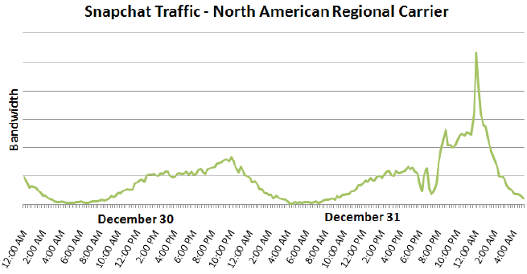

In terms of application usage behaviour, we can also see that each subscriber may have quite different application usage habits. Figure A3.6 [42] illustrates the Chinese case; about 2% subscribers consume more than 50% mobile traffic, while on the contrary, 80% subscribers generate less than 10% traffic. In the meantime, subscribers may change the application in different time periods, which is already shown in Figs A3.2 to A3.4. Such behaviour observed would also lead to non-uniform and varying traffic volume, as well as asymmetry distribution, both in the space and time domain.

Figure A3.6

Subscriber and traffic distribution

NOTE 1 – **Subscriber ratio** means the number of subscribers that consumes specific amount of data (in busy hour) relative to the total number of subscribers. For example, the blue bars for “0‑1K” means the number of subscribers that consumes 0-1K bytes is 17% compared to the total number of subscribers.

NOTE2 **–** **Traffic ratio** means the traffic amount of the subscribers that consumes specific amount of data, relative to the total amount of traffic. For example, the red bars for “1M-10M” means the traffic amount of subscribers that consumes 1M-10M bytes is 38% compared to the total traffic amount.

Annex 4  
  
Traffic characteristics of future applications supported by IMT[43]

## A4.1 Introduction

Future IMT is envisaged to support an increasingly diverse range of use cases, greater than for IMT‑Advanced, which will require a wide range of capabilities. Recommendation ITU-R M.2083-0 describes the key capabilities of IMT-2020, and gives an overview of their importance in some usage scenarios. However, the values needed for these capabilities differ from scenario to scenario, to serve diverse use cases.

This Annex considers the traffic characteristics and other capabilities for a wide range of use cases. These use cases have been merged into five groups of related applications that have similar needs in terms of traffic characteristics and other capabilities:

• Voice and data applications

• Multimedia applications

• Internet of things and machine-to-machine applications

• Ultra-reliable and low latency applications

• New applications

For the first four groups of applications, the capabilities needed have been assessed by predicting the future evolution of current and emerging applications that will need to be supported by future IMT. The fifth group envisages the types of new capabilities that might be needed by IMT in the timeframe of 2020 and beyond (assuming that new Radio Access Technologies (RATs) will need to be developed, but that previous RATs can continue to support some applications).

The three capabilities that directly influence traffic are user experienced data rate, connection density and capacity density. The other five capabilities indirectly influence traffic, because they illustrate capabilities that are needed for various applications of future IMT. These capabilities will have to be supported by future IMT in order for an application to become viable, and therefore generate traffic. For example, for some internet-of-things applications, the IoT devices do not have access to an external power supply and need to operate from a battery for the lifetime of the device. The lifetime of the IMT terminal within the device is therefore important to the viability of this application, and therefore to the traffic generated by the application.

These five groups of applications are described in the following sections. In the diagrams that illustrate them, the red line shows the envelope of the ‘core’ set of capabilities for the group of applications, and the symbols show differences for individual applications.

## A4.2 Voice and data applications

Mobile Broadband is the human centric use case for access to services and data, anytime and anywhere. The demand for MBB will continue to increase, with new application areas and a demand for improved performance and an increasingly seamless user experience. This includes the evolution of IMT-Advanced scenarios. Potential new applications include infotainment, mobile gaming, augmented reality and work in the cloud.

Many aspects of the internet of things are effectively data, and need similar capabilities (the aspect with a massive number of devices is addressed in § A4.4).

FIGURE A4.1

Capabilities envisaged in this study for current and emerging voice and data applications

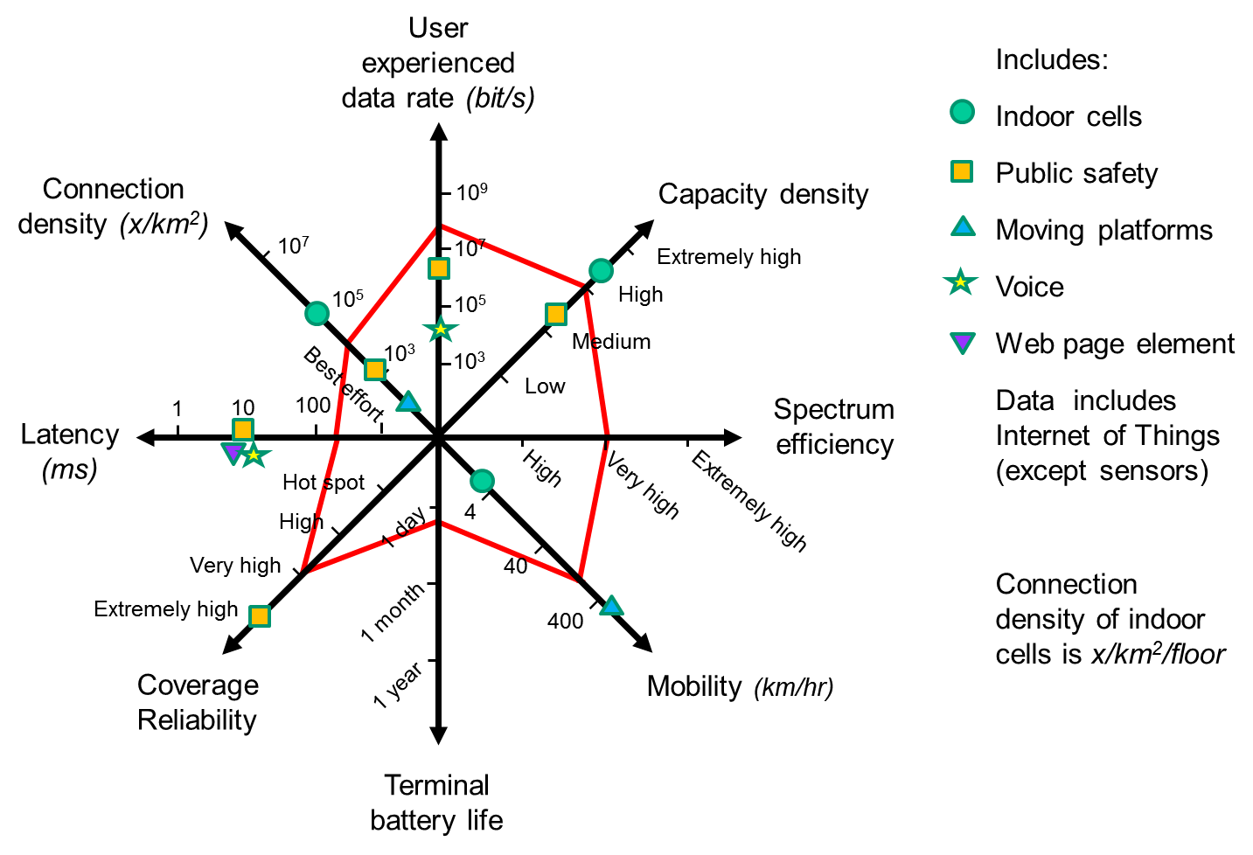

## A4.3 Multimedia applications

It is expected that there will be increasing demand for high definition media (possibly including UHD video and immersive games) displayed on mobile devices, as applications for mobile high definition media may go well beyond entertainment and could include augmented reality, video conferencing, medical treatment, safety and security.

FIGURE A4.2

Capabilities envisaged in this study for current and emerging multimedia applications

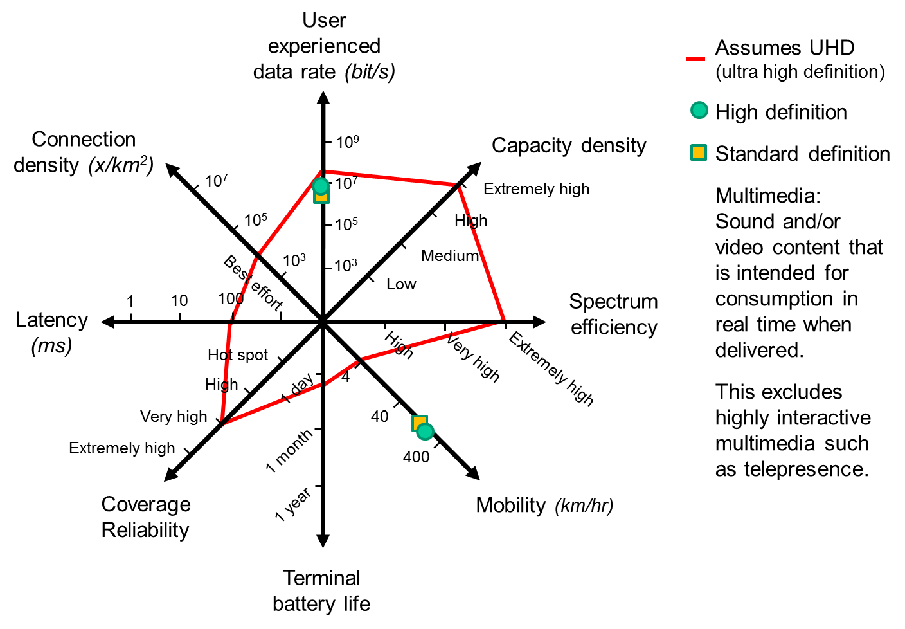

## A4.4 Internet of things and machine-to-machine applications

Some ‘internet of things’ and machine-to-machine applications are characterized by a very large number of connected devices typically transmitting relatively low volume of non-delay-sensitive data. These devices are required to be low cost, and have a very long battery life.

In the future, a large proportion of these devices will be connected to networks and to each other by wireless technologies.

FIGURE A4.3

Capabilities envisaged in this study for emerging Internet of Things sensor and actuator applications

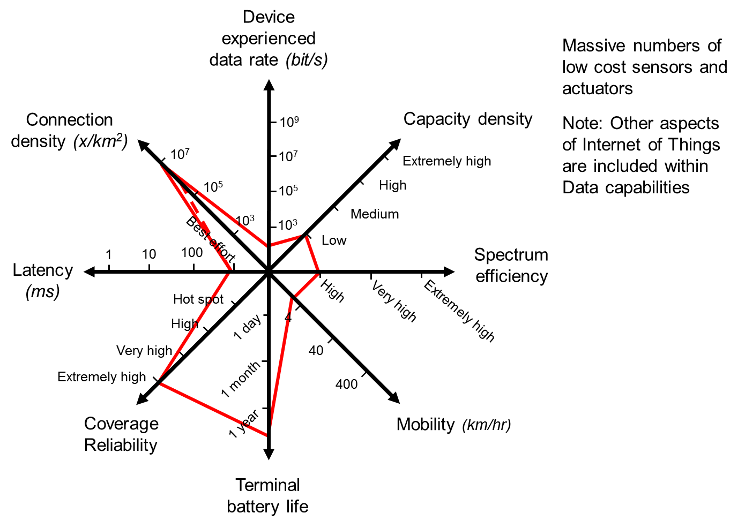

## A4.5 Ultra-reliable and low latency applications

In this use case, communication links between machines are required to have a precisely defined behaviour in terms of important KPIs such as guaranteed throughput, latency, etc. Examples include:

• wireless control of industrial manufacturing or production processes, distribution;

• automation in a smart grid;

• Automotive safety: driverless cars, machine (car) user, communicating with other vehicles and infrastructure for e.g. safety purposes;

• Ultra-Reliable Communication: includes remote control of machines, mission critical applications or e-health;

• Public Protection and Disaster Relief (PPDR) communications.

Reliability relates the capability to provide a given service level with high probability that a system or service will perform a satisfactory manner for a given period of time.

FIGURE A4.4

Capabilities envisaged in this study for emerging mission critical and low latency applications

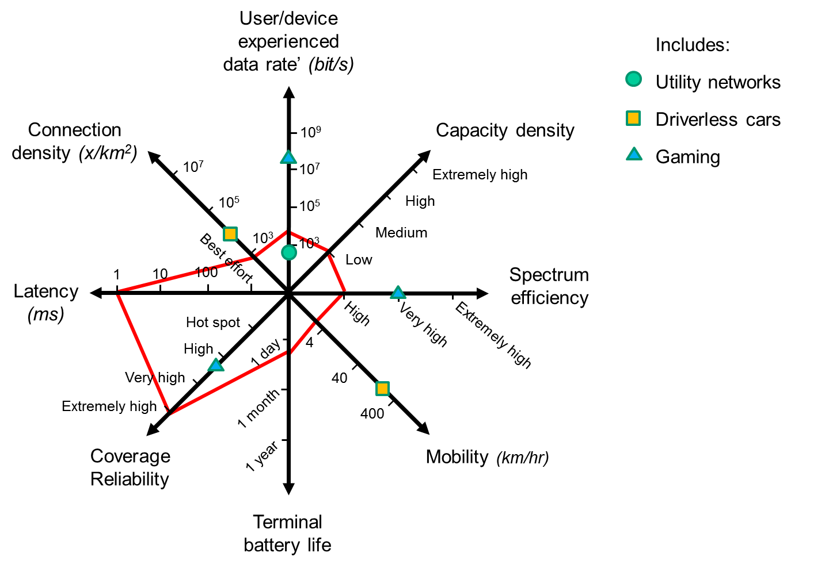

## A4.6 New applications

Additional new use cases will emerge, which are not foreseen in detail today. This will require flexibility for future IMT to adapt to new use cases with a wide range of requirements on the key capabilities.

FIGURE A4.5

New capabilities envisaged in this study for Future IMT for 2020 and beyond

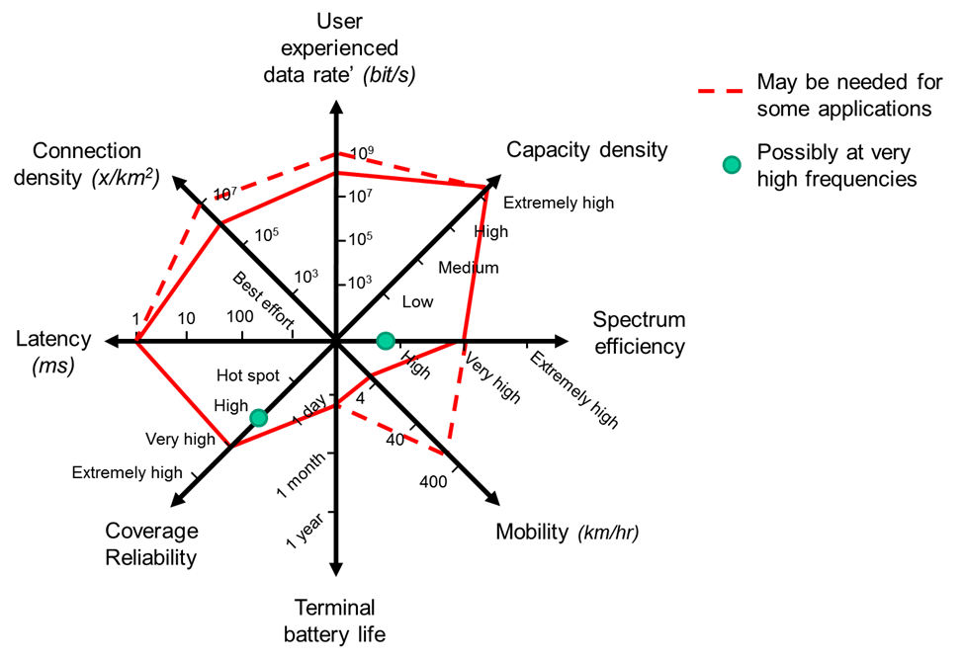

1. GSMA Intelligence, April 2015, <https://gsmaintelligence.com> .
2. In this report, Mobile Broadband (MBB) refers to devices using technologies that can offer at least IMT capabilities.
3. “The State of Broadband 2014: Broadband for all”, A Report by the Broadband Commission, 21 September 2014, page 19. <http://www.broadbandcommission.org/Documents/reports/bb-annualreport2014.pdf> .
4. The use of the term IMT-2020 will be defined by an appropriate ITU-R Resolution by the Radiocommunication Assembly 2015.
5. J.P. Bonin, C. Evci and A.L. Sanders, “ Securing Spectrum through the ITU to fuel the growth of next generation Wireless technologies ” Alcatel-Lucent Bell Labs Technical Journal (BLTJ), 18(2), September 2013, <http://onlinelibrary.wiley.com/enhanced/doi/10.1002/bltj.21607/> .

   This document can be obtained upon request from the Radiocommunication Bureau.
6. Global Smartphone Market Analysis and Outlook: Disruption in a Changing Market, [www.ccsinsight.com](http://www.ccsinsight.com), June 2014.
7. Gartner (September 2013), <http://www.gartner.com/newsroom/id/2592315> .
8. Quality of experience (QoE) measures total system performance using subjective and objective measures of customer satisfaction. It differs from quality of service (QoS), which assesses the performance of hardware and software services delivered by a vendor under the terms of a contract.
9. DigiWorld yearbook by IDATE: key indicators of the digital economy, November 2014, <http://www.idate.org/en/Forum/DigiWorld-Yearbook_40_.html> .
10. Over-the-top content (OTT) refers to delivery of audio, video and other media over the Internet without a multiple-system operator being involved in the control or distribution of the content. The provider may be aware of the contents of the Internet Protocol packets but is not responsible for, nor able to control, the viewing abilities, copyrights, and/or other redistribution of the content. OTT in particular refers to content that arrives from a third party, such as Dramatize, DramaFever, Crackle, Hulu, myTV, NetD, Netflix, NowTV or WWE Network, etc.
11. The four approaches are not mutually exclusive, but are complementary.
12. GeSI SMARTer 2020 Report on “The role of ICT in driving a sustainable future”, December 2012, [http://gesi.org/SMARTer 2020](http://gesi.org/SMARTer%202020).
13. Licensed Assisted Access (LAA) will enable LTE in licence-exempt spectrum in a licensed assisted manner, and coexists successfully with other licence-exempt applications.
14. Ericsson Mobility Report, November 2012.
15. Communication Statistics: <http://internetlivestats.com/one-second/>, June 2015.
16. Cisco Virtual Networking Index : Global Mobile Data Traffic Forecast Update, 5th. February 2015. [http://www.cisco.com/c/en/us/solutions/collateral/service-provider/visual-networking-index-vni/  
    white_paper_c11-520862.html](http://www.cisco.com/c/en/us/solutions/collateral/service-provider/visual-networking-index-vni/white_paper_c11-520862.html)
17. Estimation provided by China.
18. United Nations, Department of Economic and Social Affairs, Population Division (2013). World Population Prospects: The 2012 Revision, DVD Edition.
19. Estimation provided by Ericsson.
20. Estimation provided by China.
21. Estimation provided by Ericsson.
22. Network capacity units:

    |  |  |
    | --- | --- |
    | Zetabyte ZB=1021 B  Exabyte EB=1018 B  Petabyte PB=1015 B  Terabyte TB=1012 B  Gigabyte GB=109 B  Megabyte MB=106 B  Kilobyte kB=103 B | 1 Zetabyte = 1 000 Exabytes = 1 000 0000 Petabytes  1 Exabyte = 1 000 Petabytes = 1 000 000 Terabytes  1 Petabyte = 1 000 Terabytes = 1 000 000 Gigabytes  1 Terabyte = 1 000 Gigabytes  1 Gigabyte = 1 000 Megabytes |

   
23. Estimation provided by Nokia.
24. Global Internet Phenomena Report: Sandvine-Intelligent Broadband Networks, [www.sandvine.com](http://www.sandvine.com), February 2013.
25. <http://fr.slideshare.net/zahidtg/plum-june2011-benefitsof14ghzspectrumformultimediaservices>
26. <http://www.gsma.com/connectedliving/wp-content/uploads/2013/03/Presentation-5-Madame-Hunag-China-Mobile.pdf> slide 3 for Mobile Broadband Era.
27. A service which provides the means for the bidirectional exchange of information between users or between users and hosts. According to ITU-R M.1224, interactive services are subdivided into three classes of services: conversational services, messaging services and retrieval services.
28. <http://www.ericsson.com/TET/trafficView/loadBasicEditor.ericsson>: data from EMR and Exploration tool in 2014.
29. <http://www.gsmamobileeconomy.com/GSMA_ME_Report_2014_R2_WEB.pdf>, page 18.
30. <http://www.soumu.go.jp/johotsusintokei/field/data/gt010602.pptx> .
31. <http://www.gsma.com/connectedliving/wp-content/uploads/2013/03/Presentation-5-Madame-Hunag-China-Mobile.pdf> slide 3 for Mobile Broadband Era.
32. Source: TeliaSonera AB, 2014.
33. Source: Alcatel-Lucent, 2014.
34. *Simple* profile is a basic voice-only device and it includes all users with pre-paid subscriptions, devices referred to as non-smartphone with limited user interfaces, higher end devices used without data subscriptions and M2M devices.

    *Smart* profile is a generic high-end smart phone with a user interface that encourages data usage.

    *Large* profile covers a wide range of high end devices presenting more traffic per device than smart phones. Examples include handheld devices with a high definition screens, PCs with either built-in cellular data or external USB keys and “Wi-Fi” devices offering local WLAN service with a cellular backhaul.
35. China Statistical Yearbook (2005-2013).
36. The Xidan commercial district is a major traditional commercial area in downtown [Beijing](http://en.wikipedia.org/wiki/Beijing), [China](http://en.wikipedia.org/wiki/China). A large number of merchants gather there, and the daily average volume of the customers is more than 200 000. According to the data collected by Chinese operators, the average density of mobile users in this area could be up to 25 000 users/km2 in busy hour.
37. Ministry of Science, ICT and Future Planning, *Monthly mobile data traffic statistics (Oct. 2014)*, available in Korean at <http://www.msip.go.kr/web/msipContents/contents.do?mId=MTQ2> .
38. UMTS Forum Report: Mobile Traffic Forecast: 2010-2020, Report 44, January 2011.
39. Salesforce marketing cloud, 2014 mobile behaviour report.
40. Source: Bell-Labs, Alcatel-Lucent, 2015.
41. Global Internet phenomena report, Sandvine, March, 2014.
42. Huawei Technologies Co Ltd., MBB insight, 2013.
43. Analysis provided by the United Kingdom.