Report ITU-R RA.2428-0
(09/2018)
Parameters needed for the registration of distributed radio astronomy systems

RA Series
Radio astronomy

Foreword
The role of the Radiocommunication Sector is to ensure the rational, equitable, efficient and economical use of the radio-frequency spectrum by all radiocommunication services, including satellite services, and carry out studies without limit of frequency range on the basis of which Recommendations are adopted.
The regulatory and policy functions of the Radiocommunication Sector are performed by World and Regional Radiocommunication Conferences and Radiocommunication Assemblies supported by Study Groups.

Policy on Intellectual Property Right (IPR)
ITU-R policy on IPR is described in the Common Patent Policy for ITU-T/ITU-R/ISO/IEC referenced in Annex 1 of Resolution ITU-R 1. Forms to be used for the submission of patent statements and licensing declarations by patent holders are available from http://www.itu.int/ITU-R/go/patents/en where the Guidelines for Implementation of the Common Patent Policy for ITU-T/ITU-R/ISO/IEC and the ITU-R patent information database can also be found.

Series of ITU-R Reports
(Also available online at http://www.itu.int/publ/R-REP/en)
Series | Title
BO | Satellite delivery
BR | Recording for production, archival and play-out; film for television
BS | Broadcasting service (sound)
BT | Broadcasting service (television)
F | Fixed service
M | Mobile, radiodetermination, amateur and related satellite services
P | Radiowave propagation
RA | Radio astronomy
RS | Remote sensing systems
S | Fixed-satellite service
SA | Space applications and meteorology
SF | Frequency sharing and coordination between fixed-satellite and fixed service systems
SM | Spectrum management

Note: This ITU-R Report was approved in English by the Study Group under the procedure detailed in Resolution ITU-R 1.

Electronic Publication
Geneva, 2018
© ITU 2018
All rights reserved. No part of this publication may be reproduced, by any means whatsoever, without written permission of ITU.

REPORT ITU-R RA.2428-0
Parameters needed for the registration of distributed radio astronomy systems
(Question ITU-R 252/7)
(2018)
Summary
Question ITU-R 252/7 considers whether the characteristics currently required by the ITU-R for notification of a radio astronomy station are sufficient to adequately describe the new generation of large distributed radio astronomy systems currently coming into operation or under construction. This Report provides a response to this question. It concludes that at this stage no additional or revised characteristics need to be specified other than those already required by Annex 2 of Appendix 4 of the RR in order to ensure their protection in accordance with the Radio Regulations. As a consequence, Question ITU-R 252/7 may be suppressed.

TABLE OF CONTENTS
Page

1 Introduction 3
2 Recent experiences of the registration process 3
2.1 Issues highlighted 3
3 Conclusion 5
Annex 1 – Parameters required for ITU-R registration of stations detailing general characteristics of the satellite network, earth station or radio astronomy station 6
A.1 Identity of the satellite network, earth station or radioastronomy station 6
A.2 Date of bringing into use 6
A.3 Operating administration or agency 6
A.7 Specific earth station or radio astronomy station site characteristics 6
B.6 Radio astronomy station antenna characteristics 7
C.2 Assigned frequency (frequencies) 7
C.3 Assigned frequency band 7
C.4 Class of station and nature of service 7
C.5 Receiving system noise temperature 7
C.13 Characteristics of observations for radio astronomy stations 7
Annex 2 – The experience with registering LOFAR 8
1 Introduction 8
Page
2 Description of LOFAR 8
2.1 LOFAR Core 10
2.2 LOFAR remote stations 10
2.3 LOFAR international stations 11
3 Registration approach 11
3.1 Geographical separation 11
3.2 Substations or beams 11
3.3 Frequency bands 11
3.4 Registration of the stations in the Netherlands 12
3.5 Registration of the stations in other countries 12
4 Issues encountered 13
5 Conclusion 13
Annex 3 – Data provided to the ITU 14

1 Introduction
It is important for administrations operating radio astronomy stations to register them with the Radiocommunication Bureau (RB) of the ITU-R so that the station may benefit from the various protections available in RR footnotes and Recommendations. Annex 2 to Appendix 4 of the RR specifies the characteristics that must be submitted to the BR for the registration of any type of earth station, satellite network or notification of a radio astronomy station. Only a subset of these characteristics is required to notify a radio astronomy station (these have been extracted for the purposes of this Report, and can be found in Annex 1). Many of the characteristics required for notification are conceptually suited to the description of single dish telescopes, which have hitherto comprised the bulk of radio astronomy stations in the MIFR.
Over a number of years, techniques of aperture synthesis in radio astronomy have been developed producing telescope systems consisting of arrays of multiple receptors spaced at carefully calculated distances from each other that may be of the order of tens of metres to tens of kilometres, thus forming a distributed radio astronomy system. Most new ground-based facility radio telescopes are of this type and designs for systems currently in production are set to cover geographical areas that may cross international borders.
When the radio astronomy community started preparing the construction of this new generation of large distributed radio astronomy systems, the question arose whether the characteristics currently required by the ITU-R for notification of a new radio astronomy station may not be sufficient to adequately describe these systems and thus ensure their protection in accordance with the Radio Regulations.
Within the ITU-R this issue resulted in Question ITU-R 252/7, of which decides 1 states that the following question should be studied:
“What parameters should be specified, in addition to, or instead of, those contained in Appendix 4 of the RR, when registering distributed radio astronomy systems that may cover extended areas, in order to ensure their effective protection?”
This Report seeks to provide a response to this question, which can be taken forward.

2 Recent experiences of the registration process
The recent experiences of national administrations with the process of notification of new radio telescopes as distributed radio astronomy systems has been considered. Annex 2 contains a case study which describes the experience of the administration of the Netherlands, which has recently registered the LOFAR radio telescope. LOFAR has its core in the North-Eastern part of the Netherlands, and has remote stations elsewhere in the Netherlands and in several other European countries. It is a good example of a distributed radio astronomy system as characterized in Question ITU-R 252/7.

2.1 Issues highlighted
Most of the characteristics listed in Annex 2 to Appendix 4 of the RR that are required for notification of radio astronomy stations, are straight-forward in nature, either administrative (notifying administration, operator, name of station, etc.) or basic technical (frequency, bandwidth, etc.). However, the distributed nature of the radio telescope systems under consideration and their associated operational features means that some of their characteristics have been found to be more difficult to encapsulate within the current notification process. These are discussed in the following sections, together with the means currently used by the administrations concerned to adequately capture them for the purposes of notification.

2.1.1 Antenna characteristics
It was originally anticipated that the antennas at earth stations being registered or notified (the procedure is not specific to radio astronomy) would be simple parabolic dishes whose physical characteristics could be straight-forwardly described via a small number of standard technical parameters.
In the case of a radio astronomy observatory, the antenna is not necessarily a parabolic dish; and additionally, RAS stations can synthesise beams from a combination of single antennas or groups of antennas not necessarily located in the same geographical area or even covered by the same national administration. Practicalities, particularly of antenna construction, tend to dictate that distributed radio astronomy systems currently fall into two types, largely depending upon frequency of operation.
− Radio telescopes in the VHF and UHF range usually consist of very large numbers of small, fixed individual receptors (part of a current radio telescope nearing production – SKA-Low – aims ultimately for 1 million such receptors). Receptors are grouped into closely spaced collections of a few hundred to form a larger unit. Individual or small groups of these larger units are then placed at carefully calculated positions in relation to each other with distances varying from tens of metres to hundreds of kilometres, and in some cases even more than 1 000 km forming the telescope. Advanced processing techniques are used to achieve pointing. It is envisaged that this technique may also be used for higher frequencies in the future.
− For telescopes operating at frequencies above UHF where parabolic dish antennas offer possibilities for significant gain and additional conventional pointing ability, distributed radio telescopes become a large collection of dishes in a carefully calculated spaced layout with separations that may be tens of metres to hundreds of kilometres.
The issue for the purposes of notification of the RAS station within the ITU-R is how to efficiently describe these widely varying radio telescope systems to ensure adequate protection. However, it has been found that these features of distributed RAS systems can be dealt with within the notification process as it has some in-built flexibility. For the purposes of notification:
− At lower frequencies, the clustering of potentially many thousands of individual small antennas around a central point over an area of diameter of a few kilometres –the ‘core’– can be considered as a single unit and hence notification for this can proceed as a single station. The other parts of the telescope consisting of widely spaced small clusters of units of hundreds of individual receptors can each be considered as a single station.
− At higher frequencies, a cluster of parabolic dishes located around a central point over an area of diameter a few kilometres can be considered as a single unit and hence notification for this area can proceed as a single station. Other parabolic dish elements acting as part of the telescope that are spaced individually at tens or hundreds of kilometres from the core (usually a much smaller number) can each be considered as a single station.
Notification is usually performed utilizing the BR provided software package SpaceCap. When entering data for the appropriate parameter it is possible to add a reference to a full antenna description in the form of a code in the field for the Co-Polar Radiation Pattern Id (B6a). For radio astronomy stations, this code refers to a brief textual description of the overall characteristics which is located in Table 6 of the Preface to the BR-IFIC. When flexibly interpreted in relation to a radio astronomy station, this description may be utilized by administrations to record details covering key information such as number of antennas, effective antenna dimensions, area, etc. If an appropriate code exists in Table 6 of the Preface for the radio astronomy station that an administration wishes to notify, then this can be used. More often, administrations choose to submit an update to the data for their country in Table 6 with their notification, thus providing information for an appropriate new code to be issued by the RB. Detailed information about the ‘Antenna type and dimensions’ and ‘Effective area and angular coverage in azimuth and elevation’ and can be added with an additional electronic file that contains a full technical description of the antenna characteristics being notified.

2.1.2 Location of telescope elements in multiple countries
The notification of a RAS station to be included in the MIFR can only be submitted by the administration of the country in which the station is located. Although this clearly has some significance, in terms of the notification process it is only necessary that the station operator be listed in the appropriate table in the Preface to the BR-IFIC and have an appropriate identification code (i.e. is listed in Table 12B of the Preface under recognized operators for that administration). It is not unusual to have foreign operators registered under an administration’s section of Table 12B in the Preface to the BR-IFIC.

2.1.3 Operational nature of the station being notified
An additional characteristic to be defined within the notification is the type of station and class of observations undertaken by each individual station as notified (e.g. the ‘core’ itself, or a single station equivalent outside the core). The notification process for station ‘class’ of observations provides for either: Class A – where the sensitivity of the equipment is not a primary factor; or, Class B – where observations can only be made with advanced low-noise receivers using optimum techniques. For ‘type’ it allows for single-dish equivalents (i.e. includes closely spaced arrays) or VLBI operations. Some administrations have chosen to notify some of the more widely spaced outlying stations of their distributed radio telescope system as VLBI stations. Note that Table 3 of Recommendation ITU-R RA.769 indicates that less stringent interference thresholds may apply to VLBI operations. However, very widely spaced stations, for example, located in a neighbouring country are often designed to be operated in either interferometric mode (with the other stations of the distributed RAS system in question) or as a ‘stand-alone’ station, making additional types of observations, thus requiring Class B, single dish levels of protection.

2.1.4 Frequency bands
Technological development has meant that RAS stations are now fitted with receive systems that cover a wide frequency range, often including more than one of the ITU-R allocated RAS bands. This also means that RAS stations can, when possible, opportunistically observe in bands not formally allocated to the RAS. Some administrations choose to notify only observing in allocated ITU-R bands, whilst some decide to notify the entire frequency coverage of the radio telescope for which only a small part of its operating frequency range is allocated to RAS use in the RR. The current procedure allows for either alternative. The notification can be split into bands commensurate with the international frequency allocations designated in Article 5 of the RR and for the bands without a radio astronomy allocation there is an option within in the notification to indicate that RR Article 4.4 applies (no-interference, no-protection).

3 Conclusion
The existing system for the notification of radio astronomy stations has already been used to register a number of distributed radio astronomy systems now in operation and should be adequate to register the larger distributed radio astronomy systems currently envisaged for the future, provided that the BR and national administrations continue their flexible interpretation of the characteristics of these distributed systems in relation to the collective technical features of the antennas used.
Consequently, when notifying distributed radio astronomy systems that may cover extended areas, at this stage it is considered that no additional or revised parameters need to be specified other than those already contained in Annex 2 to Appendix 4 of the RR, in order to ensure their protection in accordance with the Radio Regulations.

Annex 1
Parameters required for ITU-R registration of stations detailing
general characteristics of the satellite network, earth station
or radio astronomy station
Taken from Annex 2 to Appendix 4 of the RR

A.1 Identity of the satellite network, earth station or radioastronomy station

A.1.e.2 | the name of the station
A.1.e.3.a | the country or geographical area in which the station is located, using the symbols from the Preface
A.1.e.3.b | the geographical coordinates of each transmitting or receiving antenna site constituting the station latitude and longitude in degrees and minutes) For a specific earth station seconds are to be provided if the coordination area of the earth station overlaps the territory of another administration
A.1.f.1 | the symbol of the notifying administration (see the Preface)

A.2 Date of bringing into use

A.2.c | the date (actual or foreseen as appropriate) on which reception of the frequency band begins or on which any of the basic characteristics are modified

A.3 Operating administration or agency

A.3.a | the symbol for the operating administration or agency (see the Preface) that is in operational control of the space station, earth station or radio astronomy station.
A.3.b | the symbol for the address of the administration (see the Preface) to which communication should be sent on urgent matters regarding interference, quality of emissions and questions referring to the technical operation of the network or station (see Article 15)

A.7 Specific earth station or radio astronomy station site characteristics

A.7.b.1 | the planned minimum angle of elevation of the antenna’s main beam axis, in degrees, from the horizontal plane. For determining the minimum elevation angle of an earth station, due regard should be given to possible inclined-orbit operation of the associated geostationary space station. In the case of an earth station, required for operation to geostationary satellites
A.7.b.2 | the planned maximum angle of elevation of the antenna’s main beam axis, in degrees, from the horizontal plane
A.7.c.1 | the start azimuth for the planned range of operating azimuthal angles for the antenna’s main beam axis, in degrees, clockwise from True North. For determining the start azimuth of an earth station, due regard should be given to possible inclined-orbit operation of the associated geostationary space station. In the case of an earth station, required for operation to geostationary satellites
A.7.c.2 | the end azimuth for the planned range of operating azimuthal angles for the antenna’s main beam axis, in degrees, clockwise from True North. For determining the end azimuth of an earth station, due regard should be given to possible inclined-orbit operation of the associated geostationary space station. In the case of an earth station, required for operation to geostationary satellites

B.6 Radio astronomy station antenna characteristics

B.6.a | the antenna type (see the Preface)
B.6.b | the antenna dimensions (see the Preface)
B.6.c | the effective area of the antenna (see the Preface)

C.2 Assigned frequency (frequencies)

C.2.b | the centre of the frequency band observed
 | – in kHz up to 28 000 kHz inclusive
 | – in MHz above 28 000 kHz to 10 500 MHz inclusive
 | – in GHz above 10 500 MHz
 | In the case of satellite networks, required only for passive sensors
C.2.c | if the frequency assignment is to be filed under No. 4.4, an indication to that effect

C.3 Assigned frequency band

C.3.b | the bandwidth of the frequency band, in kHz, observed by the station. In the case of satellite networks, required only for passive sensors

C.4 Class of station and nature of service

C.4.a | the class of station, using the symbols from the Preface
C.4.b | the nature of service performed, using the symbols from the Preface

C.5 Receiving system noise temperature

C.5.c | the overall receiving system noise temperature, in kelvins, referred to the output of the receiving antenna

C.13 Characteristics of observations for radio astronomy stations

C.13.a | the class of observations to be taken on the frequency band shown under C.3.b
 | – Class A observations are those in which the sensitivity of the equipment is not a primary factor
 | – Class B observations are those of such a nature that they can be made only with advanced low-noise receivers using the best techniques
C.13.b | the type of radio astronomy station in the frequency band shown under C.3.b
 | – Single-dish, “S”, telescope used for spectral-line or continuum observations using single-dishes or closely connected arrays
 | – Very long baseline interferometry (VLBI), “V”, station used only for VLBI observations
C.13.c | the minimum elevation angle at which the radio astronomy station conducts single-dish or VLBI observations in the frequency band

Annex 2
The experience with registering LOFAR

1 Introduction
The characteristics required to register radio astronomy stations, (listed in the Tables of Annex 2 to Appendix 4 of the RR), are conceptually suited to the description of single dish telescopes, which have hitherto comprised the bulk of radio astronomy stations registered in the MIFR. Over a number of decades the techniques of aperture synthesis in radio astronomy have been developed that produce telescope systems consisting of arrays of multiple receptors spaced at carefully calculated distances from each other that may be of the order of tens of metres to tens of kilometres, thus forming a distributed radio astronomy station. Most new ground-based radio telescopes are of this type and recent realisations and new designs for systems are set to cover geographical areas that may potentially cross international borders. Characteristics currently to be supplied for the purpose of registering a new radio astronomy site in the MIFR may not be sufficient to adequately describe these distributed radio astronomy stations, and thus ensure their protection, in accordance with the Radio Regulations.
Within the ITU this issue has resulted in Question ITU-R 252/7 existing as a work item in Study Group 7 Working Party 7D (Radio Astronomy).
The LOFAR radio telescope, which has its core in the North-Eastern part of the Netherlands, and which has stations in several European countries is a good example of a distributed radio astronomy system.
This Annex 2 describes the experience of the Dutch administration, who, in close collaboration with ASTRON, the Netherlands Institute for Radio Astronomy, has registered a large part of the LOFAR radio telescope.

2 Description of LOFAR
LOFAR, the LOw-Frequency ARray, is a new and innovative radio telescope designed and constructed by ASTRON to open the lowest frequency radio regime to a broad range of astrophysical studies. Capable of operating in the frequency range from 10-250 MHz (corresponding to wavelengths of 30-1.2 m), LOFAR consists of an interferometric array of dipole antenna stations distributed throughout the Netherlands and Europe. These stations have no moving parts and, due to the effectively all-sky coverage of the component dipoles, give LOFAR a large field-of-view (FoV). At station level, the signals from individual dipoles are combined digitally into a phased array. Electronic beam-forming techniques make the system agile and allow for rapid repointing of the telescope as well as the simultaneous observation of multiple, independent areas of the sky using multiple beams.
In the Netherlands, a total of 38 LOFAR stations have been deployed. In addition, a total number of 12 international stations has been built or is being constructed throughout Europe. Figure 1 shows all LOFAR stations in Europe. The densely sampled, 2-km-wide, core in the North-East of the Netherlands hosts 24 core stations and is located ∼30 km from ASTRON’s headquarters in Dwingeloo. Furthermore, there are fourteen remote stations (about two hectares each) spread over the North of the Netherlands and there are 13 international stations in Germany, Poland, Sweden, France, the UK and Ireland. On top of that, preparations for an international LOFAR station in Latvia have started.
One can distinguish three types of stations, each with their own configuration:
1) Core stations in the LOFAR core;
2) Remote stations in the North-Eastern part of the Netherlands, outside the core area;
3) International stations, outside the Netherlands.
Figure 1
LOFAR stations on the map of Europe. The green and yellow stations are operational
(the yellow station became operational in 2017), and the white station is in preparation
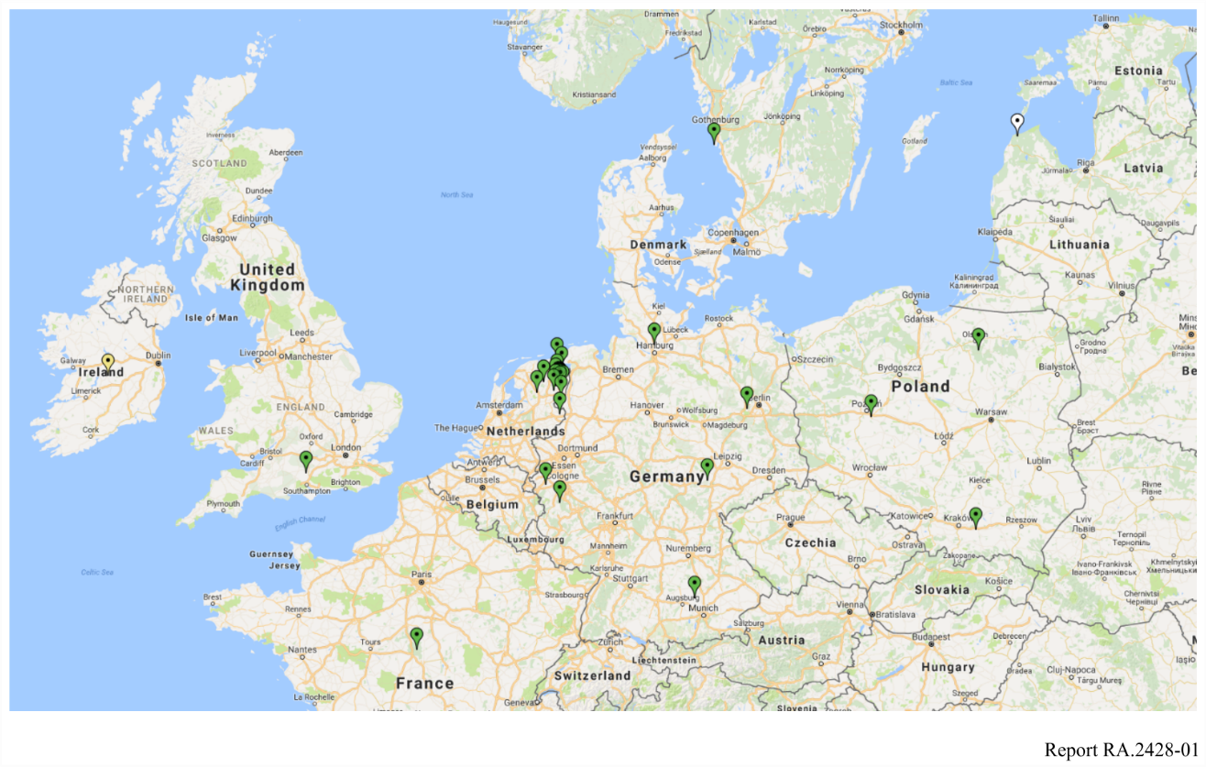
Each LOFAR station is equipped with two different types of antennas: Low Band Antennas (LBAs) with a frequency range of 10-90 MHz and High Band Antennas (HBAs) with a frequency range of 110-250 MHz. The HBAs are placed in elements of 16 antennas each. The antenna lay-out and quantity depend on the type of station.
Thanks to the use of a large number of dipole antennas in combination with electronic beam-forming techniques, different types of beams can be distinguished when dealing with the LOFAR telescope:
1) Dipole or tile beam;
2) Station beam;
3) Tied-array beam.
Moreover, the angular resolution of the LOFAR array depends on the chosen frequency in the relatively wide frequency range and baselines between the stations that are included in the observations.

2.1 LOFAR Core
The central area or core of LOFAR is located in an area of about 320 ha (2 × 3 km) between the villages of Exloo, Buinen and Buinerveen in Drenthe in the North-East of the Netherlands (reference position 52° 55′ N, 6° 52′ E). This area has been transformed into a natural reserve, which provides a relatively radio quiet area. Mounds have been created on top of which the LOFAR stations are built. Figure 2 shows an aerial photograph of the LOFAR core area. In the center of the LOFAR core six stations are built on a single mound, called "superterp''. In the core area, a total number of 24 core stations has been built.
Figure 2
Aerial photograph of the LOFAR core area. All stations are indicated with a pin
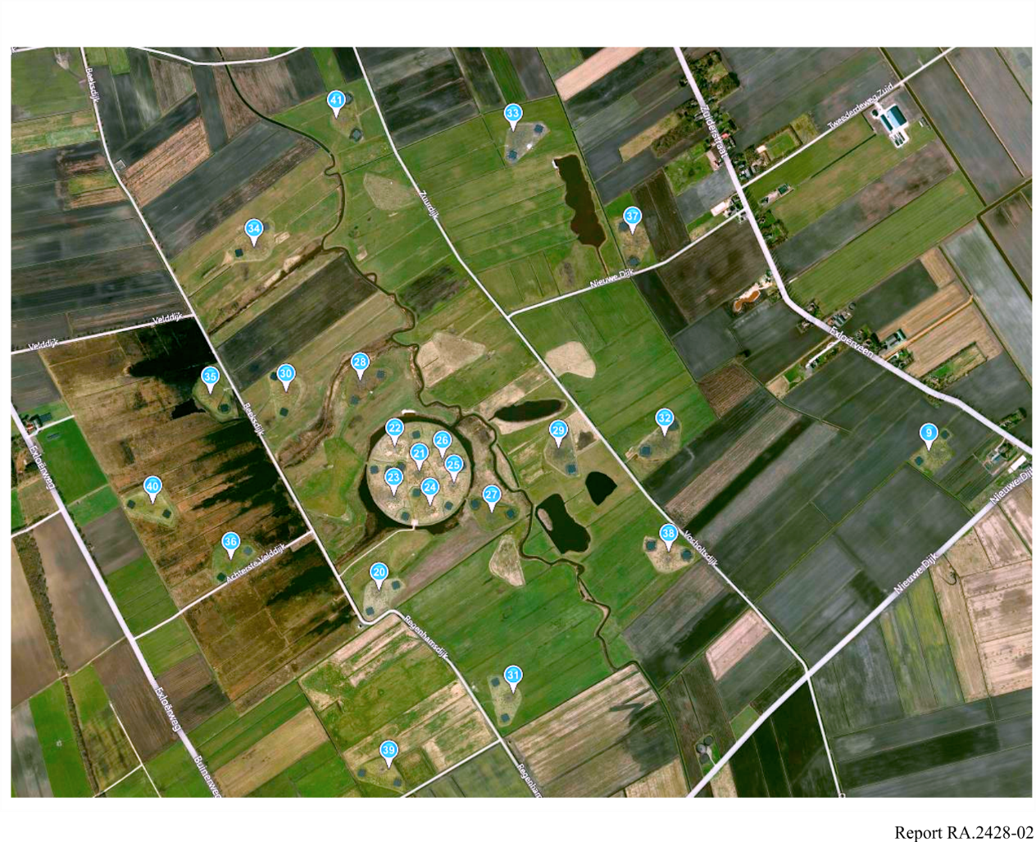
Core stations consist of two 24-element HBA fields with a diameter of 30.8 m each, straddling an 82 m diameter field with 96 LBAs.

2.2 LOFAR remote stations
The 14 remote stations consist of 48 HBA elements in a single 41 m diameter field and 96 LBAs arranged in a single 82 m diameter field.

2.3 LOFAR international stations
The 13 international stations consist of 96 HBA elements in a single 56.5 m diameter field and 96 LBAs arranged in a single 70 m diameter field.

3 Registration approach
From the description of LOFAR it may be clear that the LOFAR telescope is significantly different from the classical dish-shaped radio telescope.

3.1 Geographical separation
The stations that form the LOFAR telescope are distributed over a large area in Europe. It was decided to register the LOFAR telescope as a series of radio astronomy stations, each with their own geographical location.

3.1.1 Core
The 24 core stations that are in a confined area of about 2 × 3 km² in The Netherlands were registered together as one radio astronomy station. For certain types of observations, a number of core stations, or all core stations are used as a single radio telescope, i.e. no remote or international stations are used in these observations. Therefore, the LOFAR core was registered as a single-dish telescope.

3.1.2 Remote stations
The 14 remote stations are scattered over a large area in the North-East of the Netherlands. These stations are only used together with the core and other remote stations for interferometry. Therefore, the remote stations were registered as VLBI stations.

3.1.3 International stations
The 13 international stations are located in several countries all over Europe. The stations are owned by local research communities who can use the stations as stand-alone station for their own research. The international stations are used mostly with the rest of LOFAR for interferometry. The international stations have usually been registered as VLBI stations.

3.2 Substations or beams
The Low-Band Antennas (LBAs) and High-Band Antennas (HBAs) in the LOFAR stations are physically different antennas and they have significantly different characteristics. In fact, the LBA and HBA parts of a LOFAR station can be considered as substations of the station. In the registration process it is possible to define multiple beams, each with their own characteristics. Therefore, substations were treated as beams with the names HB (for HBA part) and LB (for LBA part). Each beam has an entry in Table 6 of the Preface to BR-IFIC in which the Antenna type and dimensions, and Effective area and angular coverage in azimuth and elevation are described. In addition to that, in the data provided for the registration, a reference to a paper document was made in which a more detailed description of the station lay-out and the characteristics of the antennas was provided.

3.3 Frequency bands
It was the aim to register the whole frequency coverage of LOFAR at the ITU. However, only a small part of its frequency range is allocated to the radio astronomy service. The frequency ranges of the LB and HB beams are split into sub-bands which cover portions that either have an allocation to the radio astronomy service or do not have a radio astronomy allocation. For the bands without a radio astronomy allocation it is indicated in the notification that RR 4.4 (no-interference, no-protection) applies.

3.4 Registration of the stations in the Netherlands
The registration of the LOFAR stations in the Netherlands was submitted to the ITU by the Radiocommunication Agency of the Netherlands. ASTRON, the Netherlands Foundation for Radio Astronomy, the operator of the LOFAR telescope, has worked closely together with the Radiocommunication Agency in order to provide all necessary data for the registration process.
In the Netherlands, a total of 15 radio astronomy stations have been registered for LOFAR:
– LOFAR-CORE (the 24 core stations as one large radio astronomy station)
– LOFAR-RS106
– LOFAR-RS205
– LOFAR-RS208
– LOFAR-RS210
– LOFAR-RS305
– LOFAR-RS306
– LOFAR-RS307
– LOFAR-RS310
– LOFAR-RS406
– LOFAR-RS407
– LOFAR-RS409
– LOFAR-RS503
– LOFAR-RS508
– LOFAR-RS509
The remote stations were registered with the names they have in the LOFAR system.
The submission of the registration was accompanied by a document providing an overview description of the LOFAR telescope and by documents specifying the characteristics of the LB and HB beams of the LOFAR core and of the remote stations.
The overview description provided details of the key elements of the architecture of LOFAR, together with a description of the different beams that can be defined for LOFAR and indicative array angular resolutions for different frequencies.

3.5 Registration of the stations in other countries
The registration in other countries must be submitted by the administrations of the countries in which the stations are located. The stations are owned and operated by local entities, who are also responsible for providing the necessary data for the registration to their administrations. To help in this process, after the successful registration of LOFAR stations in the Netherlands, ASTRON provided a template for the registration of the international stations. Only some local information still had to be filled in.
Currently two international stations are registered with the ITU:
– LOFAR-SE607 in Sweden
– LOFAR-IE613 in Ireland
In Germany, this process is still on-going. For the LOFAR stations in the UK, Poland and France the process has not started yet.

4 Issues encountered
During the registration process in the Netherlands it became clear that the national administrations can only register the radio astronomy stations that are located in their countries. This means that for international radio telescopes such as LOFAR and the Square Kilometre Array (SKA) several administrations can be involved in the registration of the whole telescope. It should also be noted that for international stations the respective administrations need to also register a local operator of the radio astronomy station in the Preface to the BR-IFIC.
It was also noted that the information provided in the supplemental documents, i.e. the overview of LOFAR and the detailed description of the LB and HB beams were not accessible in the MIFR. This means that for calculations for the protection of the radio astronomy stations this information is not available from the ITU and will have to be provided by the operator(s) of the LOFAR station(s).

5 Conclusion
Within the current framework for the registration of radio astronomy stations as laid out in Annex 2 to Appendix 4 of the Radio Regulations, the Radiocommunication Agency of the Netherlands, in collaboration with ASTRON managed to register the stations in the Netherlands of the LOFAR radio telescope, a distributed radio astronomy system as indicated in Question ITU-R 252/7. Registration of some international stations has been finalised, some others are still in the process of registration and the remainder are still waiting for registration by the national administrations of the countries in which the stations are located.
It is anticipated that the approach used for the registration of LOFAR can also be used for registration of future distributed radio astronomy systems, such as the SKA. However, when doing this, attention should be paid to the size of the stations to be registered in relation to the frequency because of propagation effects. LOFAR is a low-frequency radio telescope and therefore relatively large stations can be used. It should be investigated whether for e.g. SKA-MID, smaller stations should be used in order to provide sufficient protection; e.g. from satellite radars.

Annex 3
Data provided to the ITU
For entering the information for the registration of the LOFAR stations, SpaceCap V7 has been used. Below are a number of screenshots of SpaceCap when all fields were filled in.
Figure 3
Notice explorer page for the registration of the LOFAR stations in The Netherlands
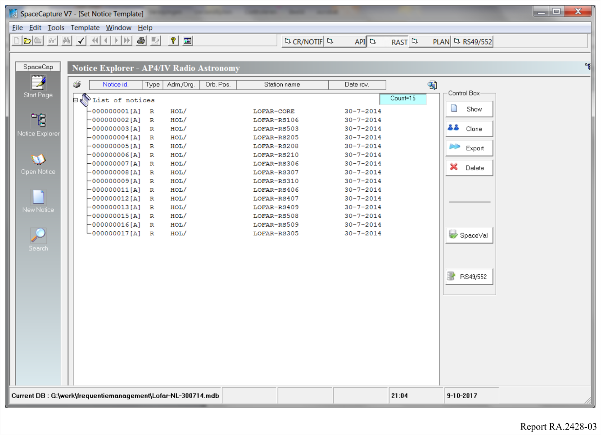
Figure 4
Notification pane for LOFAR-RS106
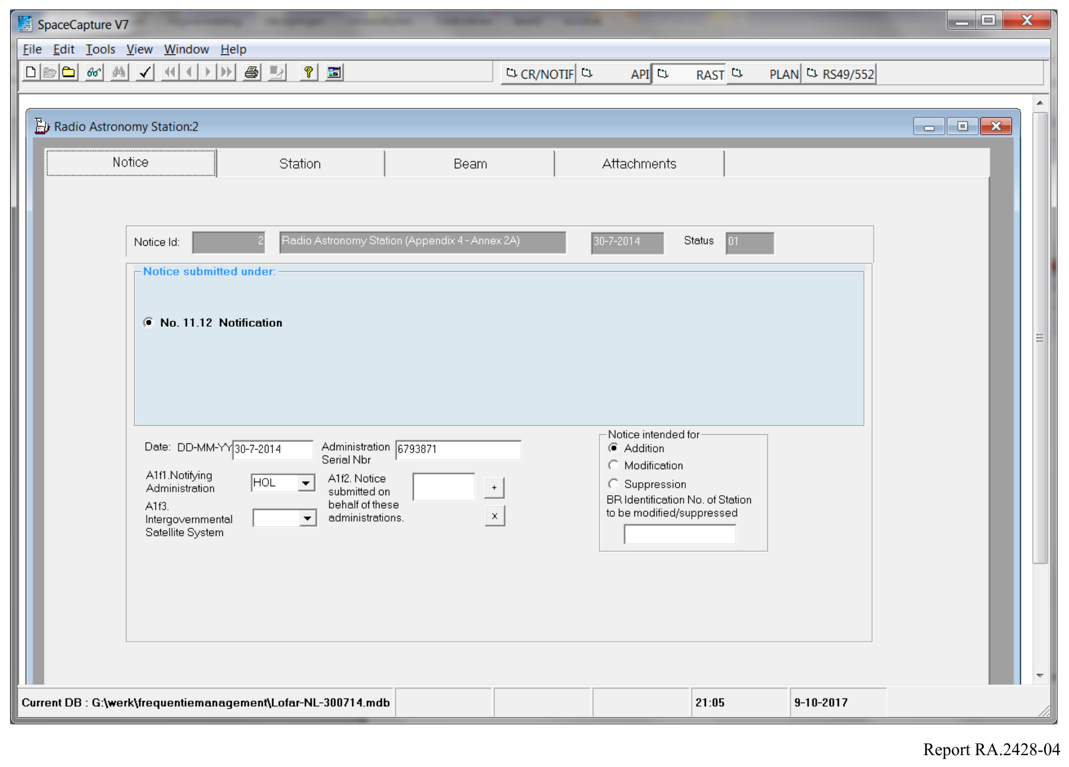
Figure 5
Station parameters for LOFAR-RS106
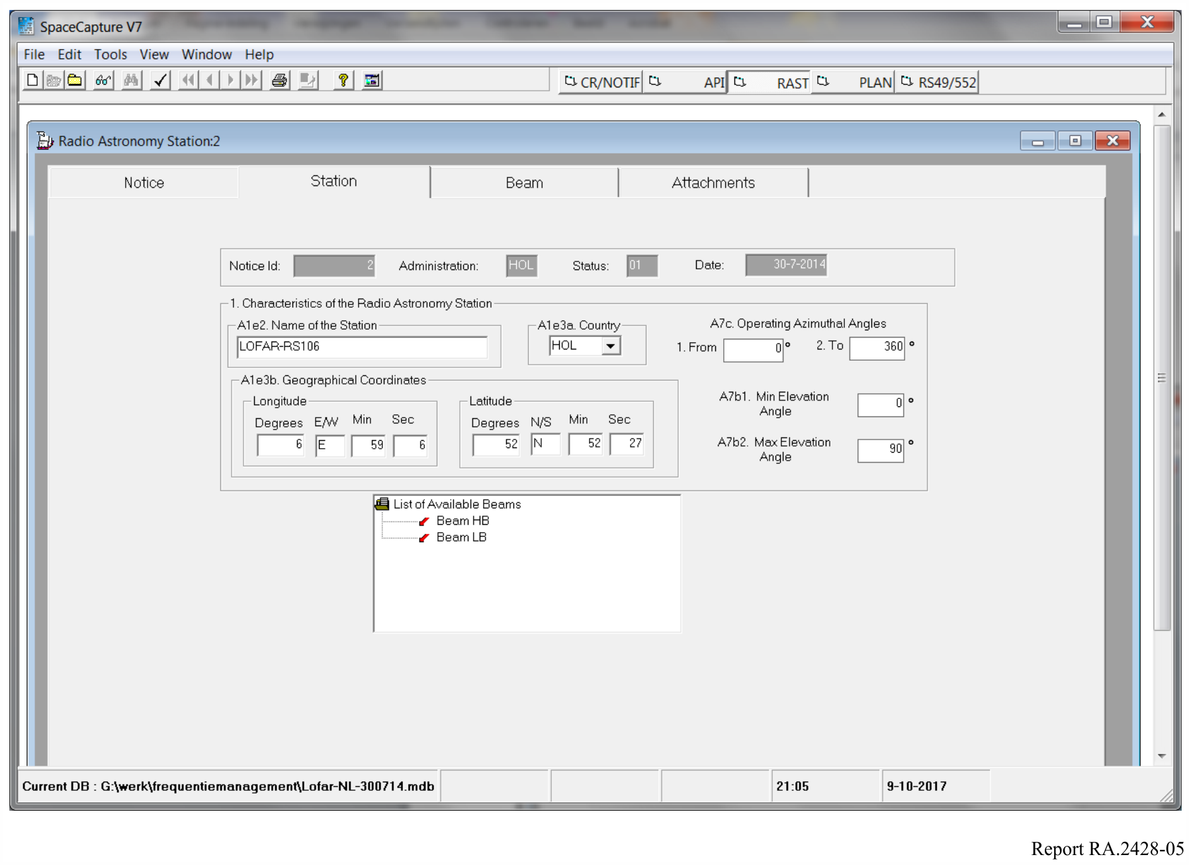
Figure 6
Main parameters for the HB beam of LOFAR-RS106
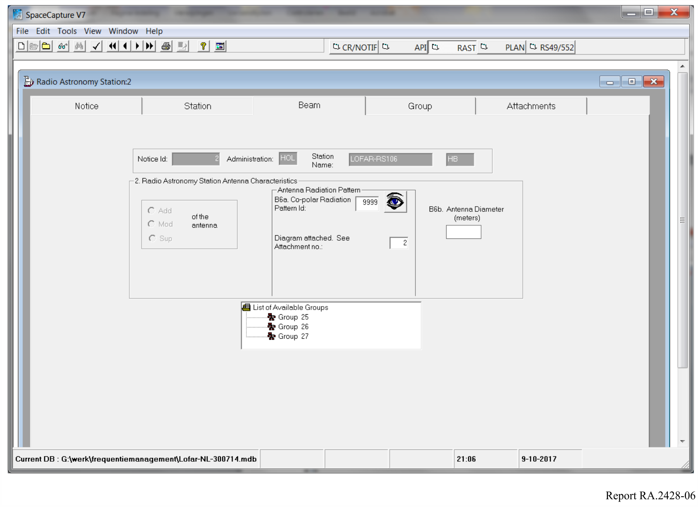
Figure 7
General description of group 25 of frequencies within the HB beam of LOFAR-RS106
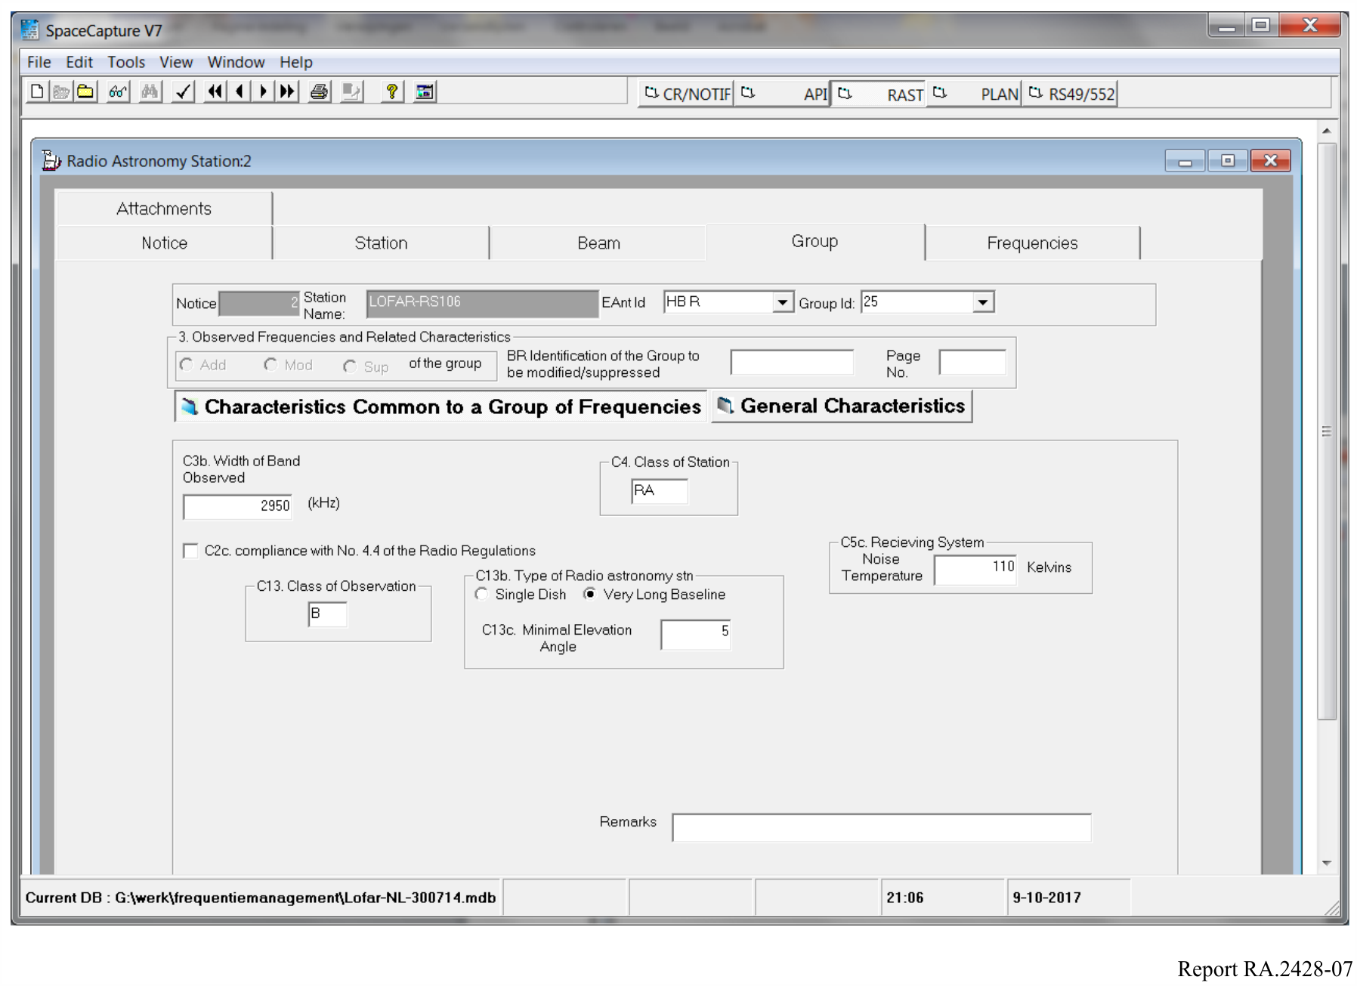
Figure 8
Frequencies within group 25 of the HB beam of LOFAR-RS106
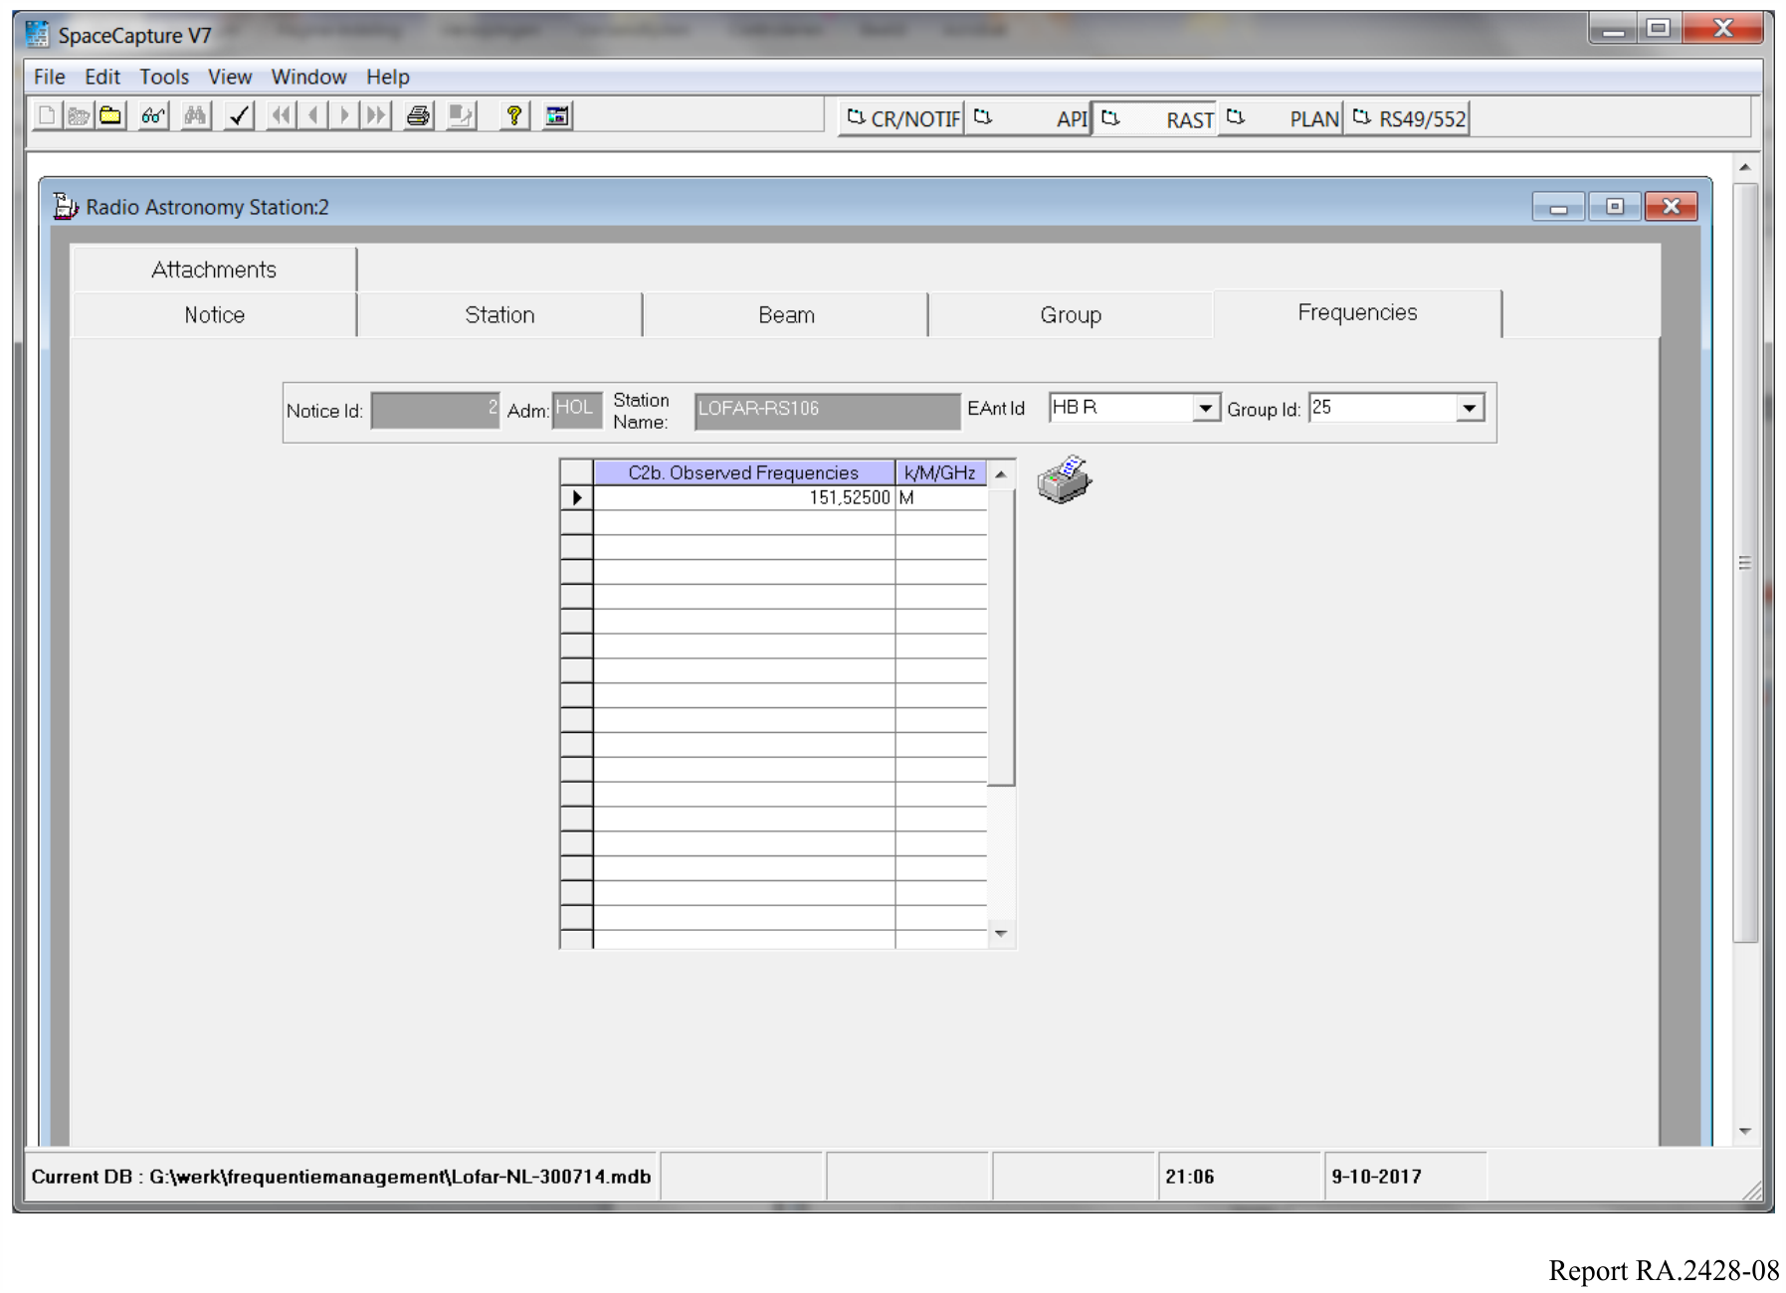
Figure 9
List of attachments to the registration of LOFAR-RS106
Note that the type of the attachments is paper and that a filename for the attachment is provided.
Also a short description is provided,which is included in the Preface of BR-IFIC
